Texas A&M University

MEEN 402 - Section 504

**Autonomous Enumeration UAV**

May 4th, 2015



"On my honor, as an Aggie, I have neither given nor received unauthorized aid on this academic work."

Dayton Savage

Bradford Stricklin

Michael Kowpak

Dennis Moore

Jui Yen Chua

Fuhua Song

Allison Bagdett

Spencer Davis

Adway Dogra

Nathan Kocmoud

# Abstract (Bradford)

This project seeks to design and build an autonomous unmanned aerial vehicle system that can travel through the inside of a building and count the number of individuals inside. Though the information gathered by the systems designed in this project could theoretically be used for any purpose, the immediate goal of this project is to provide a fast, accurate, scalable, and efficient way to collect information on occupants. The project is broken down into three main components: navigation, enumeration, and hardware. Navigation is utilizing Robot Operating System (ROS), a LIDAR sensor, and an ultrasonic sensor to provide Simultaneous Localization And Mapping (SLAM) for the UAV based on referential localization (through the use of Hector SLAM). This enables a map to be generated and provides information critical for the exploration of an unknown environment. For the exploration, navigation is utilizing a multistep algorithm based on the fusion of wall-following and the exploration of unbounded areas. Once the environment has been mapped an algorithm will be used to determine how many pictures need to be taken (and where) in order to provide complete coverage of the building so as to ensure image capture of each person (while minimizing overlap). Enumeration is utilizing a video camera and MATLAB’s Computer Vision System Toolbox to allow for the processing of captured images once the UAV has finished taking pictures. Hardware is handling the build of the UAV and how the UAV will fly. That is they are using an ArduPilot to control the rotors and allow for UAV movement and navigation.

The information on the number of people in an environment and their locations could be used to help reduce excess energy use, thereby cutting costs and saving money. Outside of the energy sector this information could be used in a variety of useful ways. For example, by knowing the number of individuals in a building and where they are located during an emergency situation, emergency service employees will be better informed and will therefore be more effective in planning rescue efforts. Additionally, information gathering autonomous UAVs could be used in military or police situations where an agency would want to know more about the occupants of a building. Regardless of the specific implementation of the data, this project will serve to set a sort of precedence in how data on people in a building can be gathered.

Contents

Abstract (Bradford) 2

Project Specifications and Goals (Bradford, Dayton, and Michael) 11

Function Structure (Michael & Dayton) 12

Solutions (Bradford, Dayton, and Michael) 13

Requirements (Bradford, Dayton, and Michael) 15

Division of Responsibilities: (Bradford, Dayton, and Michael) 17

Project Management (Bradford) 18

Hardware 20

Body Design 20

Multirotor (Ezequiel) 21

Blimp/Multi-Rotor Hybrid (Spencer) 23

Smaller Stationary UAVs (Ezequiel) 24

Propellers (Spencer) 24

Flight controller (Adway) 26

Battery (Ezequiel) 28

Chosen Design (Michael) 29

Assembly 30

Dismantling of Hexa-copter (Spencer Davis) 30

Assembly of Quad-copter (Spencer Davis) 30

Assembly of Electrical Components of Quad-copter (Adway) 32

Sonar sensor for altitude control (Spencer Davis) 33

Mission Planner (MP) (Adway) 34

Arduino Program and Ardu-Copter Software (Michael) 37

Arduino IDE (Michael) 37

Custom Controller (Michael) 38

Sensor Power Requirements (Michael) 39

UAV Layout (Bradford, Michael) 39

Navigation Development 41

Sensors (Bradford) 41

Obstacle Avoidance (Bradford) 45

Mapping (Bradford) 47

Navigation Design (Bradford) 51

Basics (Bradford) 51

Mapping (Bradford) 52

Exploration (Bradford) 53

Obstacle Avoidance (Bradford) 54

Next Semester (Bradford) 54

Spring 2015 Developments (Bradford) 55

Raspberry Pi to ArduPilot Interface (Dennis) 56

Robot Operating System on Raspberry Pi (Dennis) 57

Raspberry Pi to URG-04LX Interface (Dennis) 58

Raspberry Pi and ROS Wireless Communication Setup (Dennis) 58

Wireless Communication (Fuhua) 63

Ultrasonic Sensor Data Retrieval (Fuhua Song) 63

Raspberry Pi to Ardupilot Interface (Dennis) 66

Enumeration Development 68

Algorithm Selection (Dayton) 68

Camera Selection (Dayton) 70

Receiving Map Data (Nathan) 72

Mission Algorithm (Allison) 74

MATLAB’s Computer Vision Toolbox (Dayton) 82

MATLAB: Histogram of Oriented Gradients (Dayton) 82

MATLAB Support Vector Machine (Jui Yen) 83

People Detector (Jui Yen) 85

Tracking (Dayton) 85

Cascade Object Identifier (Jui Yen) 89

Live video feed (Jui Yen) 90

Code Status 3/23/15 (Dayton) 92

Enumeration Status 5/2/15 (Dayton) 96

Enumeration Status 5/2/15 (Olo) 97

Next Semester (Overall Project) (Bradford and Michael) 100

Integration (Bradford, Michael and Dayton) 101

Data Flow (Bradford) 101

Directional Commands (Michael and Bradford) 105

Counting Location (Dayton and Bradford) 106

Conclusion (Bradford, Dayton, and Michael) 107

Budget (Michael) 109

Schedule (Bradford) 110

Bibliography (Bradford and Dayton made recent changes) 112

Appendix 115

Failure Mode and Effect Analysis (Bradford, Dayton and Michael) 115

Fault Tree Analysis (Bradford) 117

Cause and Effect Analysis (Michael) 118

Quad-copter Dimensions (Ezequiel) 119

Calculations and Experimentation 120

Weight Test on Hexa-copter (Michael) 120

Weight Test on Quad-copter (Michael) 121

Helium Lift Capacity Calculations (Spencer) 122

Arm Reduction Calculations (Michael) 123

MATLAB code Sample for People Detector and Cascade Object Identifier (Dayton) 124

Robot Operating System Code (Bradford) 125

**Table of Figures**

Figure 1. Function Diagram 12

Figure 2. Function Structure 13

Figure 3. SCRUM Board for Autonomous UAV 19

Figure 4. Hexa-copter 22

Figure 5- Blimp design by Spencer Davis 24

Figure 6.Multirotor 2-blade propeller 25

Figure 7.PWM signal at no throttle 27

Figure 8. Assembled quad-copter frame 31

Figure 9. Electrical component configuration for APM 2.6 33

Figure 10. Mission Planner front page 34

Figure 11. MP video feed corresponding with GPS image 35

Figure 12. MUX Diagram 36

Figure 13. UAV Layout: Top Side 40

Figure 14. UAV Layout: Bottom Side 41

Figure 15. Hector SLAM Generated Map 53

Figure 16. RVIZ Mapping Screenshot 62

Figure 17.Square Hallway Search Algorithm 75

Figure 18. Branching Hallway Search Algorithm 76

Figure 19. A sample image (yellow) and its skeletal decomposition using the Zhang-Suen algorithm (blue) 81

Figure 20. HOG Process (Dalal, 2) 82

Figure 21. MATLAB Function Time Analysis 92

Figure 22.MATLAB Function Time Analysis - further results on display 93

Figure 23: Webcam Video Sample from ENPH at Texas A&M 94

Figure 24: Web Cam video footage in ENPH at Texas A&M 95

Figure 25. Data Communications Flow Chart 104

Figure 26- Arm dimensions 123

Figure 27. ROS Slam.Launch 125

Figure 28. ROS Hector SLAM No IMU Launch 126

Figure 29. ROS hector_mapping.launch 127

Figure 30. ROS geotiff_mapperer.launch 128

# Project Specifications and Goals (Bradford, Dayton, and Michael)

The Solution Neutral Problem Statement for this project is to design, build and test an autonomous unmanned aerial vehicle (UAV) that will navigate a building and count the number of occupants in the building. The requirements of the project include making the UAV autonomously navigate a building, follow a mission planning algorithm, and count the number of people in an environment. The objectives and assumptions for the project are listed below.

There are three objectives within the project

1. The UAV must be able to autonomously navigate and map its environment
2. The UAV must be able to accurately count the number of people in the environment
3. The UAV must be adept at maneuverability and obstacle avoidance

Assumptions:

* Small children and infants do not need to be counted
* All potential doors are already open
* The flight will be in a commercial or industrial setting
* People could be moving while the UAV is operating
* People will not be entering the building during an emergency situation
* No rooms larger than 40 ft. X 40 ft.

Justifications: Our customer needs to be able to arrive to various buildings with differing floor plans and quickly deploy the UAV in an unprepared environment. The UAV must complete its assignments on its own without human intervention.

# Function Structure (Michael & Dayton)

Figure 1 contains the function structure created for this projects solution neutral problem. In the function structure, the flow diagrams resemble the material, signal, and energy changes from the beginning to the end of the process. The signals for enumeration and navigation repeat continuously until everyone is counted. At the end of the flight process, the user will check to ensure the accuracy of the final count.

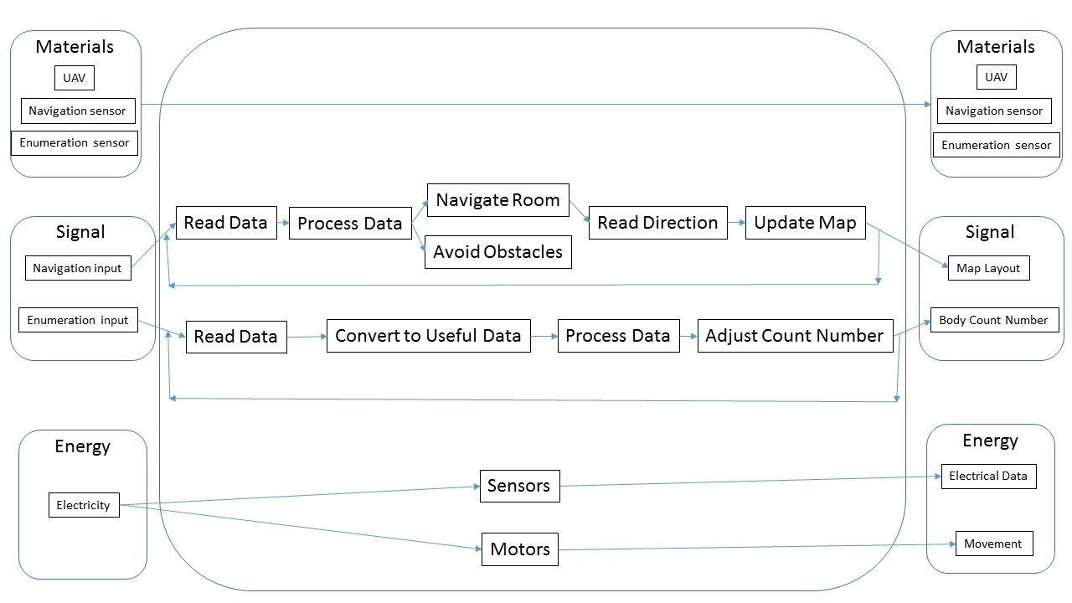

Figure 1. Function Diagram

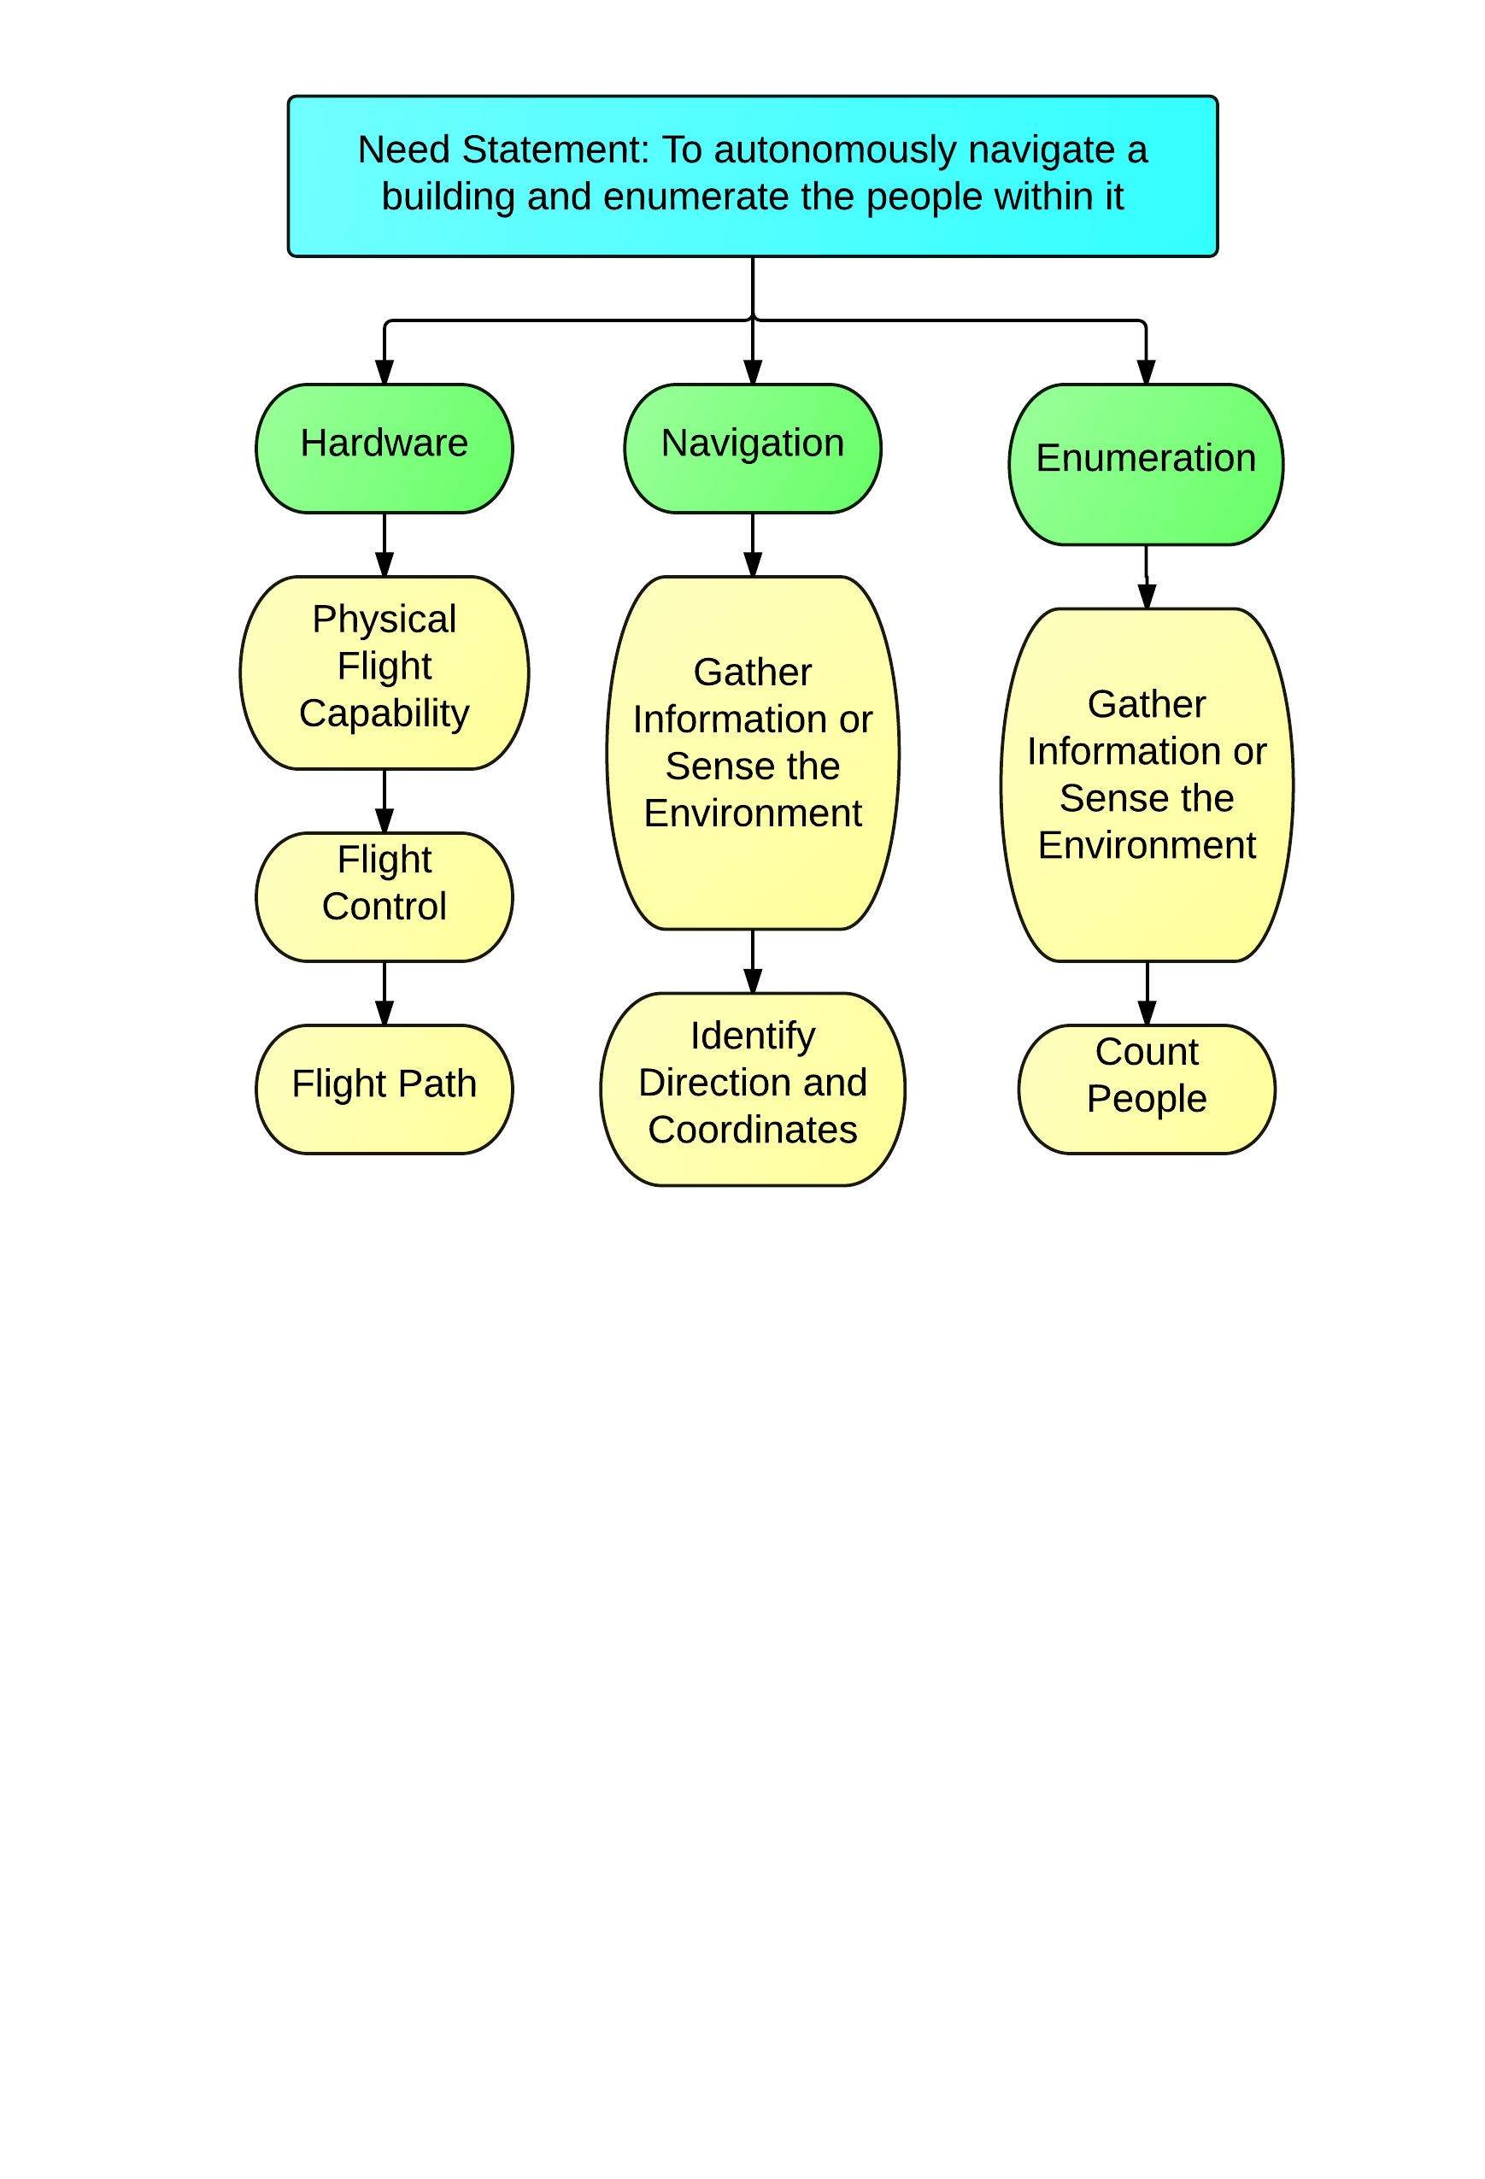

Figure 2. Function Structure

# Solutions (Bradford, Dayton, and Michael)

The group members discussed several possible solutions to achieve the general requirements of the project. The first problem was what type of UAV to use. The UAV will need to be a design that can sustain flight for the entire process while performing the navigation and enumeration functions. A hexa-copter was used in previous semesters and was the basis for the UAV design. However, a quad-copter design will be used this semester. More explanation on the UAV design selection can be found in the Hardware section.

The next problem was the order of the processes. The UAV could attempt to count the occupants of the environment while it generates a map. This would require only one run-through of the building and take less time. However, there is a much greater chance of missing people or double counting people with this implementation. Another solution was to have a UAV move through a building using a building navigation algorithm first. As the UAV was navigating, it would create a map of the building. Once the map was completely generated, the UAV would go through again and count people from critical locations determined from the generated map. This method could use 1 or more UAVs to count people all at once or in a certain order. The problem with this method is extra time required to complete the process. More explanation on different counting methods can be found in the Enumeration section.

The last problem was how the progress and results were going to be communicated to other UAVs or back to the user. If multiple UAVs are used, there would need to be communication between each vehicle. The UAVs could communicate directly to each other or transmit their information to a central computer with the user to be redistributed to other UAVs. A central computer would require extra hardware but is preferred for the heavier processing and to provide a visual response to each UAV’s progress. Also, the UAV could easily be switched to manual control for malfunctioning or safety reasons. More explanation on the UAV communication can be found in the enumeration and navigation sections.

Based on the list of possible solutions, the group decided to use multiple quad-copter UAVs to generate a map of the building first, then count the number of occupants. Each UAV would communicate to a central computer using wireless internet. This computer would perform all processing of data from sensors and return the necessary commands back to each UAV.

# Requirements (Bradford, Dayton, and Michael)

Table 1 contains the list of requirements for the project. It contains a developed metric for the Autonomous UAV to determine the level of importance for each of the UAV requirements and lists the ideal and marginal values.

Table 1. Preferential Requirements List

|  |  |  |  |
| --- | --- | --- | --- |
| Importance | Requirement | Marginal Values | Ideal Values |
| 1 | count accuracy | ±2 % error | 0 % error |
| 1 | proper mapping/navigating | 6 inches error from map | 1 inch error from map |
| 2 | size | width < 30 inches | width < 24 inches |
| 3 | durability | continues flying after contact with walls | Survive collisions or crash from 7 ft. |
| 4 | cost | N/A | < $3000 |
| 5 | run time | N/A | < 2 min per room |
| 6 | weight | 2 lb. total | 1 lb. total |

The ideal count accuracy is set to 0 percent error. This means that the UAV will return the exact number of people in a building. However, this number is optimistic because some people might be hidden behind objects or in a position that the UAV could not pick up. Therefore, the marginal count error is plus or minus 2%. For example, if there are 100 people in a building, the UAV can successfully count 98 to 102.

The ideal mapping of the navigation system is set to one inch error in map layout. The marginal value of the mapping can be up to six inches of error. When the UAV is navigating a building, the generated map can be the wrong dimensions or location of the actual map by up to six inches and still function. This will guarantee that the UAV will not miss narrow passages or extrusions from the wall that could interfere with the UAV’s flight or count.

The ideal diameter of the UAV is smaller than 24 inches from one rotor tip to the opposite rotor tip. This would provide enough clearance for the UAV to navigate through doorways with slight error. The marginal value for diameter is 30 inches. When the UAV gets larger, it risks not being able to clear the doorways. The UAV needs to have a certain level of durability when interacting with the environment. Ideally, the UAV should not be damaged if it falls from 7 feet. This would allow the team to test the navigation and enumeration functions without concern of damage to the UAV. The marginal durability of the UAV should be continued use after some contact with walls or boundaries. The budget for the project was set at $3000. However, if a budget increase can be justified, more funding will be provided. The ideal run time for the project is 2 minutes per room in the building. This value was chosen to provide time for navigating, mapping, and counting that is adjustable for the scope of the project. However, the UAV can take as long as need to prove the concept. The weight of the UAV should ideally be less than 2 lb. to allow proper maneuverability. However, the group determined that the UAV can weigh up to 3 lb. before control issues start occurring.

# Division of Responsibilities: (Bradford, Dayton, and Michael)

The project was broken up into three sub teams: the Enumeration Team, the Navigation Team, and the Hardware Team. Each of the three capstone students are leaders of their chosen team while the remaining team members on each team consist of the Aggie E-challenge students. Table 2 contains the list of the teams and their organization. Dayton Savage, Bradford Stricklin, and Michael Kowpak are the leaders for each section.

Table 2. Team Breakdown

|  |  |  |
| --- | --- | --- |
| Enumeration Team | Navigation  Team | Hardware  Team |
| Dayton Savage | Bradford Stricklin | Michael Kowpak |
| Allison Badgett | Dennis Moore | Adway Dogra |
| Jui Yen Chua | Fuhua Song | Ezequiel Garcia |
| Nathan Kocmoud | Yucheng Guo | Spencer Davis |

The navigation team was responsible for ensuring that the UAV can successfully navigate the building. This mandates that the vehicle be able to determine its position, map its environment and surroundings, and respond to obstacles both moving and stationary. With the layout of the surroundings (or map) generated by the vehicle, the enumeration team should have all of the information they need to ensure all areas of a building are scanned and that everyone is accounted for.

The enumeration team was responsible for determining and implementing the algorithms and equipment necessary to count people within the building without double counting. This entails the development of a pre-determined path for the UAV to acquire the needed data in, collecting the actual data, and processing the data into useful headcounts.

The hardware team is responsible for constructing a functional UAV that can hold the necessary sensors and successfully move around a building. The mechanical engineering department already has a hexa-copter from a senior design project from last year. However, the objective of the project was different and used a remote to navigate. The hardware team focused on developing a design of the UAV to meet the functional requirements of the navigation and enumeration teams.

Though the three teams were integral during the first semester of the project, the teams have since begun to meld with one another as the project has come together. For example, as hardware has been working to get the communication between the APM and the Raspberry Pi’s navigation systems working, the navigation team has been working to help this process from both the Pi and APM sides. Obviously the integration of the UAV’s systems could not be accomplished if the teams did not work together and so the teams have been working so closely that a lot of team division has dissolved. This is especially true of the navigation and hardware teams as their systems heavily rely on one another.

# Project Management (Bradford)

To aid in the merging of teams and work-flow process as a whole, the team decided to implement a modified version of SCRUM. SCRUM is a bottom-up, multi-step, iterative design process used for projects that are able to be broken down into parts. Though some of the tasks the team has had to tackle have had components that had to be completed first, the vast majority of work during the second semester consists of tasks that can be completed independently of one another. This is especially true because of the large amount of coding involved in the project. By laying out all of the components that must be completed for a project to be deemed “successful” or “accomplished,” the team gains a better understanding of the project’s components. With all of these components laid out into a “To-Do” category, the idea behind SCRUM is that anyone can pick up and work on any of the tasks. This is signaled by the team member moving the task into the “In Progress” section. Once a tasked has been completed, it is moved to the review section where a team manager can go through and check that the task was completed properly. It is then lastly moved into the “Complete!” section. All of the tasks in progress are attached to a team member’s name so that everyone knows what everyone is working on and who is working on what.

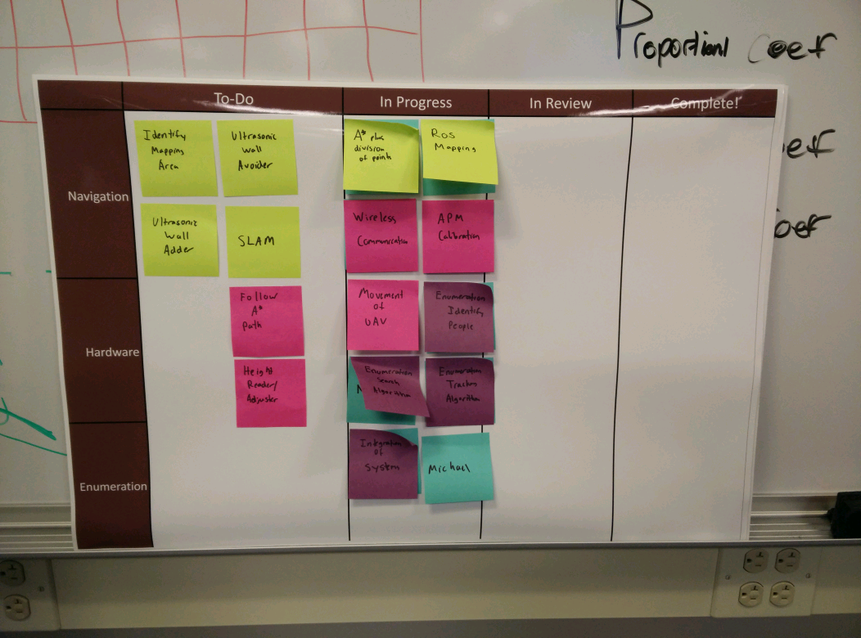

Figure 3. SCRUM Board for Autonomous UAV

# Hardware

The objective of the hardware team was to construct a fully functional UAV that integrates the sensors and functions of the enumeration and navigation teams.  The hardware team members included Michael Kowpak, Spencer Davis, Adway Dogra, and Ezequiel Garcia in the fall and Michael Kowpak, Spencer Davis, and Adway Dogra in the spring.

The tasks for this team included choosing a design for the UAV, creating a functioning UAV that is stable while flying, and attaching the numeration and navigation sensors.  Throughout the early stages of the project, team members were tasked with conducting research to determine the best design for meeting the project specifications and requirements.  The hardware team was aware that several key components and characteristics of the UAV are needed to meet the project requirements. These components include: a stable design with enough lift & power for the housed sensors and hardware to operate, enough battery life for the UAV to complete its mission, controlled maneuverability, and minimal disruption of the surrounding environment.  The UAV should not move objects or interfere with anything in the building, and should fly high enough to avoid interfering with people.

## Body Design

The body design was the first consideration the hardware team made in the design of the UAV.  The suggested options consist of a multi-rotor copter, a blimp/multi-rotor hybrid, and the use of many small copters that can be deployed and remain stationary.

### Multirotor (Ezequiel)

The multirotor design was the first design considered for the UAV.  A multi-rotor copter utilizes 3 or more rotors spaced evenly around the copter frame.  This configuration provides more stability than a single rotor copter and allows equipment to be placed in the center of the frame. Below are some different multi-rotor copters that were considered for this project

Tri-Copter: The tri-copter is a multi-rotor copter with 3 rotors symmetrically oriented around the center.  This design provides the least amount of lift and control but is also the smallest size. The tri-copter will not be able to perform a controlled landing if a rotor malfunctions. (Tri vs Quad Copter, 1) For this project, the tri rotor was not selected due to its limited lift capacity and stability, especially when sensors will be added.

Quad-copter: The quad-copter contains 4 rotors and provides more lift and stability than the tri-copter.  However, the size is larger and the battery requirements are increased. The quad-copter can still perform a controlled landing if it loses a rotor with the right software. (Coxworth, 1)  For the purposes of this project, the quad-copter is a viable solution because it provides a reasonable amount of area for sensors (size in Quad-copter Dimensions section). The 4 rotors on the quad-copter will also provide greater control for 4 directional (planar) movement (forward, back, left, and right) than the tri-copter. (Tri vs Quad Copter, 1)

Hexa-copter: The hexa-copter was the first design considered because it was provided from last year’s capstone project.  This copter contains 6 rotors and provides more lift and stability at the cost of size and increased battery usage.  It would also be able to land safely if a rotor malfunctions.  A significant issue with the hexa-copter build was its large diameter. The hexa-copter provided spans roughly 32 inches in diameter from rotor tip to rotor tip creating concern when it comes to maneuvering through doorways and tight spaces. A minimum sized doorway in a public building is at least 36 inches wide in order to meet legal building code requirements. (Ramsey, 1). This only leaves about 2 inches on either side of the copter assuming there is complete control of its position.  Should one of the propellers hit an obstacle such as the frame of a doorway at that speed, the rotor could break and cause issues in stabilizing the hexa-copter.  It was determined this risk must be avoided and a smaller size would be needed to ensure the UAV functions properly. (Gortolev, 1)

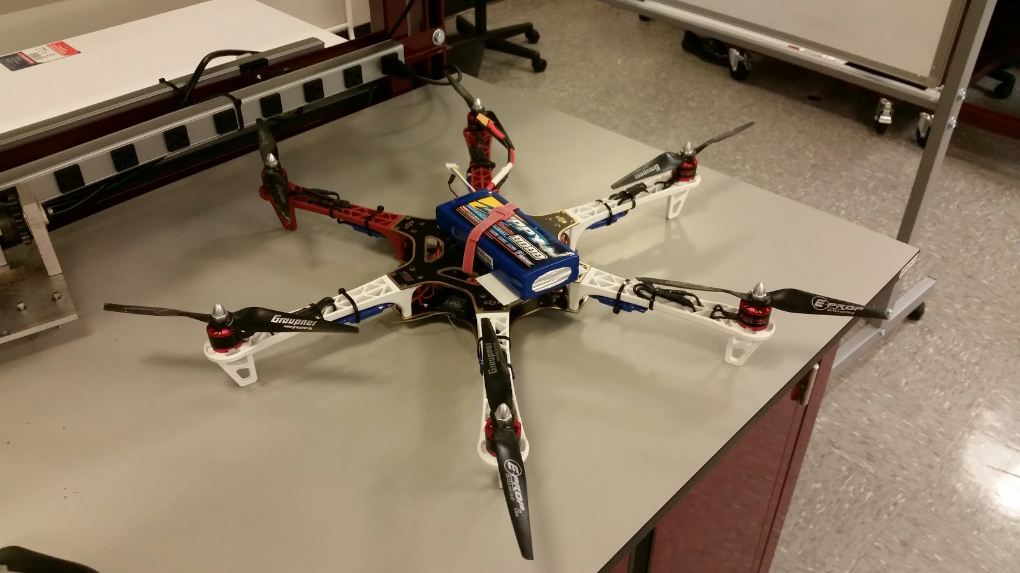

Figure 4. Hexa-copter

Octo-copter: The octocopter is the largest multi-rotor with the greatest lift.  Considering that the hexa-copter is too large and the amount of lift was unnecessary, the octocopter is not a viable solution.

A coaxial design was also researched where every 2 rotors are stacked to create the size of a quad-copter while providing more lift.  This option was not chosen because the rotor efficiency is decreased by about 33% and increased lift is not needed for the UAVs application (Gortolev, 1). A weight test on the hexa-copter was used to calculate the needed lift for the UAV and can be found in the Calculations and Experimentations section in the appendix.

### Blimp/Multi-Rotor Hybrid (Spencer)

The blimp/multi-rotor hybrid was an idea considered with the aim of solving the problem of sustaining battery life for a long period of time and also providing stability. This concept would involve attaching a small helium balloon to the top of the UAV body. This balloon would provide an upward force that would come close to matching the force of gravity acting on the entire UAV, allowing for minimal effort to be produced by the UAV’s rotors to achieve lift. The problem with such a concept is that at standard pressure it takes 16 cubic feet of Helium to lift 1 pound of mass. (Neer, 1) This would mean that a balloon on the UAV would have to be exceptionally large. The data in the Calculation and Experimentation appendix section indicates that the scale to lift factor was not sufficient enough to meet the specific needs of our project. It would take 60 cubic feet of helium to lift 3.75 pounds (the weight of the UAV) and a sixty cubic foot balloon attached to the top of the UAV would be unusable indoors. Also, there are not commercial designs for a multi-rotor, blimp hybrid so the hardware team would have to design one.

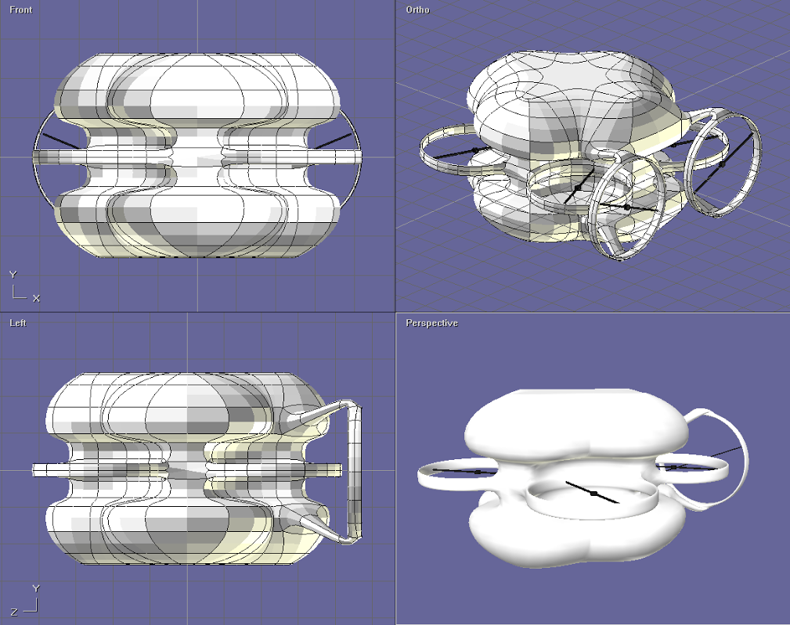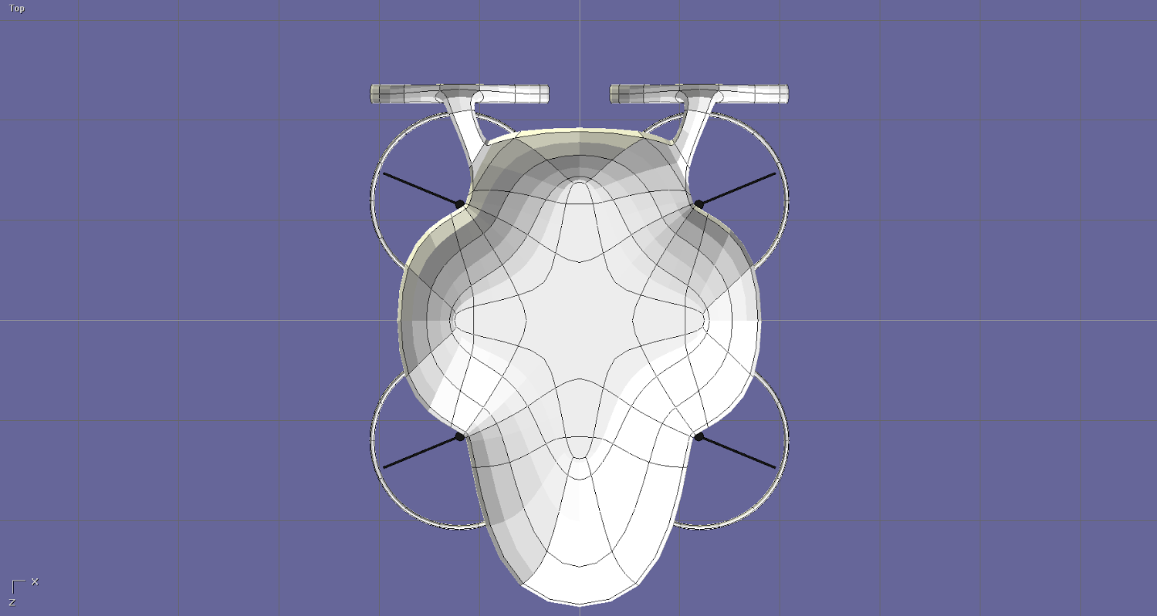

Figure 5- Blimp design by Spencer Davis

### Smaller Stationary UAVs (Ezequiel)

The final design consideration was the use of smaller, stationary UAVs along with the multi-rotor or blimp design.  The smaller UAVs would be used during the enumeration process to keep track of people who move.  When locations are found that need to be monitored for traffic, a smaller UAV could be deployed and watch the area while the primary UAV scans the rest of the building.  This consideration is good for very high counting accuracy but would require much more equipment and communication between devices.  There is also an increased chance of equipment or counting error with more components.

### Propellers (Spencer)

On the multi-rotor design, the argument was made to use three blade propellers instead of the standard two blade propellers. There are three known advantages to three blade propellers. A three blade propeller can produce more lift, the flight is quieter, and the copter is much more stable (less vibrations from rotors). (Three Blade or Two Blade, 1) Multi-rotor copters that are used in high quality aerial photography may have three blade propellers because of these advantages. However a three blade propeller is less efficient than a two blade propeller and produces more drag. Three blade propellers also need to be “balanced” to work properly in sync. If the enumeration or navigation teams need more stability while flying next semester, the hardware team will consider switching to 3 blade propellers.

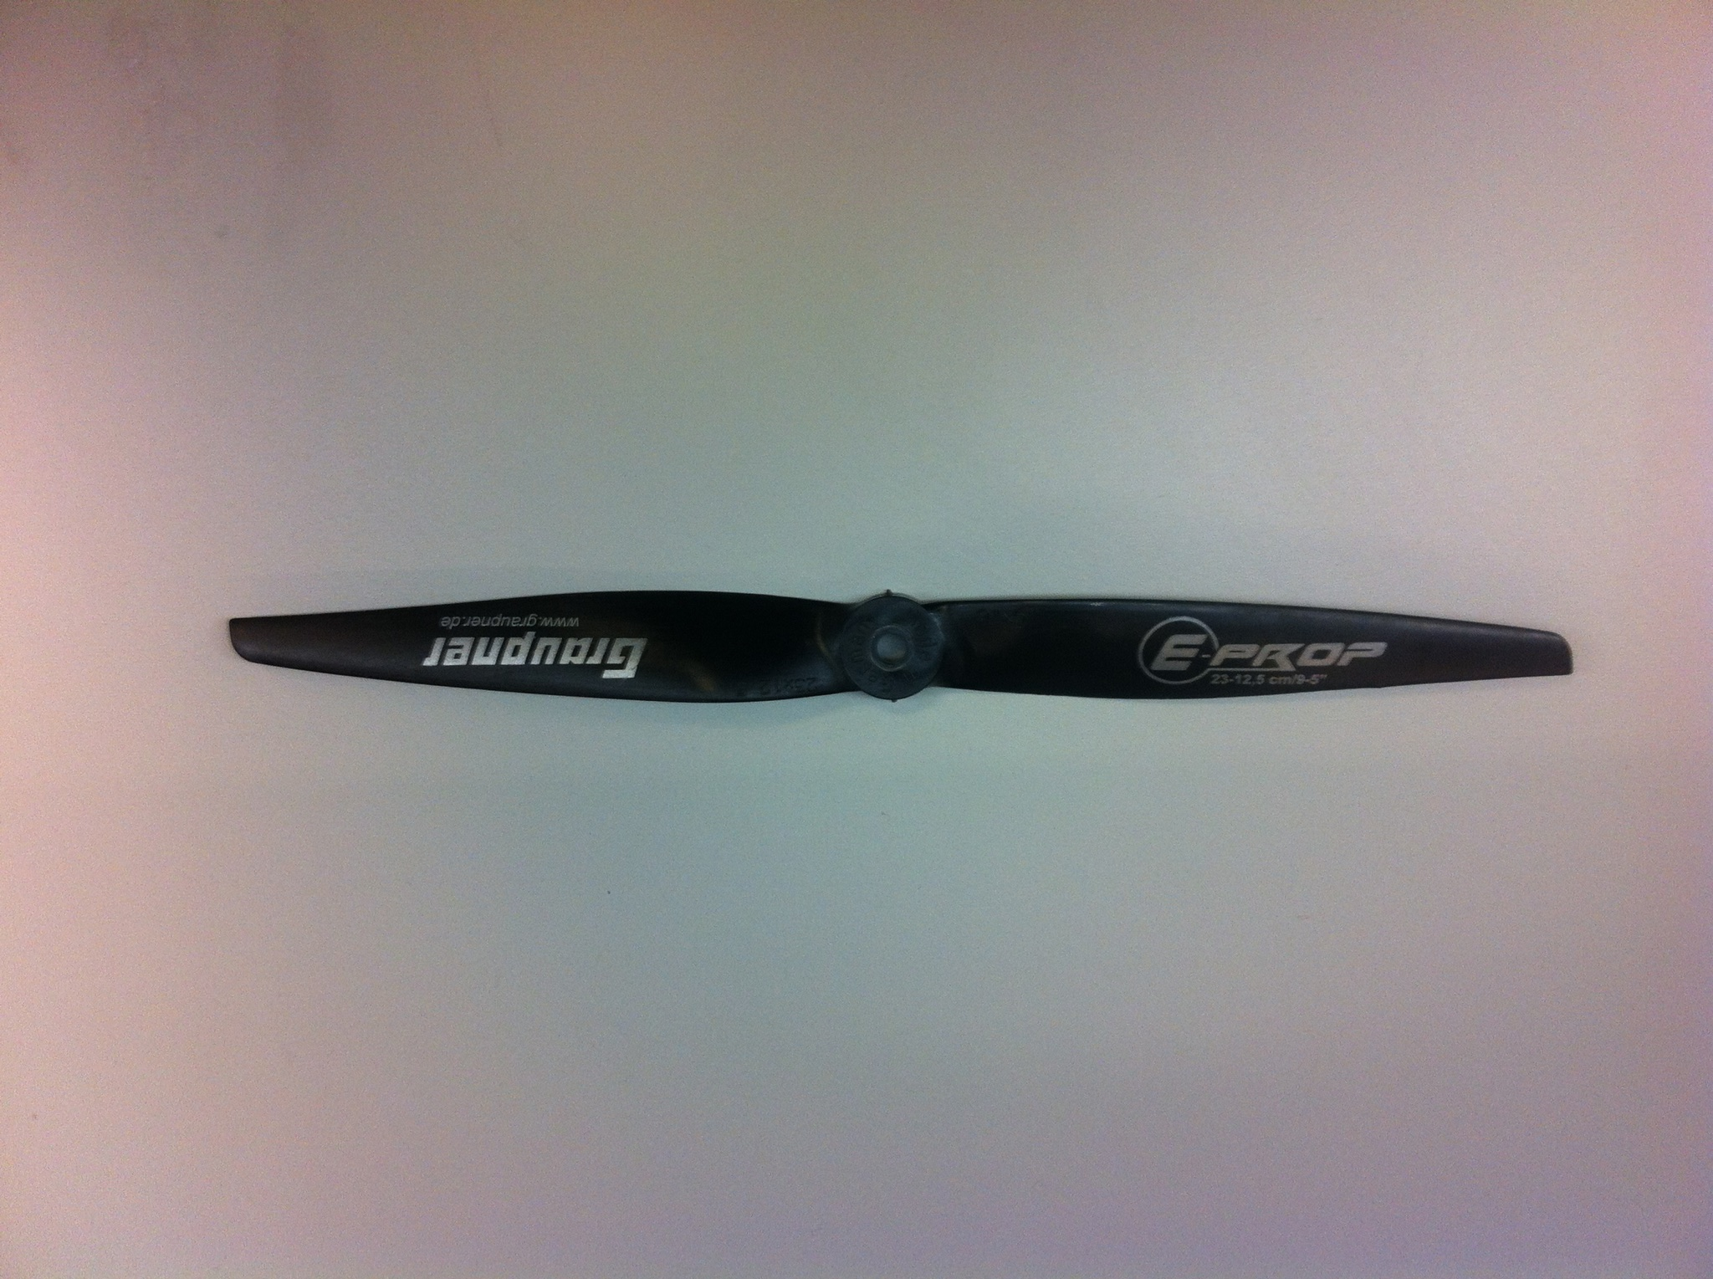

Figure 6.Multirotor 2-blade propeller

There are safety concerns when flying a multi-rotor copter indoors or around people. In our case we will be doing both.  The propellers could easily injure someone or cause damage to the building.  To protect people, the building, and the rotors themselves, rotor guards will be employed. The rotor guards are mounted to each of the four arms to secure the sweeping path of the propeller blades. The guards are currently in place and working properly. The diameter of the UAV was increased to 24 inches. We believe this is necessary to ensure the safety of bystanders and protection of the UAV.

### Flight controller (Adway)

The most crucial step for this project was the selection of a flight controller. The hardware focused on three flight controllers that would work for this project. The selection process is summarized below.

Naza M-Lite: The DJI Naza is by far the most well-known and reliable flight controller in the market. Since DJI is an extremely popular company, the customer support for this module is excellent. However, the Naza series is not open source & most of the accessories are proprietary, making third party components impossible. (APM 2.5 or DJI Naza Version for quad-copter, 1) Additionally, the Naza doesn’t allow the user to change the firmware and it doesn’t have any analog input pins that will be needed for project. Access to analog pins is required to connect the Raspberry pi/Arduino to the flight controller so that the flight controller operation could be interrupted momentarily when any serial data from the raspberry pi or Arduino is received on those pins. This data may include instructions to move forward, backward, turn right, or turn left. (NAZA-M LITE, 1)

**APM 2.6 (Final Selection):** The APM is the most reliable flight controller considered. Since it has been in the market for quite some time, there are many support forums available online. The 2.6 is the final revision of the APM (replaced by the Pixhawk) which means that the firmware has been user tested multiple times, is very stable and glitch free. The APM is completely open source which means that third party components can be interfaced with it. (APM 2.6 Set*, 1*) It also has analog pins for sensors that the user might desire to use.

Pixhawk: The Pixhawk and APM are quite similar in that both are open source and fully customizable and manufactured by 3D Robotics. The Pixhawk is a successor to the APM 2.6 and it provides more processing power. However, being a new controller, the software is still in early stage of development and still has a few unresolved bugs. Additionally, The Pixhawk also doesn’t have much support available from online forums.

The hardware team considered mimicking PWM signals an Arduino that is fed directly into the APM's input pins. The raspberry pi will be controlling the Arduino.  Figure 7 contains a schematic showing the response of the PWM signal at no throttle. The APM will also keep a radio transmitter as a failsafe in case manual override is required.

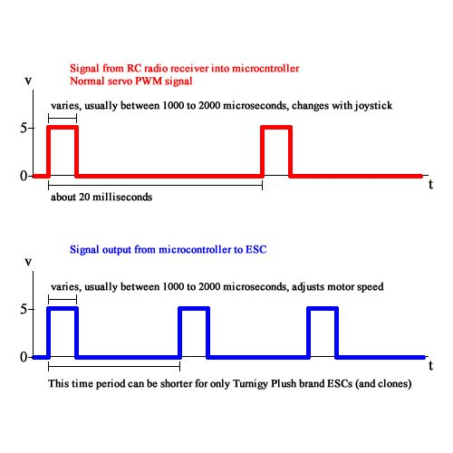

Figure 7.PWM signal at no throttle

### Battery (Ezequiel)

The current battery in use can produce a current of 240 Amps at the most (8 Amps * 30 capacity) however running at maximum capacity will exhaust the battery’s energy very quickly. This battery also has mostly positive reviews on online stores that carry it. (ZIPPY Flightmax 8000 mA-h 4S1P 30C, 1) The same manufacturer offers batteries of varying power and weight so other options for the battery were looked into during the weekly research phase. The higher current and voltage output by each Zippy, battery the greater the weight of the battery. For example, the company offers a 6 cell battery that also has an 8Amp*hour capacity and offers 22.2 volts (8.2 extra volts, which does not necessarily make the battery last longer). This comes at a cost as it weighs about 2.8 pounds and is priced at 100 dollars. With a higher voltage battery and the same current, the UAV can power more devices for the same period of time than a battery with less voltage (power equals current multiplied by voltage). It would be necessary to measure the amount of wattage the UAV is using in order to see if our battery would be the best option or not. This can be done by just testing the amps through the battery, the voltage across the battery, and solving for the power output. With this information and an estimate of how long it would take to scan a room for people, a lighter & weaker battery could be used if cutting back on the weight of the UAV was absolutely essential.

Other battery brands include the “Venom 7.4 VOLTS 8000 mA 20 C”. This battery is about 16 dollars cheaper and weighs half as much. However, the decrease in voltage and, reduced power would mean a shorter life span. All batteries seem to be on par with each other with weight dropping in direct correlation with current and voltage. (ZIPPY Flightmax 8000mAh 4S1P 30C, 1) However, until the battery life becomes an issue with the UAVs performance, the hardware team will continue to use the current batteries.

### Chosen Design (Michael)

After considering all the above designs, the hardware team decided to use a quad-copter with the APM 2.6 flight controller.  Although the hexa-copter was already available, the diameter was too large to move through doorways.  Calculations were done to reduce the size of the arms but new arms would have to be custom made and the size could only be decreased to 28” which will still be larger than the quad-copter’s diameter.  Size calculations can be found in the Calculation and Experimentation appendix section.  A weight test on the hexa-copter also showed that the lift capacity of the hexa-copter is much greater than the expected need.  Results of the weight test can be found in the Calculation and Experimentation appendix section.  The quad-copter provides the most lift and control for the navigation and enumeration components while still small enough to fit through doorways. Results of the quad-copter weight test can be found in the Calculation and Experimentation appendix section.  There are assembly kits available to build the quad-copter with flight controllers designed for multi rotor use.  The quad-copter is built using the DJI Flame Wheel 450 quad-copter frame.  The DJI quad-copter frame’s diameter is 27.5” which will provide better clearance than the 32” diameter of the hexa-copter.  Using the DJI kit will allow the team to create a working quad-copter that will be successful at flying.

## Assembly

### Dismantling of Hexa-copter (Spencer Davis)

The dismantling of the hexa-copter was done with great care so as to not lose or damage any part.  The center of the hexa-copter consists of two F550 flame wheels designed to receive six arms.  The two F550 flame wheel plates sandwich the arms between them providing a stable and sturdy flying platform.  The skeleton of the hexa-copter was removed from the upper F550 flame wheel plate by unscrewing the hex screw connections to each arm. Each arm meets the F550 flame wheel with four housings.  Two screws were torqued in place at opposite corners of each other leaving two housings empty for each arm reception.  The motor is housed at the end of the arm with four hex screws torqued in place to fasten the motor above the arm and a rotor is bolted to the motor’s axis of rotation.  Once all of the arms were properly removed a heated soldering iron was used to remove the electronic speed controls (ESC) wired connections from the hexa-copter plate.  The last step to dismantling the frame side of the hexa-copter was to remove the landing feet in a similar fashion as the arms.

### Assembly of Quad-copter (Spencer Davis)

To assemble the quad-copter the connections from the ESCs were soldered to the bottom F450 flame wheel. The arms were then screwed in to place using two hex screws at opposite corners of each other to the bottom plate.  The top plate was left off while hardware components were added.  The connections were re-established between the base F450 flame wheel and the motor via the wires that were channeled across the arms to the corresponding ESC.  The wires are fastened to the arm by zip ties to keep them from moving during flight.  Once the electrical components were in place the top F450 flame wheel was fastened in place by putting two screws in each arms’ housing.  The 9” rotor blades were bolted back into place on each of the four motor axis of rotation.  Any rotors that were damaged were replaced with an extra set. The landing feet were fastened by screwing in two hex screws to each of the four legs connecting them firmly to the bottom center F450 flame wheel frame. The landing feet are rigid with a slight flexibility to absorb shock on landing.  Once all frame pieces had been properly connected and fastened a check was done so as to ensure the screws were tight enough so as to not come loose during flight.  A check with a multi-meter was done to ensure all wires were properly fastened to the frame.  In the spring the design will include rotor guards and sensors for the enumeration and navigation functions. For detailed measurements of parts see the Quad-copter Dimensions section in the appendix.

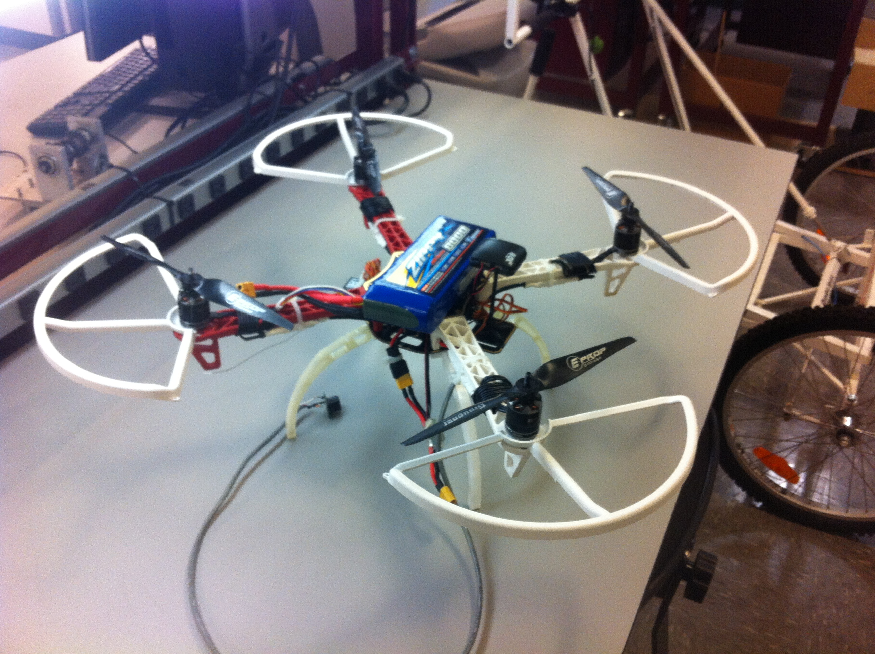

Figure 8. Assembled quad-copter frame

### Assembly of Electrical Components of Quad-copter (Adway)

As stated earlier, the APM 2.6 receives the signal from the radio transmitter via the radio receiver connected to APM’s input pins. The gyroscope and accelerometer module is embedded on the APM itself while the GPS and compass module is external and had to be procured separately. Even though APM 2.5 had an onboard compass, the 2.6 was made external due to complaints of interference in the magnetometer from the motors.

Figure 9 contains a diagram of the assembly of the electrical components of a quad-copter using the APM. The APM can be powered either by a USB cable or by a power supply module that draws power from the quad-copter battery. The advantage of using the power module is that it lets the user monitor the battery percentage on Mission Planner GUI.

The motors are connected to the ESCs which are connected to the output pins of the APM and the battery. The ESC converts the output of the APM into a PWM value for the motors which directly translates into motor rotation speed. A sonar sensor can be connected to the A0 auxiliary port to determine elevation of the quadcopter. The sonar sensor (MaxBotix) was tested and worked as expected for altitude hold. The navigation team will connect the Raspberry Pi to the APM using a micro USB cable to receive IMU reading. However, it will control the quadcopter using the PWM mimicking from the Raspberry Pi. (DJI F330 FlameWheel QuadCopter Assembly, 1)

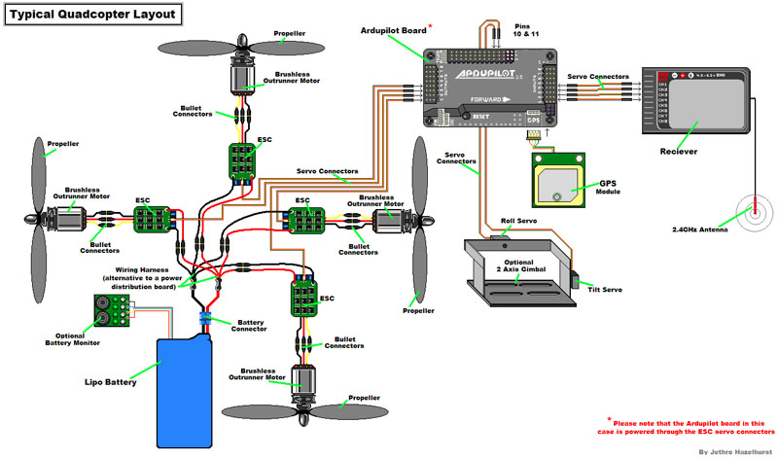

Figure 9. Electrical component configuration for APM 2.6

### Sonar sensor for altitude control (Spencer Davis)

An EZ MaxSonar MB1210 sonar sensor device was outfitted to the quad-copter with a simple RC circuit that sends an analog signal to the APM microcontroller. The sonar sensor is responsible for accurate distance readings from 25cm to 765cm (25ft). This range is adequate for this project as the quad-copter for the most part will maintain a constant altitude indoors except when landing or performing obstacle avoidance. The sensor will be mounted under the quad-copter pointing normal to the plane of the ground surface. This sensor will feed directly into the flight controller and the data will be used by the APM’s altitude hold function. The data can also be exported to the Raspberry Pi which will be sending signals to pilot the quadcopter and perform obstacle avoidance. The sensor has been tested using Mission Planner and reads distances accurately. When control of the quadcopter is switched to manual the RC controller can toggle the altitude hold on/off so that the person can assume full control of the quadcopter.

### Mission Planner (MP) (Adway)

Mission Planner is a freeware that can be used to as a flight parameter planner for the Ardu-Copter firmware. The Mission Planner has support for a terrestrial tracking antenna and is compatible with most types of multirotor copters. Once the right frame and firmware is selected and all the sensors on the copter are calibrated successfully by Mission Planner, the system can be armed. Mission Planner then acquires all the sensor parameters and presents them to the user on a Graphical User Interface (GUI). On the GUI, the user can monitor parameters such as altitude, velocity, compass heading, GPS location, base signal strength, and battery charge (Figure 10).

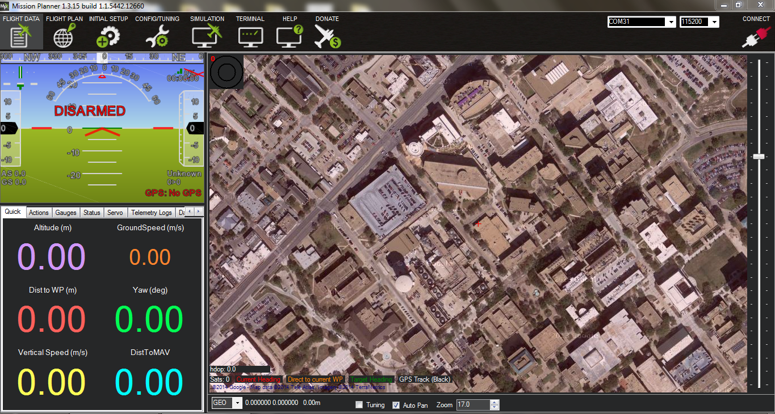

Figure 10. Mission Planner front page

In order to use MP with a quad-copter or hexa-copter, all the sensors on the copter have to be calibrated. Sensors on the controller include the gyroscope, magnetometer, and accelerometer. The radio transmitter also needs to be calibrated to get the minimum and maximum offsets from the control sticks on the transmitter. For this project, these sensors were the only ones required to successfully arm the flight controller. However, MP required a serial connection to the flight controller using a USB cable. Additionally, an OSD (On Screen Display) module can be used to determine the general location of the UAV using GPS (Figure 11).

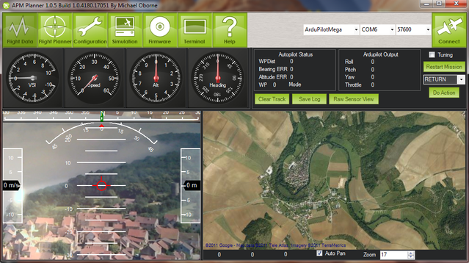

Figure 11. MP video feed corresponding with GPS image

Ardu-Copter will be configured to hold altitude mode via Mission Planner. The Ardu-Copter firmware will stabilize the UAV in flight while directions from the Navigation team will direct it where to go. Altitude hold, by default, is achieved by the barometric pressure sensor. However, the pressure sensor has a minimum resolution of 10cm which is not as accurate as the sonar sensor for indoor flight. Additionally, indoor settings pose sudden change in pressure due to air flow via air vents. Even the APM website (3dr) doesn't recommend using the barometric pressure sensor for altitudes less than 20 feet. The alternate solution to this is using the ultrasonic sensor with narrow beam angle and a long range. Mission Planner and Ardu-Copter has built in provision that lets the user add a sonar module. Once added, the sonar module will replace the barometric pressure sensor for the altitude hold function.

The RC transmitter will be completely bypassed by using a Raspberry Pi’s PWM inputs. The Raspberry Pi utilizes the mavlink communication protocol used for all communication between Mission Planner and the APM. The Raspberry Pi is capable of acquiring sensor data such as: Altitude, GPS lock, heading, etc. Acquiring the IMU (Inertial Measurement Unit) data will assist the navigation team in calculating a rough displacement estimate, however, most of the displacement estimate will come from the URG scanning laser range finder. The Raspberry Pi will also forward any data that the enumeration team might need.

The hardware team did not want to completely remove the RC from the quadcopter incase manual control was needed. As an added failsafe, a Multiplex switch was designed using two 2-1 Multiplexers. This switch (Figure) is capable of switching the input to the APM between the Raspberry Pi and the receiver. This ensures that in case the Raspberry Pi apparatus malfunctions or loses connection, manual control will be able to recover the UAV by using this switch.

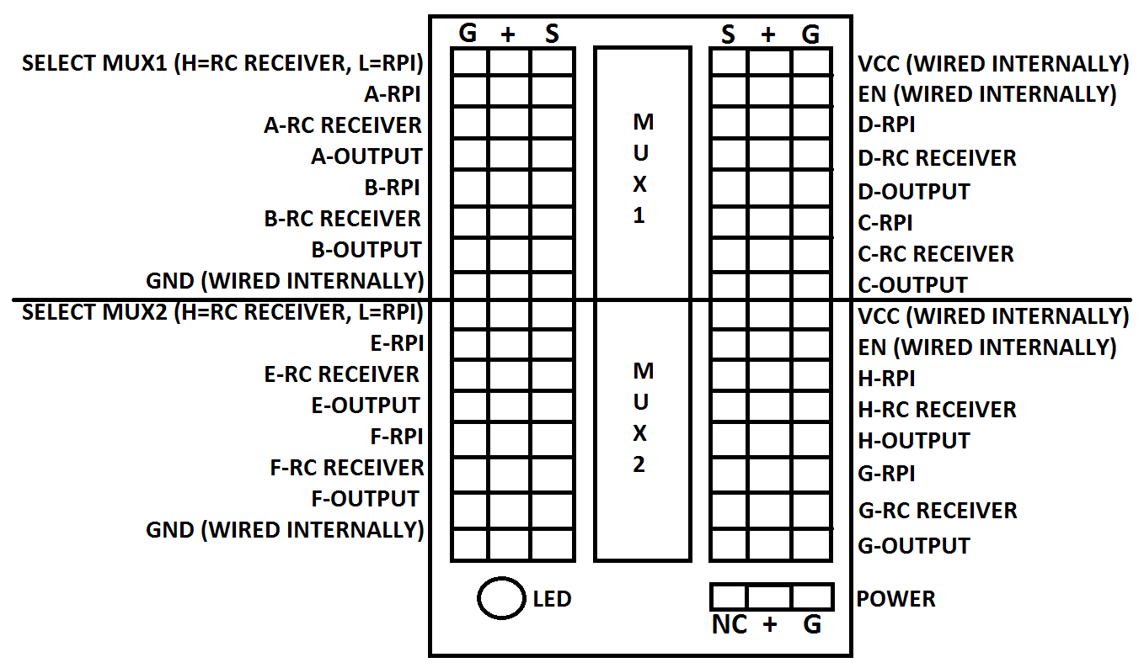

Figure . MUX Diagram

## Arduino Program and Ardu-Copter Software (Michael)

The Mission Planner program is a good start to ensuring the quad-copter is assembled correctly and getting it to work with a remote.  However, the hardware team also wanted a more flexible flight controller that could be changed to meet the navigation team’s specific needs. Mission Planner is very user friendly but is limited in its uses. Mission Planner by itself will not work with autonomous control because it uses GPS to navigate.  The GPS is not precise enough for navigation within a building which is why the navigation team is using their own sensors to determine the UAV location. However, the navigation team will be able to override the RC controls to the UAV and enable autonomous command. As mentioned earlier in the Mission Planner section, Mission Planner will be the first plan in getting the quadcopter flying stably. However, the hardware team wanted a backup plan just in case. The Arduino IDE was used to modify the Ardu-Copter firmware and also write a backup flight controller.

### Arduino IDE (Michael)

The Arduino IDE still uses the Ardu-Copter firmware that Mission Planner uploads to the APM. The only difference is that the code is easily accessible to the user through the Arduino IDE instead of Mission Planner. The Arduino IDE allows users to view all scripts and headers in any version of Ardu-Copter to make changes. Then once the code is uploaded to the APM, Mission Planner can be used to change the quadcopter’s parameters. This allowed the hardware team to make modifications to the firmware when the navigation team was having trouble accessing certain functions. For example, the elevation of the UAV is currently being measured by a sonar sensor directed to the ground that is directly connected to the APM. This is the only sensor that is not communicating directly with the Raspberry Pi. Mission Planner can use a sonar sensor to determine altitude but the navigation team will not have access to the sonar’s data. To access this data, the navigation team added an extra library to Ardu-Copter that sends sonar data over the serial port. The ability to adjust the code was very important for the completion of this project.

### Custom Controller (Michael)

The backup flight controller that is available is the Custom Controller. This controller uses the Arduino IDE as well but uploads a custom made flight controller. This flight controller is contained in 1 script and only contains the functions needed for flight and stabilization. However, the controller is only a backup because it is very difficult to establish communication between the APM and the Raspberry Pi over the serial port. The navigation team was able to read accelerometer and gyroscope data using the Ardu-Copter firmware and the custom controller does not have the same communication functions. While the custom controller is not being used, it is still available if needed and provides insight to the workings of the code that stabilizes the UAV. (Owen, 1)

(Adway)

The hardware team opted to use the Mission Planner software this semester primarily because the Arduino IDE based community code is extremely complicated to comprehend. Without the MP software, the user has to manually configure all the parameters that are usually calibrated by mission planner. The hardware team attempted to accomplish that initially, but realizing how long it was taking, decided to focus on Mission Planner. It is also worth mentioning that the PID values for the orientation (accelerometer, gyroscope & magnetometer) can be tweaked on Mission Planner itself. The altitude hold PID values can also be modified if desired. It is clear that Mission Planner provides almost all provisions needed to make this project work.

### Sensor Power Requirements (Michael)

The navigation team and enumeration team will need a power source for their sensors while the UAV is flying. Table XX contains a list of all sensors that will be attached to the UAV.

|  |  |  |  |
| --- | --- | --- | --- |
|  | **Sensor** | **Voltage** | **Current** |
| Navigation | Raspberry Pi | 5V | 400mA |
|  | URG | 5V | 500mA |
|  | MaxSonar | 3.5-5.5V | 3.4mA |
| Enumeration | Raspberry Pi | 5V | 400mA |
|  | Camera Module | 3.5-5.5V | 10mA |

Fortunately, all sensors require around 5 volts and required a total current of around 1300 milliamps. The hardware team did not want to regulate off power from the main battery because the Zippy battery already has a large current draw due to the motors and a separate external battery would allow for longer flight. The Anker external battery was suitable to power all devices with a voltage output of 5 volts and a current of 2 amps. The battery operates at 6000 milliamp hours which is more than enough for the operation of the UAV. The battery will distribute power to all the sensors using USB ports.

### UAV Layout (Bradford, Michael)

The general layout of the UAV was designed to ensure that weight distribution is not a problem, that everything fits, and that the UAV is able to lift all of the required equipment. This arrangement can be seen in the images below. The wires that go to the equipment have been removed to make viewing easier. The top of the UAV consists of the URG sensor and the external battery on top of the battery used for powering the motors. The ultrasonic sensor used for adding transparent obstacles to the map is positioned in front of the main battery. The bottom of the UAV contains two Raspberry Pis balanced across the middle from one another with the powered USB hub situated between them. The second ultrasonic sensor used for determining the altitude of the UAV hangs from the bottom of the frame. The flight controller is situated in the middle of the UAV in its own case. This layout is the best configuration to minimize the off-balance of the UAV while keeping as much weight in the center as possible. Velcro is used to attach each sensor for easy removal if necessary

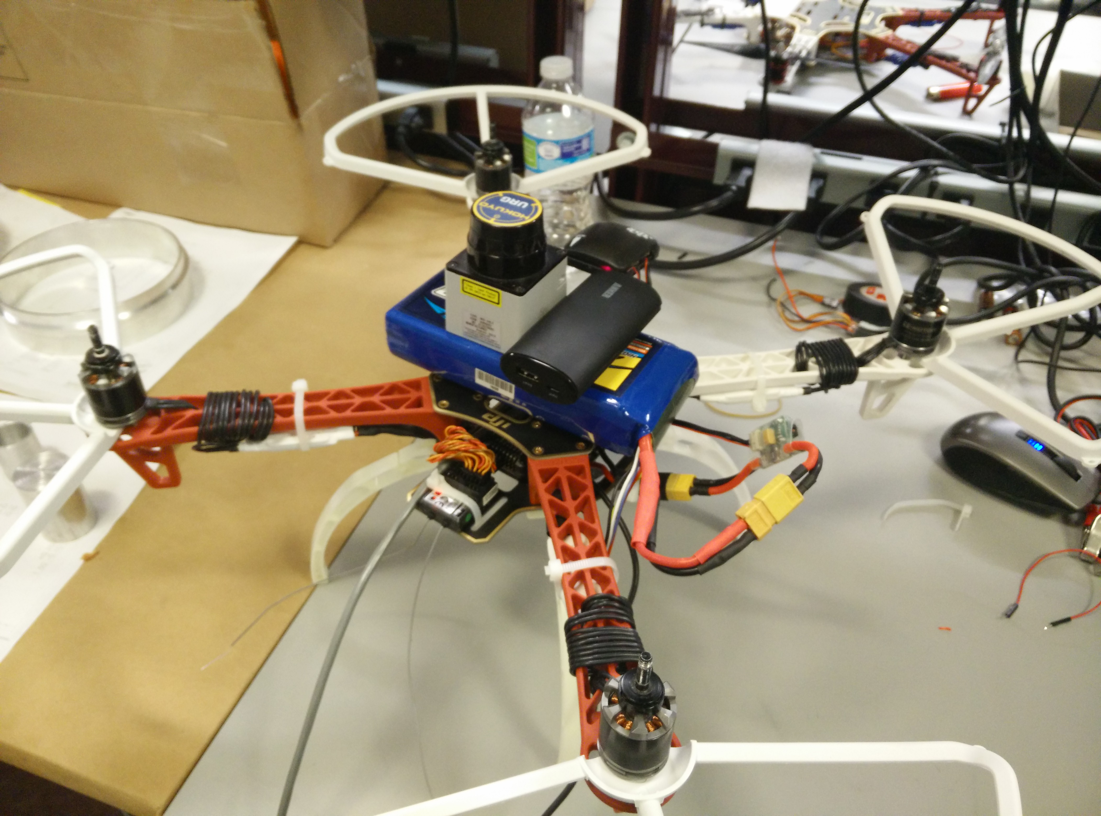

Figure 13. UAV Layout: Top Side

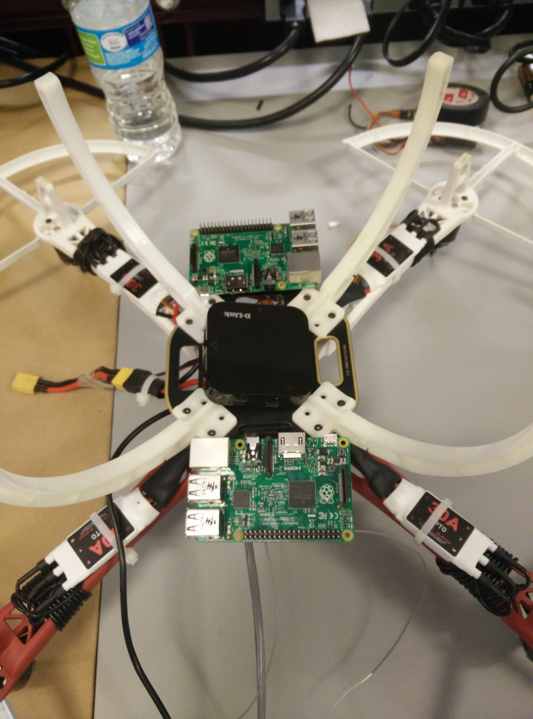

Figure 14. UAV Layout: Bottom Side

# Navigation Development

As the navigation team’s understanding of the difficulties and challenges involved in implementing an autonomous system like this has developed, so too has the list of possibilities and research topics. Though mapping, sensors, and obstacle avoidance are all related in the field of navigation, an attempt to differentiate the three will be made for the sake of organization.

### Sensors (Bradford)

When it comes to sensors in navigation, all sensors are devoted to either recognizing obstacles (generally with a camera), measuring distances, or defining the state of the UAV (orientation, acceleration, etc.). For this vehicle, state sensors are being included in hardware as most flight control packages include most if not all of the sensors necessary to define the state of the vehicle. As for measuring distances, three sensor categories were explored.

* Ultrasonic: These sensors are light and cheap. Unfortunately these sensors are not generally very accurate or do not have an adequate range for our purposes (not more than 3 m with an accuracy of about 8 cm). Not only this but the use of sound waves means that their data collection rate is relatively low compared to other types of sensors. Thus, these sensors are good for close range scanning but there are better options for our purposes.
* Infrared: These sensors are very similar to ultrasonic sensors. Though they do allow a greater data collection rate (as they are not limited by the speed of sound) they still generally suffer the problems with accuracy and range.
* Laser: These sensors are generally more expensive than either ultrasonic or infrared. This is offset though by long range and high accuracy (up to 200 m with an accuracy of about 50 mm). Though there are infrared lasers, laser is a separate category to make the distinction that it is the coherent infrared beam (or laser beam) that is required for the improved characteristics. This is the ideal choice and is the one being pursued as the long range (up to 300m) means that an entire room can be mapped very quickly.

Table . Navigation Sensor Decision Matrix

|  |  |  |  |  |
| --- | --- | --- | --- | --- |
| Navigation Sensor Decision Matrix | | | | |
|  | Weighted Importance | Ultrasonic | Infrared | Laser Range Scanner |
| Accuracy | 1 | - | - | + |
| Range | .8 | - | - | + |
| Sampling Rate | .7 | - | + | + |
| Cost | .5 | + | + | - |
| Support | .2 | + | + | + |
| Total | N/A | -1.8 | -.4 | +2.2 |

***Wireless Communication (Bradford and Fuhua):***

In order to maintain wireless communication with the UAV, we needed to determine which method of communication would be optimum for our situation. We had to take into account the range, reliability, and speed of the wireless transmission. Thus extensive research was conducted to see the advantages and disadvantages of various methods of wireless communication. After the research we narrowed the selection of wireless connection down to Wi-Fi and Xbee.

* Wi-Fi: This a very efficient method of communication for this project. The speed of transmission is fast and very flexible. Wi-Fi does not require additional modules unlike other methods like Xbee. It works by converting radio signals transmitted by an adapter and then translating the data to be used. Its relationship is based on a Master/Slave system where the adapter which sends out the data is the master and everything being controlled are the "slaves". The main draw back with this method of communication however is the range. Furthermore, Wi-Fi has "Hotspots" which are locations where Wi-Fi is available. As the UAV gets further away from the source, the wireless connection becomes more fragile. Lastly, the connection of between Wi-Fi and the UAV would be continuous which means a large amount of energy would be wasted due to maintaining the connection.
* XBee: The main advantage of using XBee as source of wireless communication is the range of the communication. It's more than sufficient for XBee to maintain wireless connection in any large room. Furthermore, the communication between devices are reliable and the speed of transmission is also relatively quick. It does however require additional modules that needs to be mounted. Unlike the Master/Slave relationship with Wi-Fi, XBee relies on a Master/ Master relationship.
* Bluetooth: This method of wireless communication is very fast and is much faster than XBee. However, the range of Bluetooth modules are very limited and the connection is very unreliable. We dismissed this method quite quickly.

Table . Navigation Wireless Communication Decision Matrix

|  |  |  |  |  |
| --- | --- | --- | --- | --- |
| Navigation Wireless Communication Decision Matrix | | | | |
|  | Weighted Importance | WiFi | XBee | Bluetooth |
| Speed | 1 | + | - | = |
| Range | 1 | + | + | - |
| Ease of Implementation | .7 | + | = | - |
| Cost | .2 | + | + | + |
| Support | .2 | + | = | = |
| Total | N/A | +3.1 | +.2 | -1.5 |

### Obstacle Avoidance (Bradford)

While obstacle avoidance and the methods of implementation are heavily dependent on sensors, there are multiple methods for implementation in any given sensor setup. As such, several different obstacles avoidance methods were researched.

* 3-D Camera: This setup requires the use of two cameras to give a “3-D” view similar to how humans perceive things. This setup enables an easy way for software to pick up on movement and objects that move within a certain range of the cameras. Both of the cameras do not need to be for the visible spectrum and though they are generally expensive, two cheap cameras can be wired to function the same as a store bought 3-D camera. Though the two cameras add significant weight, the system can be very effective as it can easily detect the movement of an object near the cameras. This serves the purposes of obstacle avoidance extremely well. Furthermore, the 3D camera has the capability of mapping a 3D environment. The 3D cameras also have the ability to detect and identify people based identifying major points of the body. As of now, this research is on hold as it has been determined that the extra information provided by the 3-D camera is unnecessary. Furthermore, the implementation of a 3D camera would require too much processing power which is not available.
* Camera and Laser: This setup requires that the camera and laser be pointed in the same direction. The two function similar to a 3-D camera except the camera uses the distance (in pixels) between its view center and the point of the laser as seen on the camera to calculate the distance of the object in question. While this setup does decrease the weight of the camera rig, it is really only able to evaluate one point at any given time and is therefore not very effective for rapid obstacle detection.
* Two Spinning Distance Sensors: By placing one continually spinning distance sensor on top of the UAV and hanging one below the UAV, the sensors can pick up objects that are “moving” near the UAV and can mark them as possible obstacles to avoid. The main weakness of this setup is that anything floating within the 6 inches in between the two sensors will not be picked up. The simplicity and effectiveness of this implementation appears to outweigh this unlikely negative however as the UAV will be able to continually monitor positioning in relation to the walls and should pick up anything that gets too close. This is the main avenue being pursued for obstacle avoidance as of now because of the 360 degrees of view that this setup affords.

Table . Navigation Obstacle Avoidance Decision Matrix

|  |  |  |  |  |
| --- | --- | --- | --- | --- |
| Navigation Obstacle Avoidance Decision Matrix | | | | |
|  | Weighted Importance | 3-D Camera | Camera & Laser | Laser Range Scanners |
| Coverage | 1 | + | - | = |
| Speed | .9 | = | = | + |
| Range | .6 | - | + | + |
| Additional Weight | .5 | - | = | + |
| Cost | .2 | = | + | + |
| Total | N/A | -.1 | -.2 | +2.2 |

### Mapping (Bradford)

Generating a model of the environment first requires determining exactly what information will be included on the model. Though the first thought was to generate a complete 3-D environment, the processing power and post-processing required for such a task turns out to make the idea unworkable on a small UAV such as the one in this project. Though data transmission is still being looked into, even with the best hardware, there is simply too much data to process for this to be an effective method for the purposes of this project. Thus the mapping side boils down to the generation of a 2-D map. The information for this map will be obtained from the distance sensors attached to the UAV. It has been determined that the best way to do this is to attempt to maintain a constant height above the floor with one distance sensor and read outward distances with another distance sensor. Due to the nature of creating a map of the environment, it is required that the location of the UAV is known as its gathering data. Thus, mapping breaks down to several data gathering methods and two localization methods. The mapping methods explored include:

* Stationary Distance Sensor: as the UAV travels along, it will periodically stop to spin around and gather distance readings from the sensor. By doing this multiple times from various known locations a 2-D map can be built. The largest downside of this method is that as the UAV spins, any tilt imparted to the distance sensor will skew the resulting map.
* Spinning Distance Sensor: Similar to the stationary sensor, the advantage of this setup is that it allows the UAV to take data while stationary. In this way the UAV will not tilt as the sensor is spinning and collecting data. This data will be used just like it would be in the stationary setup only now, as long as the UAV can ensure it stays level the data will not be skewed.

As for localization, the two methods that are possible are:

* Dead Reckoning: By utilizing the starting location as a “home” location, all movement can be recorded as in reference to this point. This allows the UAV to start anywhere but requires that the system knows how it is moving at all times. This in turn requires that the sensors used for movement (namely the accelerometer) are extremely accurate. Though this method is potentially promising initially, any error quickly propagates leaving too much uncertainty for reliable mapping.
* Referential Localization: By using sensors (in this case the distance sensors) to check the UAV’s relative positioning compared to two determined critical points, the 2-D position of the UAV can be found. This method is versatile and allows the UAV to travel without error propagation. The key part of this method is identifying the critical points. Using an adaptive algorithm to identify corners as critical points should allow the UAV to travel virtually anywhere and “know” its position. This will allow accurate mapping and data collection regardless of how long it flies for.

***Exploration (Dennis)***

Our preliminary research led us to believe that a wall following technique would be the best way to explore an unknown room, and it had the added benefit of being relatively simple. To test the wall following method, we created a simulation in LUA of a UAV exploring different shaped rooms, and it was a great success. The worry with the wall following method is that we might miss objects in the center of the room, but with the assumption that each room will only be 40ft x 40ft, this should not be an issue since our laser scans 20ft. This has been tested in simulation, but we plan to test it on the UAV at the start of next semester.

***Simulator (Yucheng)***   
For the Mapping and Exploration algorithm, we were able to find a very useful 2D robot simulator online that's written in Lua. The simulator worked very well. We first implemented a wall following algorithm such that the robot can successfully complete a maze by following one side of the wall. This denotes that under the assumption that the room only has one entrance, or in another word, the system is a closed environment, our robot will surely come back to the starting point after looping around the whole outer side of the building. The whole process was accomplished using trial and error technique. Occasionally we had to reference the program developer's website for tutorial. Based on the wall-following algorithm, we also tried to do data gathering for 2D mapping. Thanks to the pre-set robot position and angle function, we easily relate the laser distance to generate a set of x, y coordinate using simple geometric method. The plot looks very good. And improvements can surely be made in the future as well. Also, finding a room exploration algorithm is very hard. I am still working on it. Again, the process is also based on trial and error just like writing code in general. The divide and conquer technique is also been used since room exploration algorithm is more complex.

***Autonomous Control System (Dennis)***

For the autonomous control system, we have decided to use a PID controller to move us along the wall and decrease our throttle as we get closer to an obstacle (wall, corner, pillar, etc.). We will use the URG-04LX to do position tracking, and the APM flight controller to give us the attitude (roll/pitch/yaw) of the UAV. We plan to limit the range of the UAV's movement to make the autonomous control simpler, i.e. the UAV will only be able to move forwards, backwards, left, and right. Also, we plan to add an altitude controller to the APM that will hold the UAV at a certain height. This will be the bulk of our work next semester.

## Navigation Design (Bradford)

After considering all options, the navigation team has begun moving forward with the following design in mind. While the exact design is subject to change, the core methods mentioned below will not be changed (unless absolutely necessary) and this should be considered very similar to the final design. As of now, the team has the simulation program in Lua working and are still developing the exploration algorithm that will be ported to Python. The team also has the Hokuyo URG-04LX reading into data through ROS and has managed to map data real time using .bag files. Thanks to the Hector SLAM package being used, navigation is able to generate a map and determine the position of the sensor over time through purely referential localization.

### Basics (Bradford)

The UAV will use three sensors: two ultrasonic sensors and one laser range scanner to input data from its environment. One of the sensors will be on the bottom of the UAV and will be pointed down to record the height of the UAV. As the UAV will be flown at a constant height (about 7ft above the ground), this sensor will be used to keep the UAV at approximately the right height. A script will be written to ignore sudden changes in height in case the UAV flies over furniture our other obstructions. The laser range scanner will be placed on top of the UAV and will be used to gather 2D mapping data as the UAV flies around. This data will be used to create a map and allow for the exploration of the unknown environment. Finally, the second ultrasonic sensor will be an ultrasonic scanner set on the bottom of the UAV and pointed towards the front. This scanner will be used for obstacle avoidance as well as ensuring that windows are mapped as the laser range scanner is incapable of picking up transparent windows.

### Mapping (Bradford)

The Hokuyo URG-04LX will be implemented through the use of Robot Operating System (ROS) and a modified SLAM algorithm known as Hector SLAM in order to generate the map as the UAV travels along. Hector SLAM works by using referential localization to determine critical points and allow tracking of position (and therefore fluidity of movement in the map) as the UAV moves around its environment. The generated environment will be 2.5D as though the LIDAR sensor is only a 2D sensor, the inertial measurement unit on the UAV will allow the ROS package to account for changes in roll and pitch (as well as height to a lesser extent). The map generated from this package in combination with the Hokuyo sensor is extremely accurate and is generated real-time. This package is also adept at handling moving obstacles as the walls are continually updated as more data is gathered from the sensor. As can be seen in Figure 3 below, the package is able to generate a map and track movement based only on the laser range scanner.

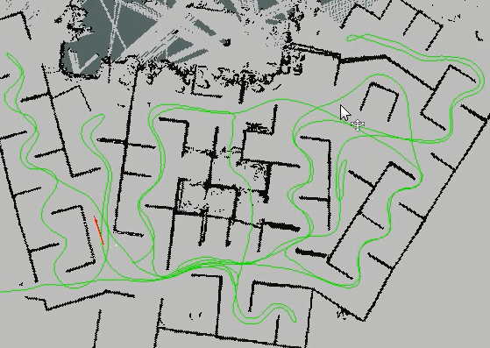

Figure 15. Hector SLAM Generated Map

### Exploration (Bradford)

The UAV is to utilize a multistep algorithm based on the fusion of wall-following and the exploration of unbounded areas. That is, the UAV will find a wall and then follow that wall until it comes to a section that it has already mapped. It will then use a path planning algorithm (most likely A* Search) to move to the closest unexplored area of the map where it will then travel until encountering another wall. It will then follow this wall until it has come across an area that is already mapped upon which it will travel to a new unexplored sector. This process will repeat itself until the UAV has explored the entire bounded area. This algorithm allows flexibility in the map as well as provides a simple, flexible, and robust method to ensure that the entire bounded environment is explored thoroughly.

### Obstacle Avoidance (Bradford)

The UAV will have two data scanners on it: the laser range scanner and the ultrasonic scanner. The laser range scanner will be placed on top of the UAV and the ultrasonic scanner will be placed on the bottom. Since both of these sensors will read in a 2D strip of data around the UAV, there will be a small strip of area (about 4 inches tall by the width of the UAV) that will be able to interfere with the UAV but will not be picked up by sensors. Anything protruding into this zone from above or below will be picked up by one of the scanners and it is only if a narrow object is floating at the exact height of the UAV that the object would remain invisible to the UAV. Due to the unlikelihood of this scenario, the navigation team has opted to classify this design of the obstacle avoidance systems sufficient. If after further testing, it turns out that the two 2D scanners are not adequate in a reasonable environment, then the team will pursue a 3D camera and will use that for obstacle avoidance instead.

### Next Semester (Bradford)

The next semester will be spent ensuring the Hector Mapping can be implemented using real-time data gathered from the URG sensor while the UAV is in the air. This will require ensuring that ROS can either be run on one of the processors available or utilizing wireless communication to ensure data can be transferred quickly between the off-board processor and the UAV. The inertial measurement unit that is part of the ArduPilot package will also be set up to feed its data into the mapping systems so that the Hector Mapping can be done in 2.5D. This will help account for fluctuations in pitch and roll. The two ultrasonic sensors required for maintaining an approximate height as well as checking for transparent obstacles (like windows) will also be added to the UAV. On top of this, ROS will be integrated with the calibrated flight controller to allow for controlling the UAV through ROS. The exploration algorithms written in Lua will need to be ported over to Python to be implemented on the ROS systems so as to allow control of exploration straight from ROS. Finally, integration of all of the systems and testing them all together will take place.

## Spring 2015 Developments (Bradford)

The current setup of the navigation systems is as follows:

* A Raspberry Pi will be used as the microprocessor in charge of all navigation systems on the UAV itself
* The Raspberry Pi will collect data from the sensors on the UAV (the laser range finder and the two ultrasonic sensors) and transmit this data via Wi-Fi to a base computer
* The base computer will use the data and determine commands which it will then send back to the UAV
* The UAV will execute these commands by talking with the APM flight controller

The Raspberry Pi has been uploaded with Raspbian (a version of Debian optimized for the Raspberry Pi). On this, ROS has been downloaded. As determined last semester, ROS will be the operating system on which the UAV is based around. The Pi will pull in data from the URG (used for mapping the surroundings) and the ultrasonic sensor (used for mapping windows and other transparent obstacles that the URG will miss). This data will be sent wirelessly to a base computer that is also running ROS. This data will be used in the Hector SLAM package as well as the modules the team has built to generated a map of the environment and determine the commands that will be sent back to the UAV. These commands will be transmitted to the flight controller through the UAV’s Raspbian system. Once the system has determined it has mapped the entirety of the bounded area, the UAV will return to its starting location where enumeration will take over. From there, only position tracking will be used to aid in movement as enumeration’s programs will dictate where the UAV needs to fly.

### Raspberry Pi to ArduPilot Interface (Dennis)

After a lot of research into the different ways to interface the Raspberry Pi with the Ardupilot, the best way seems to be via USB connection. Normally a C driver would have to be developed in order to achieve this connection, but fortunately Robot Operating System (ROS) has libraries for interfacing with ardupilot flight controllers using ArduPilot's MAVLink protocol. MAVLink is a communication protocol used on the ArduPilot for sending data between hardware, and as such it takes care of message packing and definition. The ROS libraries mentioned above utilize this protocol to provide code for two important features:

(i) Allow for control of the ArduPilot by overriding the RC command (this will allow the quad to be controlled autonomously)

(ii) Publish IMU sensor data to a ROS Topic

These libraries are packaged together in a ROS package called ROScopter. Along with the functionality mentioned above, ROScopter also provides code to arrange and send various commands such as launch, altitude hold, land, and others. ROScopter breaks these higher level commands down and organizes them according to the MAVLink protocol, and then sends them across a USB connection to the flight controller. The flight controller then decodes these messages and, depending on the command received, either commands the motors or publishes the IMU data to ROS.

### Robot Operating System on Raspberry Pi (Dennis)

In order to use the ROS packages for interfacing with the ArduPilot and URG-04LX, ROS must be installed on the system the sensors are connected to, which in this case is the Raspberry Pi. Originally it was thought that ROS would only be installed on the host computer, not the Pi. However, after the discovery of the ROScopter and Hokuyo_node ROS packages, it was decided that trying to install ROS on the Raspberry Pi was worth it. Unfortunately, installing ROS on the Raspberry Pi is different, and much more difficult, than installing ROS on an Ubuntu machine. This difficulty stems from the fact that Raspbian (Raspberry Pi OS) is not officially supported by ROS, and thus certain ROS dependencies must be built from source before ROS will install successfully.

Once ROS was installed successfully, the next step was to install the ArduPilot (ROScopter) and URG-04LX (Hokuyo_node) packages. Similar to the ROS install, this proved to be difficult because Linux's package manager "apt-get" is not capable of resolving all of the dependencies of certain packages, and thus those dependencies must be installed from source. With the URG-04LX and ArduPilot interface packages installed, the only interface left to figure out is the wireless communication, which ROS will help with as well. This will be discussed shortly.

### Raspberry Pi to URG-04LX Interface (Dennis)

ROS has four main concepts that are crucial to developing code for ROS: Nodes, Topics, Publishers, and Subscribers. Nodes are drivers that communicate with hardware/software and either publish or subscribe to a certain Topic. Topics are basically data busses that transmit data of a specific type, and any node can choose to publish or subscribe to them. For example, the hokuyo node communicates with the laser sensor hardware and then publishes the data it receives to a Topic called “/scan”. Thus if you want to read in the data retrieved from the sensor, you must write a subscriber node to subscribe to the Topic “/scan”. This is the case for all ROS packages and nodes.

It is simple to run a node in ROS, but as mentioned above, in order to read in the data from that node a subscriber node must be wrote to subscribe to whatever Topic the data is being published on. However, ROS has a simple command ("rostopic echo /scan") to print the contents of a Topic to the serial port. This command was ran in order to see if the Hokuyo_node was functioning properly, and then the data returned from the node was plotted in Excel to check for accuracy. The Excel graph generated from these points looked similar to the room being scanned, but the map was not as accurate as the one generated last semester with the URG "C" library.

The next step was to determine the source of the inaccuracy of these measurements and to write a subscriber node so that the laser data could be accessed by any ROS package. This will be discussed further in the next section

### Raspberry Pi and ROS Wireless Communication Setup (Dennis)

Basic Setup:

In order to achieve Wi-Fi communication from the host computer to the Pi, both devices must be connected to the same network through a router. Since the Pi does not come with a wireless module, a USB wireless adapter was bought in order to allow the Pi to connect to the router. To setup the wireless module on the Pi, the "/etc/network/interfaces" file must be modified and given the router's network information. Once the Pi is connected to the network and given an IP address by the router, it is capable of SSH connection to any other computer on the network. Once the host machine and Pi were connected to the same network, simple python TCP socket code was run to verify the connection and make sure the machines were in fact capable of communicating with each other wirelessly. A sample of this code is provided below.

Communication between Multiple ROS Machines:

The above setup is the foundation that allows ROS to communicate between machines. In order to communicate between the ROS system on the host computer and the ROS system on the Pi, the host computer must be told to connect to the roscore running on the Pi via the Pi’s IP address. This can be done by editing the ROS_MASTER_URI file on the host computer to connect to the ROS system running on the Pi. Once this is done, the host computer can access any node running on the Pi as if the node were running on the host computer itself. To test this out, a subscriber node was wrote on the host computer to subscribe to the Hokuyo_node (running on the Pi) topic “/scan” and print the laser range values to the serial console on the host computer. This code, provided below, is the basis for wireless communication through ROS and will allow the Hector SLAM package to access the laser data from the host computer and create the map of the room.

Below is the code for the TCP sockets and simple subscriber node. A screenshot of the laser data being displayed on the host computer by a ROS program called RVIZ is also included. RVIZ connects to the Hokuyo node topic “/scan”, similar to the simple subscriber node, and plots the data it receives.

Python TCP Server Code:

import SocketServer

import json

import threading

class MyTcpServer(SocketServer.TCPServer):

def initialize(self, command_dict):

self.command_dict = command_dict

self.allow_reuse_address = True

def finish_request(self, request, client_address):

"""Finish one request by instantiating RequestHandlerClass."""

self.RequestHandlerClass(self.command_dict, request, client_address, self)

class MyTcpServerHandler(SocketServer.BaseRequestHandler):

def __init__(self, command_dict, request, client_address, server):

self.command_dict = command_dict

SocketServer.BaseRequestHandler.__init__(self, request, client_address, server)

def handle(self):

# self.request is the TCP socket connected to the client

self.data = self.request.recv(1024).strip()

if self.data == "sup":

serializedJsData = json.dumps(self.command_dict)

self.request.send(serializedJsData)

class MyTcpServerThread(threading.Thread):

enabled = False

def __init__(self):

while not self.enabled:

try:

# Create the server

HOST, PORT = "192.168.0.143", 9996

self.MyServerObject = MyTcpServer((HOST, PORT), MyTcpServerHandler)

self.enabled = True

threading.Thread.__init__(self)

except:

self.enabled = False

def initialize(self, command_dict):

self.MyServerObject.initialize(command_dict)

def run(self):

self.MyServerObject.serve_forever()

Subscriber Node Code:

#include "ros/ros.h"

#include "sensor_msgs/LaserScan.h"

void ScanCallback(const sensor_msgs::LaserScan& scan) // this function runs whenever new // data is published to the Topic /scan

{

// ROS_INFO("I heard: [%s]", scan.ranges); // scan.ranges

for (int i=0; i<scan.ranges.size(); i++){

cout << scan.ranges[i] << " "; // print scan.range values to serial port

}

}

int main(int argc, char **argv)

{

ros::init(argc, argv, "/scan"); // initiate topic

ros::NodeHandle n; // create node handler

ros::Subscriber sub = n.subscribe("/scan", 1000, ScanCallback); // subscribe to /scan

ros::spin(); // while(1)

return 0;

}

RVIZ screenshot:

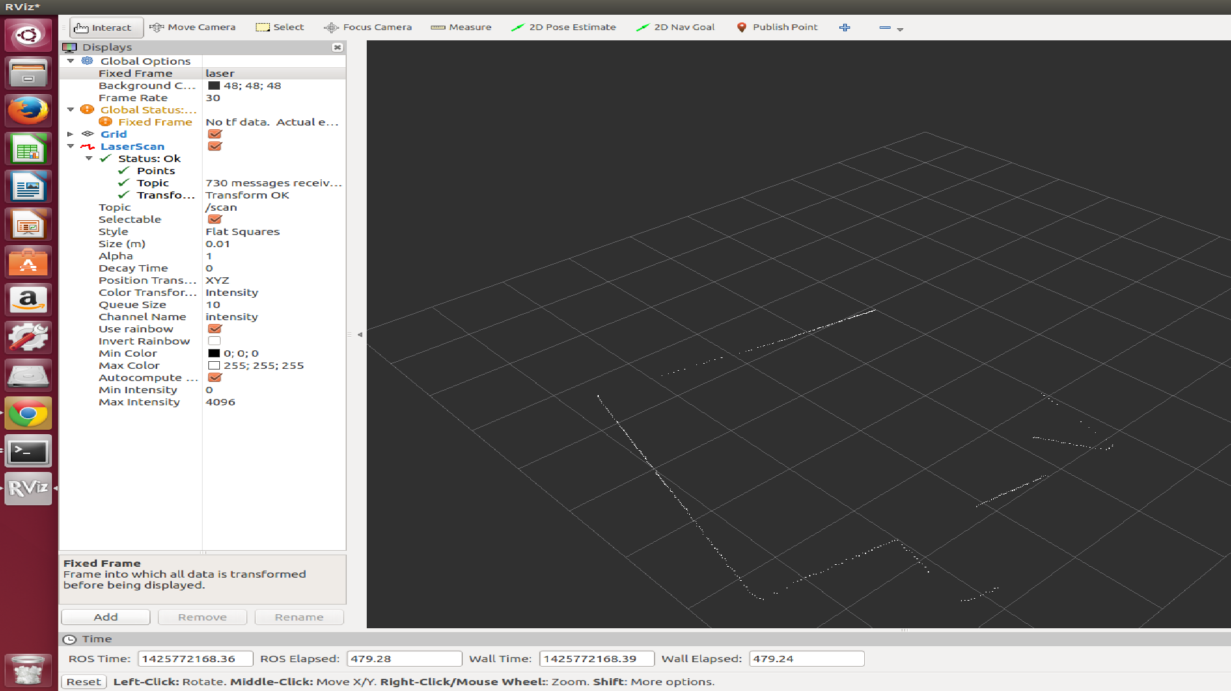

Figure . RVIZ Mapping Screenshot

### Wireless Communication (Fuhua)

For wireless communication, we will use TCP ROS Wireless communication which is the default transport used in ROS. There were two options to choose from. We could have either gone with the UDP ROS or stuck with TCO ROS for serial communication. For TCP ROS, the main advantage is the fact that TCP will always be resend in the case that the message failed to be delivered. This will persist until the message is finally sent. In contrast, the UDP ROS is much faster but will not resend any message that fails. However, for the project, reliability also plays a major role in how the UAV would perform thus TCP is a more suitable option. The TCP works by having a publisher and subscriber system. First, the publisher would provide the subscriber an IP address and the specific connection port. The subscriber would then create a TCP/IP socket for the port and address. The nodes would exchange connection header which includes information such as the MD5 sum to verify data integrity. After all is done, the publisher would now be used to send serial data over the sockets.

### Ultrasonic Sensor Data Retrieval (Fuhua Song)

We had to find a way to export data from the ultrasonic sensor through wifi to a hector_slam host computer. One method is to export data would be to use python and the Raspbian operating system that comes with the python module needed to communicate with the GPIO pins. A python code (found) can be then utilized and modified to read the data from the sensor. The code works by sending a command telling the ultrasonic sensor to start measuring the distance between itself and whatever’s in front of it. It makes the sensor send pulses and listens for echoes. It would measure the time it takes for the echoes to be received and calculate the distance in centimeters. We would have the data from the Ultrasonic sensor go directly to go through the raspberry pi through the serial USB link. From there, the raspberry pi has a Wi-Fi access Point which the computer is connected to and data published to a ROS network topic. After that, the PC would become capable of accessing real time status by reading the data from the ROS topic which can be used for hector slam to produce maps. For accessing the data from the ultrasonic sensor, I utilized a raspberry pi. I read the datasheet and utilized various methods to access the data but was not able to for a long time. For Arduino, the analog pin was easily used to output the correct values, however, it wasn’t the case for the raspberry pi. At first, I tried to use the serial pin of the raspberry pi and connected it to the serial pin of the ultrasonic to access the serial data but was unsuccessful. I later found out that an inverter is needed and the MAX 3232 module is needed. Furthermore, there's also the PWM and analog pin on the ultrasonic that can be used to retrieve data. However, the analog pin is the usable since the raspberry pi is purely digital. Finally, I was able to use the pwm pin to retrieve data through the raspberry pi **which although doesn’t output the most accurate distance like digital, it's still sufficiently accurate. Furthermore, the code commands that 3 data inputs are taken and the median of the 3 are outputted.**

Attached is the following code which is use to retrieve data. I was able to receive help from Trevor who helped me substantially. The code works by measuring the time it takes for a pulse to be sent and received by the sensor. Then it turns it into distance. The outcome is data displayed in feet and the median value of three numbers are chosen as the distance to avoid making any errors. Furthermore, there's a distance limit to how close the sensors is to the object it's detecting. The object can't be too close or the data output is incorrect. However, when utilized on the UAV, it should serve as an adequate secondary to the laser range finder.

Code in Python:

import RPi.GPIO as GPIO

import time

import numpy as np

global r1

global r2

global r3

global st

global ed

r1 = 0

r2 = 0

r3 = 0

st = 0

ed = 0

GPIO.setmode(GPIO.BOARD)

# Waits for a rising edge

GPIO.setup(7, GPIO.IN, pull_up_down=GPIO.PUD_DOWN)

# Waits for a falling edge

GPIO.setup(11, GPIO.IN, pull_up_down=GPIO.PUD_UP)

def start_signal(channel):

global st

st = time.time()*1000000

#print st

def end_signal(channel):

ed = time.time()*1000000

global st, r1, r2

# update previous variables

r3 = r2

r2 = r1

r1 = (ed - st)/58

GPIO.add_event_detect(7, GPIO.RISING, callback=start_signal)

GPIO.add_event_detect(11, GPIO.FALLING, callback=end_signal)

while(1):

time.sleep(1)

median_val = np.median([r1, r2, r3])

print median_val/2.54/12

### Raspberry Pi to Ardupilot Interface (Dennis)

ROS provides a package called "Roscopter" for communicating with aerial vehicles via the MAVLink protocol. Roscopter provides two relevant topics for this project: the "/attitude" and "/send_rc" topics. As their names suggest, the "/attitude" topic is where the IMU data from the Ardupilot is published, and the "/send_rc" topic is where values are published to override the RC control. With these two topics, the Pi is able to send IMU data to Hector Mapping to complete the 2.5D referential map, and it is also able to receive movement commands from the host computer and relay them to the flight controller.

The IMU data was relatively straightforward to read in once the Roscopter package was successfully installed on the Pi. However, publishing values over the "/send_rc" topic to override RC control proved to be difficult. Due to the high level of abstraction of the Roscopter code, it was difficult to debug and pinpoint where exactly the errors were occurring. The other issue with Roscopter was that it seemed to slow down the Raspberry Pi quite a bit because it was continuously polling the serial port. To overcome these two issues, the team decided to try to use the Python library PySerial to send movement commands over the serial port directly to the Ardupilot.

In order to achieve direct communication with the flight controller via PySerial, the Ardupilot code needed to be edited and re-uploaded to the flight controller. This is not possible with mission planner, so APM provides a special Arduino IDE specifically for Ardupilot to allow users to make changes to the flight controller code. The idea was to find where exactly in the Ardupilot code the PWM signals were being written to the motors, and then override these functions with the values read in from the serial port. As with Roscopter, this method did not work out due to the complexity of the code base, and so another method was pursued.

The final idea to command the quadcopter’s motors with the Raspberry Pi was to directly connect the GPIO pins of the Pi to where the RC receiver was plugged into the Ardupilot. In order to do this while also allowing for manual override, a multiplexer was used to multiplex the PWM signals from the Pi with the PWM signals from the RC. Once the multiplexer was setup, Python code was written to send software PWM signals out of a few of the GPIO pins on the Raspberry Pi. These signals were connected to the multiplexer along with the signals from the RC, and finally the motors could be turned by the Pi and by the RC.

The final step of the process was to integrate the python PWM code with ROS to allow for wireless communication. A node was written to read in values from the host computer's keyboard, and then publish these values over a specified topic. Another node was written on the Pi to read in these values, and then based on what key was pressed, command the motors to a certain value via the PWM signals discussed above. This method proves the concept of autonomous control from a host computer, and the next step is to integrate the A* algorithm with this setup.

# Enumeration Development

### Algorithm Selection (Dayton)

The Enumeration team has decided on a final algorithm to count people within a building. However, this section is going to cover the algorithm selection from the brainstorming sessions. At the beginning, many ideas and solutions were researched and most of them did not make it past the first or second stage of the brainstorming process.

* The idea of using RFID (radio frequency identification) chips to track each person in the building was entertained. Reasons why it was dismissed was that it defeats the purpose of being “autonomous”; there would be a required human involvement. The act of giving the occupants RFID chips alone would be a simple enough way to count people. This is not a practical or relevant solution although it would be highly accurate.
* Next, facial or feature recognition was investigated. This approach could be very useful in eliminating the problem of double counting. If occupants’ facial features could be converted to useful data and stored, then they would never be counted again upon recognition of these specific facial features. A major issue with this method is that the UAV will be flying above peoples’ heads, making capturing clear images of faces difficult. It may need to follow people and move closely to their faces to get an acceptable image. In addition to this, many people in commercial or industrial setting may be looking down at their desks or other obstructions could block the view. We determined that storing and comparing facial features would not be realistic because of the time needed to detect every face in the building and the advanced dynamics of hunting each person down until their features could be recorded. This idea has been rejected because of its impracticality and lack of speed.
* The MATLAB Computer Vision toolbox is the latest approach of the research conducted to attain an appropriate enumeration algorithm. The Computer Vision toolbox uses the method of histograms of oriented gradients and the support vector machine to identify occupants within a video or picture frame. Although these methods are incredibly complex and were developed by researchers (Dalal, 2), MATLAB has incorporated the algorithms into easy to use functions and code ("Object Detection and Recognition"). For this method there is an incredible amount of online support, accuracy, speed, and it’s practical because of MATLAB’s user friendliness.

Table : Enumeration Algorithm Decision Matrix

|  |  |  |  |  |
| --- | --- | --- | --- | --- |
| Enumeration Algorithm Decision Matrix | | | | |
|  | RFID | Feature Identification | IR detection | MATLAB People Detector |
| Support and Community | + | + | - | + |
| Accuracy | + | + | - | + |
| Relevance to objective | - | + | + | + |
| Speed | + | - | + | + |
| Practicality | - | - | + | + |

This analysis on the benefits and pitfalls of each of the methods has indicated that MATLAB’s People detector is the winning method. It has the most online support and community, has tunable accuracy with lots of room for improvement and calibration, realistic speed constraints (able to detect humans in one picture frame on an average home computer in 0.07 seconds), and its user friendliness makes it practical and seamless. It is also useful to note that this method is favorable in a dynamic situation and does not require an incredible depth of unique data to begin identifying large groups of moving occupants.

### Camera Selection (Dayton)

When choosing a camera for enumeration purposes, frame quality, weight, power draw, user command capability, community support, and color type were all important considerations when planning for the objective.

Table : Camera Selection Matrix

|  |  |  |  |
| --- | --- | --- | --- |
| Camera Selection Matrix | | | |
|  | Thermal Camera | Web Camera | Pi Camera Module |
| Video quality | - | + | + |
| Weight | - | - | + |
| Power draw | - | - | + |
| User command and capability | - | + | + |
| Community support | - | - | + |
| Color type | - | + | + |

From the chart above, it is apparent that the Raspberry Pi camera module is awarded the most points for enumeration purposes. This is because the Raspberry PI camera has the lowest weight, lowest power draw, highest command capability, highest community support, and the appropriate color type.

Raspberry Pi Camera Operations (Dayton)

Essentially the Raspberry Pi camera module will be instructed to begin recording when the UAV is in operation or on its mission. As it records video, it will be writing the video file to a Wi-Fi network stream so that the base computer will have the video saved and should be able to run the matlab code on the incoming feed. The specifics of the people detection operation on the live video stream will be discussed further in a following section. If there are any issues with the Wi-Fi connection during a mission, there are codes available on board that will instruct the camera module to begin writing the video to the on board micro SD card which should have plenty of space for the video files.

Raspberry Pi Webcam and MATLAB Features (Jui Yen)

Here is a more in-depth explanation for the reasons why Raspberry Pi is preferred: its webcam package and MATLAB support.

Other than its built-in camera module, Raspberry Pi allows standard USB webcams to be directly connected to it after installing the fswebcam package. With this package, Raspberry Pi not only is capable of taking photos and recording videos directly via the webcam, but also is enabled to adjust the properties of the webcam such as resolution, frequency in picture taking, and so on. The photos and videos acquired can also be sent afterwards via SSH and other methods.

Raspberry Pi’s MATLAB support is also a major factor that affects the final decision. According to MathWorks, acquiring data from sensors and imaging devices that are connected to the Raspberry Pi is allowed with MATLAB Support Package for Raspberry Pi Hardware. Moreover, MATLAB support for Raspberry Pi also includes access to signal processing and video algorithms through add-on products including the Computer Vision System Toolbox, which is where the people tracking and identifying algorithms are applied. This implies that using Raspberry Pi is a promising strategy since everything is compatible with one another.

### Receiving Map Data (Nathan)

Before actually starting an algorithm to count and track people, the UAV must know the layout of the building. It will receive this data from the navigation team after the UAV has analyzed the building and constructed a model of the layout. In order for us to be able to properly use the data, expectations must be established for the data being passed into our enumeration algorithm.

First, the 2D laser scanner on the UAV will output a file of all data points gathered and this will be the primary source of data. These points are taken sporadically along the walls and have relatively fine detail. It is important to realize that all data gathered will have a certain threshold of error. We have to establish a few expectations for the data points being received.

All points passed in:

* Will be given as the x coordinate and then the y coordinate separated by a comma and on separate lines ("x, y").
* Can be made of positive or negative integer values.
* Will be given in millimeters which will be converted to inches.

After points have been read in, it is time to use them to simulate the layout. The 2D laser scanner automatically measures using millimeters so the input is first converted to inches for simplicity. The entire floor plan is divided into a grid of 4 inch cells, which is most often used for robotic mapping. This size enables good simplification of the map while still maintaining enough detail for the robot to effectively navigate around obstacles. After this, the number of points inside each cell is counted and maxed at a certain threshold. A two dimensional vector holds an array of integers representing all of the cells and the value in each cell indicates whether the cell contains a wall (0) or just empty space (1). A vector is used so the map can be dynamically changed according to the building size and dimensions. This vector will then be passed to the simulation program to simulate UAVs and plan a proper traversal of the building to count all occupants.

To make sure that the output of the grid array is good, a few expectations are defined for the array being outputted. The array:

* Will be comprised of numerical integers indicating if the cell is a wall (0) or is empty (1).
* Will always represent 4 inch blocks of the real building.
* Will always be a square.
* Will have a border of zeros around the array.

Instead of marking a cell as just having points in it or not, each cell is given a way to track the number of points inside it. This is vital since there may be errors in the original readings from the 2D laser scanner. When the array is used the simulate, the cells with just a few points can be seen as errors. The UAVs can then flag these areas as trouble spots that may or may not have walls or objects there. In addition to passing the array of characters to the simulation program, this program also sends the x, y coordinates of the origin point. The origin point will be the current location of the UAV and will be helpful in telling the simulation where to start.

It is good to note that this portion does not label individual rooms, doors or hallways in the layout. The incoming points are simply applied to a 2D grid and filtered, and then passed to the mission planning program to plan how the UAV navigates the map. The map is never analyzed for key features because the Zhang-Suen algorithm was found to produce better results with better accuracy. This algorithm gives a complete path through the building which the UAV follows to get full coverage of the building. For the Zhang-Suen algorithm to work, the map is passed over only as 1's and 0's along with the point of origin that the UAV starts from.

### Mission Algorithm (Allison)

A text file of data points will be received from the navigation team that represent a map of the building. From this map, networks of passageways will be determined, marked with the entrances to rooms branching off of it. The number of necessary UAVs will depend on the shape of the building layout. For many layouts, the number of UAVs required to ensure a fully accurate scan is very impractical. A square hallway layout may only require two UAVs to scan. A layout with multiple branches will require significantly more UAVs. In order to minimize the total number of UAVs used, two separate search algorithms have been devised as approaches to two different layouts. During the spring semester, a program will be developed that recognizes these shapes within the layout of the building and determines the number of necessary UAVs as well as their paths.

The first algorithm will determine the searching pattern for a square layout with rooms branching off. This approach requires two UAVs, denoted as UAV1 and UAV2 for this section of the report. UAV1 will initially function as the guard UAV, and UAV2 will act as the roving UAV. UAV1 will move to a corner of the square and rotate, monitoring motion in two of the four hallways. UAV2 will search room by room within the area guarded by UAV1, counting the occupants. The method of scanning the rooms will be discussed later in this section. After the guarded area is completely scanned, UAV2 will move to the corner diagonal from UAV1 and begin guarding this area. UAV2 will become the roving UAV and move room-to-room looking for occupants. With this approach, the area between checked and unchecked areas is continuously monitored to ensure that all people inside the building are accurately counted. If the guard UAV does detect motion, the following chart describes the program’s response

*Table 4: Guard UAV Motion Responses*

|  |  |
| --- | --- |
| **Event** | **Response** |
| Occupant leaves known room/area to go into unknown room/area | Subtract one from the number in the known room’s corresponding vector element |
| Occupant leaves known room/area to go into another known room/area | Subtract one from the first room’s vector element and add one to the second room’s vector element |
| Occupant leaves unknown room/area to go into another unknown room/area | Do nothing |
| Occupant leaves unknown room/area to go into a known room/area | Add one to the known room’s vector element |
| Occupant leaves known room/area and remains in hallway until the end of the scan | Do nothing. The occupant has been accounted for within known area |
| Occupant leaves unknown room/area and remains in hallway until the end of the scan | Add one to any nearby room’s vector element |

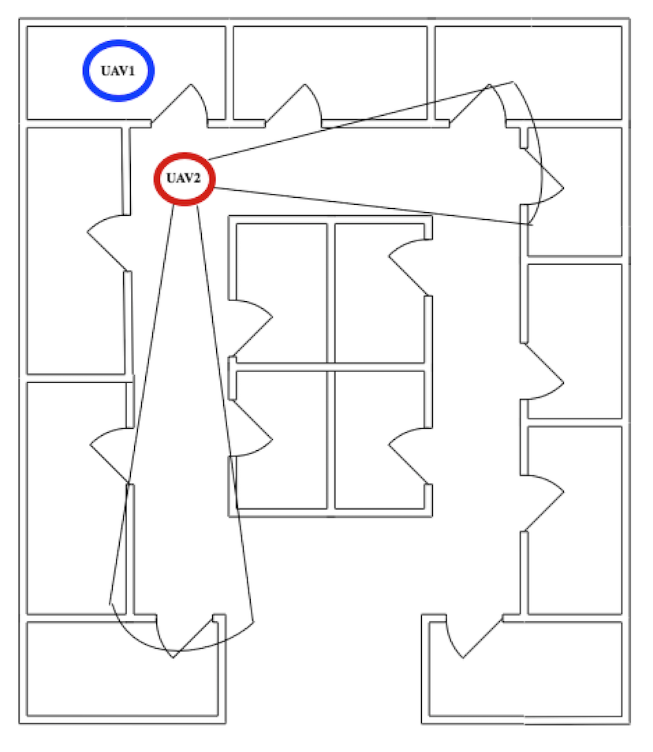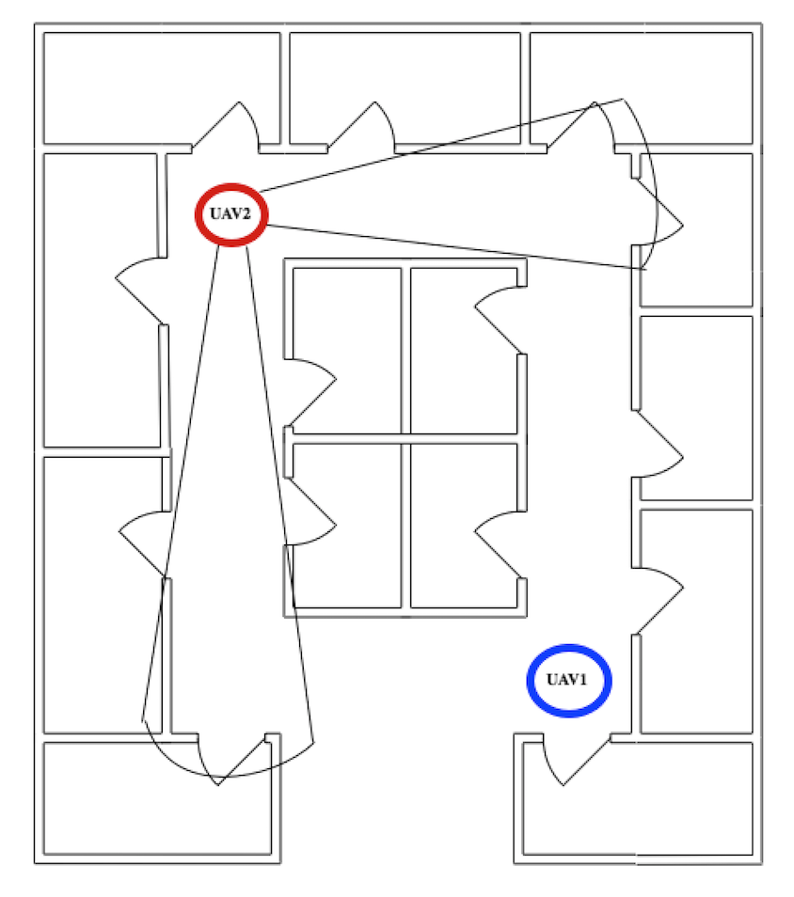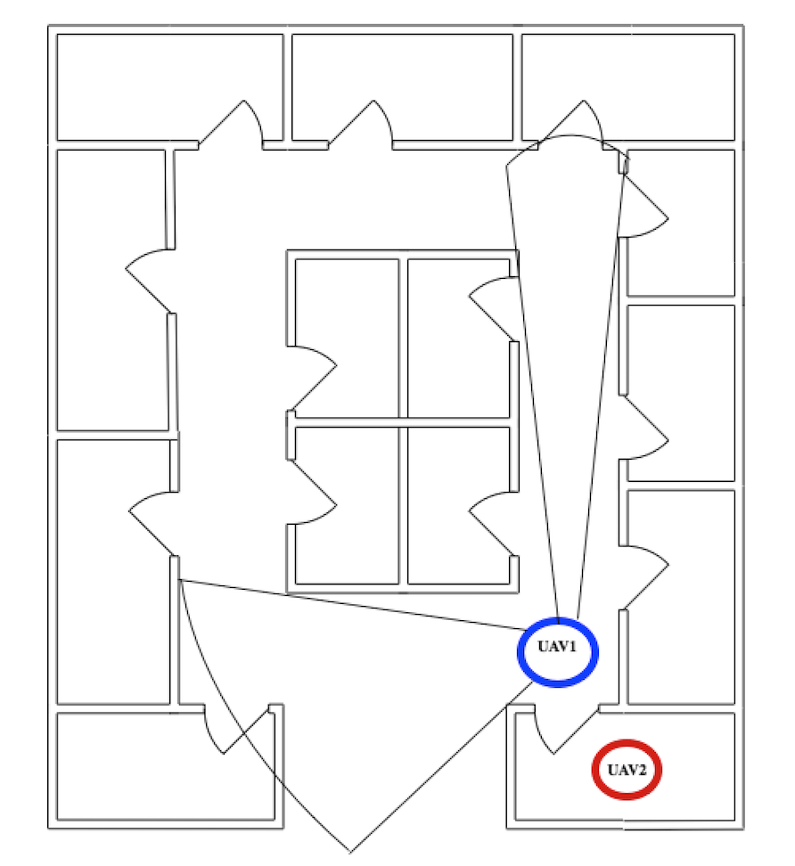The following sequential diagram displays the motion described above. The blue circle represents UAV1, and the red circle represents UAV2. While fields-of sight for the guard UAV are indicated on the diagram, these do not represent the actual field-of-sight of the UAV, as it will be rotating through 360 degrees. The modified fields-of-sight function as visual aids to show more clearly which hallways will be monitored at each point of the process.

Figure .Square Hallway Search Algorithm

The second algorithm determines the searching pattern for a layout with branching hallways that do not loop backward. This approach will require one guard UAV (represented by the red circles) for every branching area and one roving UAV (represented by the blue circles) for each initial branch as shown on the diagram below. Ideally, there would be one UAV for every branch, but this quickly becomes very impractical. The number of UAVs can be further minimized, but this trades off with the speed at which the building can be analyzed. It is possible to use only one roving UAV for the whole area in the diagram below. However, this would be a very slow process, and in an emergency situation, speed is of the utmost importance.

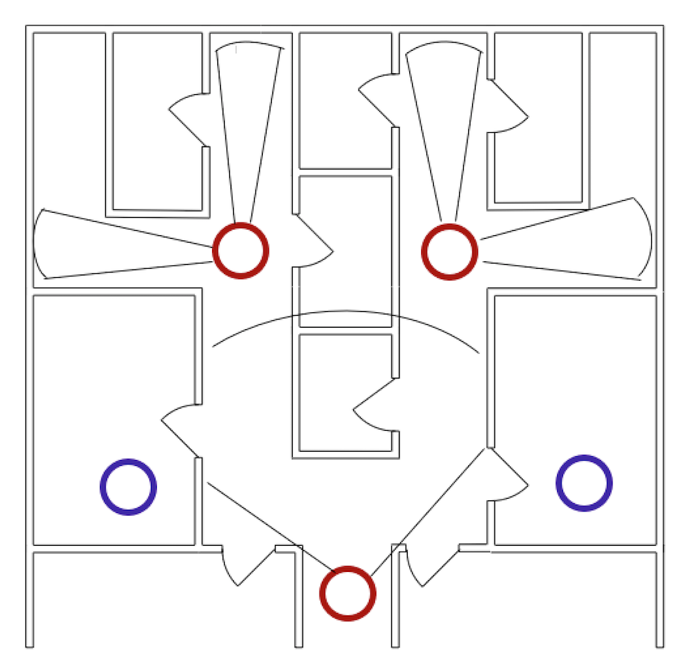

Figure 18. Branching Hallway Search Algorithm

While most hallways should be in the range of a video camera, the enumeration program will limit the range. The person detection program seems to be accurate to around 100 feet based off of previous tests. However, these tests were done in areas with many background features and varying light levels. In a typical hallway, there should not be many background features and the lighting levels should be consistent along its length. After further testing in hallways, it is expected that the range will increase.

At this point in the project, the plan is to analyze a panoramic image to enumerate the occupants of a reasonably sized, square room. The UAV will rotate in the center of the room with the video camera recording. In order to test the effect of motion of the quality of the panoramic image, a Python script was written to capture video from the webcam of a laptop and converted it into still frames. Autopano 3.7 was used to convert these frames into a panoramic image. This program is a user interface version of Hugin, a command tool library used to create panoramas. However, there is not much continued support for this library for Mac OSX systems. A full installation of this library may no longer be possible. In addition to this, this script would not be portable, as file paths to installed libraries are specified within the code. It would also need to be run on Mac OSX. Though this program may not be practical for the final project, it demonstrates the feasibility of using a panoramic image for analysis. The program was tested at various speeds and with varying degrees of subject motion, and the panoramas produced were consistently clean and crisp. MATLAB also has panorama creation capabilities (“Panorama Creation”). It is likely to be used in the final project because it will link more easily to the enumeration code and is more portable than the scripting. MATLAB uses the same method to produce the panorama as Autopano, so it is anticipated that the image quality will be similar.

There will be a small area underneath the UAV that will not be captured by the video camera. In order to detect people in this area, another video camera or some sort of infrared sensor array will be mounted at the bottom of the UAV, pointing directly toward the ground. At this point, the first choice would be to use a video camera and analyze the video with MATLAB to detect people beneath. However, the functions within the Computer Vision toolbox may not be able to detect of the top of occupants’ heads. Further testing will be necessary to determine if this is a possibility, but there are no built-in functions that specifically do this.

If an infrared sensor array like the Tau 2 camera is used, a program already exists that can analyze the resultant data. At this point, it would be able to detect and count multiple figures when the Tau is pointed directly downward from the bottom of the UAV. A more simplistic sensor array would not be able to determine the number of people underneath the UAV or differentiate between a person and another heat source, like a computer. A challenge with this approach would be sending data from the Tau to the off-board computer. The best way to do this would be to use an RF transmitter and receiver. Because the other video data will likely be sent over a Wi-Fi network, synchronizing these two video feeds may be difficult. At this point, this is a backup plan to the video camera only to be implemented in the case that MATLAB is unable to detect people from directly overhead.

The difficulty with this approach will be ensuring that the search area underneath the UAV and the main search area did not overlap. This is something we will have to calibrate at a later point in the project based on the mounting angles of the various cameras. The actual programming is fairly simple; certain pixels (or, more accurately, data points) sent from the video camera or Tau 2 will be ignored in the enumeration program. The difficulty will be in determining which pixels overlap.

In order to demonstrate this flight path with one UAV, a computer simulation will be created showing all UAVs moving along their assigned paths. The off-board computer will select one of these paths for the physical UAV to take. In order to demonstrate proof-of-concept, the demonstrated path will require the UAV to act as both a roving UAV and a guard UAV at some point during the test.

Instead of utilizing a complicated motion algorithm, the project has been scaled back with a simplified motion algorithm that traces the hallways in the building to find the main paths. The map data will be read in from the navigation's team mapping program and filtered by Nathan's program into a grid of squares that are marked as open space or wall piece/obstacle. The motion algorithm is able to take this data and marks the doorways on this grid based on the standard size of doorways within commercial buildings. After all the doorways are marked, the program assumes that there is a hallway on one side of a door and a room on the other. While this doesn't account for room-within-a-room layouts, it certainly maps the vast majority of commercial office space layouts. After all open-space squares on the grid are marked as rooms, hallways or doorways, the Moore Neighbor Tracing algorithm is applied to the hallways to find a traversal path along the outer perimeter of each as well as a list of rooms that branch off that path. This tracing algorithm is also applied to each room to aid in finding the centroid. The UAV will transverse the outer border of the hallway containing the starting point, moving into each doorway of branching rooms as they are passed. From the doorway, the A* algorithm will be used to avoid obstacles while traveling to the centroid of the current room and back before continuing along the hallway path. When at the centroid, the UAV will rotate and record video data to be transformed into a panorama and analyzed with Matlab using the enumeration algorithms .For most building layouts, only one hallway border will need to be traversed. For the layouts with multiple hallways (notably the layout including a ring-shaped hallway), after the first hallway border is traversed, A* will be used to move to the closest point of the border of the next hallway to be traversed and the process is repeated until all hallways have been traveled. The simulation will output a visual model showing the motion of the UAV across the building layout, and this motion will be converted into simple motion commands for the quadcopter.

This new algorithm is much simpler to implement that the algorithm based on guard and roving UAV coordinated motion. It requires only one UAV, but implementing it with multiple UAVs cuts down on necessary time and improves the accuracy of our results. The new algorithm is very easy to scale up when multiple UAVs are available. This is also applicable to more building layouts than the branching and square hallway layouts discussed in the previous lab. It also eliminates the problem of dividing the guard UAV video feed into "known" and "unknown" areas. However, this algorithm is less accurate because they are not extensive safeguards against double counting as compared to the guard/roving UAV model. It also cannot process a layout with rooms-within-rooms. Though there are certainly downsides to the new algorithm, the benefits outweigh the costs and it better fits within the scope of the project.

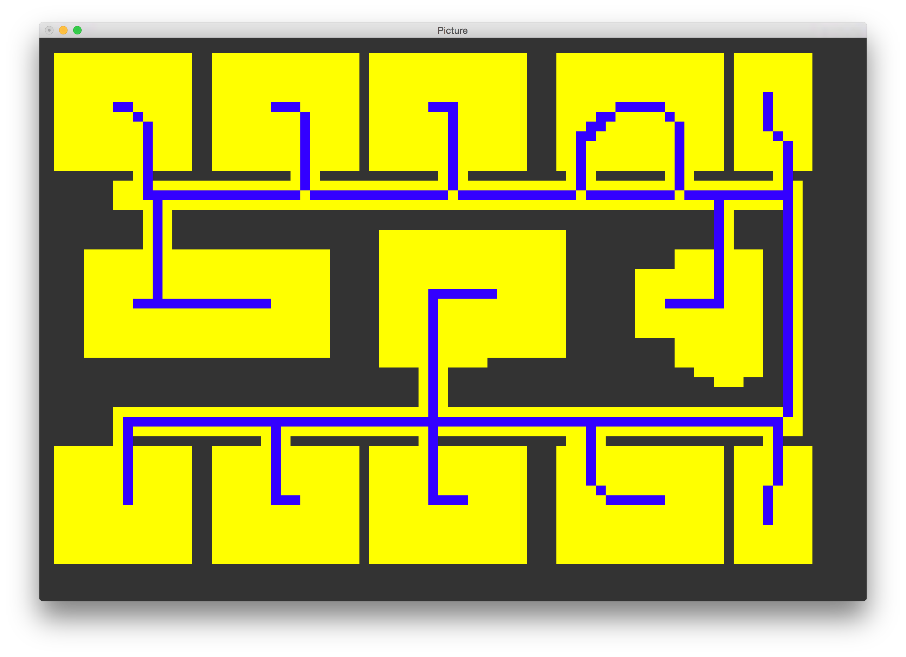

Figure . A sample image (yellow) and its skeletal decomposition using the Zhang-Suen algorithm (blue)

The approach described above also had issues when it came to practical application. Because identifying a doorway is an integral step in the process, marking off the rooms from the building hallways, being able to recognize doorways of all sizes is important. This proved to be more difficult than expected. Instead of identifying building features, the Zhang-Suen image-processing algorithm was used instead to pare down the map into a skeletal image that could function as a pathway. This approach is by far the most versatile, and a map can be produced from every closed layout design. The Zhang-Suen algorithm uses a series of “tests” on the pixels of the image grid to determine which pixels to remove each iteration. After no more pixels can be removed, the image is considered to be fully decomposed. The endpoints (or “spurs”) on the map can be used to identify the individual rooms with only one entrance. These endpoints as well as the branching points for loops will be used in the A* star algorithm in order to determine the motion order.

***Raspberry Pi Video Streaming (Allison)***

Python code using the picamera library was used on the Raspberry Pi to set up a network socket that live streams video from the Pi Camera module. During operation, this video is continuously retrieved from the network and saved in a file on a base computer for analysis using the following command with the command-line VLC library: “vlc tcp/h264://<pi IP address>:8000/ --sout='#standard{mux=mov, dst=<filepath>/test_vid.mov, access=file}'” .

### MATLAB’s Computer Vision Toolbox (Dayton)

The people detection algorithm for counting and tracking people without double counting will be implemented using MATLAB’s computer vision toolbox. The toolbox is a reservoir of functions and code that are tuned and adapted specifically for computer vision purposes such as identifying people or objects and tracking. The capabilities with the toolbox are broad and have great depth. First, to include some background to the problem, the UAV will be moving as well as the people that it will be enumerating. So the code will need to be able to detect, count, and track people even as the UAV moves around. To begin, the “people detector” background algorithm will be explained.

### MATLAB: Histogram of Oriented Gradients (Dayton)

The people detector uses the histogram of oriented gradients (HOG) method and support vector machine (SVM) to detect upright people in true color video feeds. Now the HOG method will be briefly explained. Figure 2 below is a diagram of the steps in the algorithm of HOG (Dalal, 2) that will be completed by the MATLAB function. Although the user will not necessarily need to go through these steps, the background must be explained for project purposes.

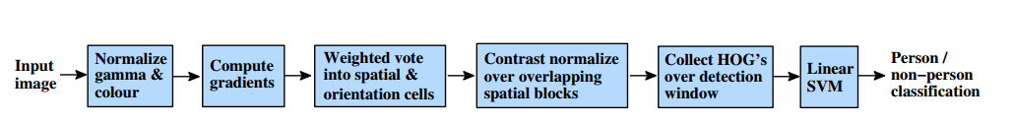

Figure 20. HOG Process (Dalal, 2)

For this case, the UAV must fly into a room and take pictures with the previously described, predetermined flight path. Once the video frames are acquired from the live video, the input data for the image must go through the HOG process which is completed by MATLAB. First the “Normalize gamma and color” step will be skipped because it requires extra unnecessary time and does not help to increase the accuracy of the program, even the creators of the algorithm suggest that it is not necessary (Dalal, 4). Now computations of the gradient, magnitude and orientation must be completed using a point discrete derivative mask, which is just a vector that represents the central difference theorem, and the standard equations for magnitude and orientation angle (Dalal, 5). The orientations of the cells within the data will be organized into 9 different bins (Dalal, 5). Each bin represents an orientation angle between 0 and 180 degrees, for example (0, 20, 40, 60, 80, 100, 120, 140, 160, and 180). After organization, the gradients must be locally normalized to account for changes in contrast of the photos. This means that the cells are grouped together into larger blocks that each have cell histograms where the entire image will be broken up into. “The HOG descriptor is then the vector of the components of the normalized cell histograms from all of the block regions.” (Dalal, 4). The final step to the HOG method is to submit the histogram oriented gradients to a Support Vector Machine, which is a supervised computer learning process. The support vector machine will identify and remember patterns of occupants and thus will allow a count once the person has been detected.

### MATLAB Support Vector Machine (Jui Yen)

According to a study conducted by AT&T Bell Labs, the support vector machine (SVM) is a supervised learning model with implemented learning algorithms that analyze data and recognize patterns, used for classification and analysis (Cortes and Vapnik). To be more precise, it is capable of separating a set of data points through constructing a hyper plane or set of hyper planes in a high- or infinite- dimensional space (Cortes and Vapnik). From there a hyper plane that has the largest distance to the nearest data point is determined, which is then treated as a distinguishing factor for different data points (Cortes and Vapnik). SVMs are helpful in several aspects, such as classification of images, recognition of hand-written characters, and so on.

Here is a more in-detailed description about how the algorithms of SVM work. In a 2-D case, assume that there are several data points in the plane. These data points are chosen based on the distinguishable features we pick. To discern the data points into two categories, one approach is to determine a line that maximizes the minimum margin, which is also known as the maximum-margin separator.

To compute the separator, several data points are needed within the plane to decide which side of the separator a test case is on. These data points are also known as “support vectors”. An approach called “quadratic programming” is then used to determine the maximum margin separator, and based on this mathematical optimization, the time required in finding the separator is proportional to the data size. This implies that if the datasets are really big in size, it is more desirable to perform approximate optimization.

If there is no separating plane, a much bigger set of features can be used or an extension of the definition of maximum margin to allow non-separating planes. The former requires a strategy called “the kernel trick”, while for the latter, it needs an introduction of slack variables.

### People Detector (Jui Yen)

One of the algorithms that is already available in MATLAB’s Computer Vision System Toolbox – the People Detector ("Object Detection and Recognition"). What it does is that when an image is imported into the People Detector, boxes that identify the people within the image will be displayed. Even though a grayscale or truecolor (RGB) image is good enough for the algorithm to launch smoothly, truecolor images give better results and hence are more desirable.

To optimize accuracy of people detection, seven properties – Classification Model, Classification Threshold, Min Size, Max Size, Scale Factor, Window Stride, and Merge Detection - are properties to be adjusted. Classification Model specifies the model that is going to be used, which gives a different image size; Classification Threshold specifies a nonnegative scalar threshold value to control the classification of individual image sub regions for detections; Min Size allows us to specify the minimum height and width ratio of a person in an image, which enables the algorithm to detect the people that are further away from the camera; Max Size does the exact opposite to that of Min Size; Scale Factor multiscales object detection scaling, which can change computation time; Window Stride allows the coder to detect the window stride; Merge Detections control the merge of similar detections. Overall, through implementing the properties aforementioned, the algorithm is able to identify the people in an image efficiently, which allows accurate counting and tracking.

### Tracking (Dayton)

The people detector works effectively, but now it’s time to explain how the people will be tracked from a moving camera. The computer vision toolbox has an example on the Mathworks website that gives general algorithmic steps to creating a code that tracks and detects people from a moving camera ("Tracking Pedestrians from a Moving Car"). There are essentially twelve steps that need to be covered to explain the tracking algorithm.

First, this tracking system requires a data file that contains information that relates the pixel location in the image to the size of the bounding box marking the pedestrian’s location. The bounding boxes are the annotation boxes that show up around a person on the video frames whenever a human is identified. For example if you’re looking down a road and you see a person far away, they will need a smaller bounding box than a person who is near you on the sidewalk. This type of information is received from the expected testing environment and stored in a pedestrian scale table as the expected height of the adults in pixels. There is a provided helper function that has algorithmic steps to develop a regression model for the relationship between height and location which will help develop this table ("Tracking Pedestrians from a Moving Car"). The table will only need to be developed one time because it is essentially a calibration for the program to perform in the most accurate way possible.

Aside from the data file which would be loaded into the MATLAB work space, there are a few global parameters that can be adjusted numerically to increase the performance of the program. For example, the visual threshold parameter identifies the minimum visibility needed to determine if a track is a true positive. A true positive is a successful detection of a pedestrian and will generally be used when describing true positives per image (tppi). A false positive is when an object other than a pedestrian is classified as a pedestrian and will generally be used when describing false positives per image (fppi).

Now it is time to create system objects for the tracking initialization. The system objects for tracking initialization is basically a function that reads the video file, implements the people detector function, and loads the pedestrian scale data calibration into the workspace.

Moving on to initializing tracks, which means creating a function in MATLAB code to create structures for each track and then making an array of these tracks. A structure is an array with named fields that contain data that are easily related to variables such as a “track”. For example some data that would be necessary to store in a structure would be the track ID which is an integer that defines the track, or the scores of the tracks which is a vector that describes the confidence of the track.

After the “tracks” structures have been created it is appropriate to begin with reading the video frames and detecting the people so that data can begin to be analyzed and stored. A simple function is applied to the system objects function if it is a previously saved, loaded video. If it is a live feed there is another similar function for receiving frames from the webcam. Now that the people are being detected, it is useful to optimize the performance of the code. In the detect people function, there are ways to specify regions of interest so that the people detector will only search for pedestrians within a predetermined field of view. This is such that the code will not waste time trying to count people in the sky. Also, by calculating the centroids of the bounding boxes, the tracker may begin to track the center point of the bounding box instead of tracking the whole box itself. It is also a good time to implement the pedestrian scale table to use the height estimations of the pedestrians as a filter. Essentially it would be used to eliminate detections that deviate from the expected size of the pedestrians.

It is useful for the tracking, to estimate new locations of existing tracks. Using the previously calculated centroids, and the previously developed bounding boxes, a kalman filer can be implemented to predict where the centroid is going to be in a future time. A Kalman filter is a linear quadratic estimation that uses a series of data points to estimate the future trends of the data points. MATLAB has a function to implement the Kalman filter on the centroids of the bounding boxes. However, the Kalman filter tracking of the centroid loses its effectiveness as an occupant may move toward the camera because it is only a two dimensional application. In response to this, there is another algorithm that involves two steps to begin its correction ("Tracking Pedestrians from a Moving Car"). First the code must compute the cost of the track assignments using a bounding box overlap ratio. Each of the bounding boxes will have a calculated centroid, but computational cost can be saved if the computer knows to assign detections to tracks that are at the expected distance away. This is based on the difference in location of the centroid of the bounding box and also reduces confusions in tracks that are at different distances but are in similar areas on the x-y plane. Essentially from here MATLAB has a function that can assign tracks accurately, with tunable properties.

After the future tracks have been predicted, it is useful to correct the predictions using another function. This function also updates the age of the track as well as the visibility. If it is an accurate track the confidence will increase as well as the age and visibility. To keep the code running at optimal speeds, it is useful to delete tracks that have been absent over a series of frames. Essentially the deleted tracks provide the best data for providing a people count and this is a good time in the algorithm to grab the numbers from the local output. The deleted tracks are the choice of selection because unlike new tracks, they will contain more information such as track age, and track certainty history.

At the same time creating new tracks is vital to the accuracy of the count of the building and can be manifested in a similar way. After the end of the tracking algorithm is reached, displaying the tracking results will show the actions of what’s going on behind the scenes. There are many ways to display the tracking data or the visual tracking, but the most common way is using the bounding boxes around the occupants and a glowing tail at the feet of the bounding box to display the history of the track.

### Cascade Object Identifier (Jui Yen)

To further enhance the accuracy of people detection, an algorithm called the Viola-Jones is used. Through using this additional algorithm, an object can be created – a cascade object detector - that enables us to detect very specific features of people, including their facial features like eyes and noses or the upper body ("Vision.CascadeObjectDetector System Object"). One convenient thing about the Viola-Jones algorithm is that, it is also readily available in MATLAB’s Computer Vision System Toolbox. Besides, the idea behind is pretty similar to that of the People Detector: boxes that indicate the features will appear in the image that is either grayscale or truecolor. And again, truecolor images give better results and hence are more desirable.

Other than the absence of Classification Threshold, Window Stride, and Merge Detection, the properties that allow better accuracy of the program performance are very similar to those of People Detection. In addition to that, the Viola-Jones algorithm allows us to adjust Merge Threshold, which is the control of threshold detection. Merge Threshold is capable of suppressing false detections by requiring that the target object be detected multiple times in an image. The adjustable criteria in Viola-Jones' Classification Model are also a little different: specific identification of features like eye pair, mouth, frontal face, just to name a few, is available in order to produce better results. Due to the fact that these two algorithms originate from Computer Vision System Toolbox, it is extremely handy to use the two of them simultaneously, since an extra line of code is the only thing that we have to be aware of in order to create two different objects at the same time. Furthermore, both objects require images for identification and further manipulation. This implies that the detection of people can be further utilized.

### Live video feed (Jui Yen)

After taking different forms of vision input into consideration, we came to a consensus that live video feed is the one that will preferably be used for the enumeration procedure. This is due to the fact that if the UAV is indeed in an emergency situation, there is a probability that the UAV may not return after it is deployed for its mission. Therefore, it is most efficient to enable the UAV to transmit live video stream, which will then be sent through Wi-Fi and be broken down into frames on an off-board computer for autonomous identification and manipulation. However, like aforementioned, since both the People Detector and the Viola-Jones algorithm require still images for identification purposes, some sort of conversion between live video stream and image frames is necessary. This can be easily done through MATLAB as well, which makes the process a lot more convenient. To initialize the computation, it is required to create a webcam object as a source of live video stream. Once this is done, numerous tasks to analyze the video feed can be conducted, including taking snapshots of it, breaking it down into consecutive frames of still images, and so on ("Acquire Images from Webcams"). Hence, the requirement for people identification can be met easily.

Here are a couple of things to note: first of all, a webcam of driver type USB video device class (UVC) is needed to accommodate for the webcam feature. Besides, as one can probably infer this intuitively, the two algorithms will be used on images of different sizes, which means that calibration is always required to acquire the number of counts of people correctly. For example, a smaller image may require a smaller scale for Max Size and Min Size, since the people that will be displayed in the image may be very small in scale as well. Yet, please remember calibration is only needed once for each case, meaning that once it is done, as long as the UAV is generating live video stream at a fixed angle and height within a building, further calibrations are not necessary.

MATLAB Computer Vision System Toolbox Efficiency Optimization (Jui Yen)

Like what was stated in the previous report, algorithms from MATLAB’s Computer Vision System Toolbox will be used for the project’s people detection and tracking. In order to improve the computation efficiency of the algorithms, optimizations are mandatory. Currently there are several aspects that can be looked into to reduce the computation time, such as minimizing the input video size, eliminating unwanted functions, just to name a few.

### Code Status 3/23/15 (Dayton)

The Matlab People detector algorithm has been run on sample videos taken by cell phones, web cams, and the raspberry pi camera module that will actually be used on the UAV. The code speed initially was incredibly slow compared to a real time video speed, but by utilizing frame resizing commands, the code speed has increased by about 4 times. After running further tests, it is promising to know that the run time of the code can be decreased further, significantly. Using the function time analysis that is built into matlab, the software is able to identify which functions in the code require the most time. This code, in particular, spends over 25% of the processing time displaying the graphical results. Since it is still necessary to speed up the code and the robust graphical display is not the main objective, some features of the display may be toned down or omitted to speed up the code and output counts, quicker.

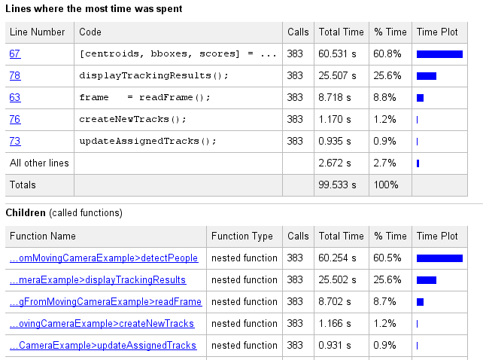

Figure 21. MATLAB Function Time Analysis

The figure above, is a result of running the “Run and Time” function in matlab. Two key functions to note from these analyses are the “people detector” and “displaying results”. The people detector on line 67 takes about 60% of the time of the operation but is fully necessary for the objective of the project. The “display tracking results” function however, requires about 25% of the process time and there are current plans in place to cut down on this function’s processing time.

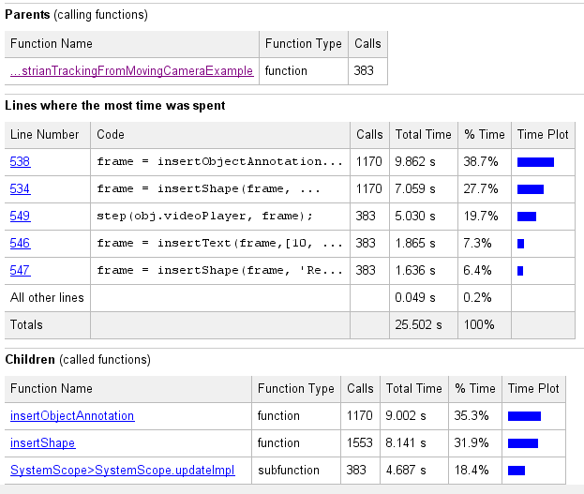

Figure 22.MATLAB Function Time Analysis - further results on display

Also, the accuracy of the code has been significantly increased to about 7 out of 9 (about 78%) occupants that are fully visible in the Region of Interest or ROI. These advances have occurred by tuning the global variables and by performing the proper code calibration for a specific camera. The calibrations are important because they help to filter out false positives and they help increase the accuracy of future predictions. The figure below shows this example.

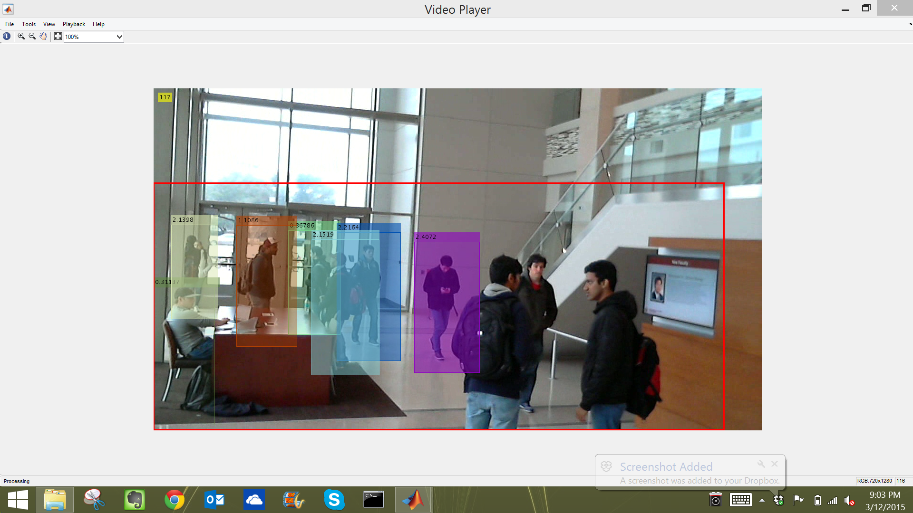

Figure 23: Webcam Video Sample from ENPH at Texas A&M

From the figure above, it is apparent that the group of 3 on the right are not counted. These subjects are new to the ROI so the algorithm is still working to identify them and it does eventually identify one of them, but only one. It is possible that errors arise when occupants are facing away from the camera and have their lower body cut out of the ROI.

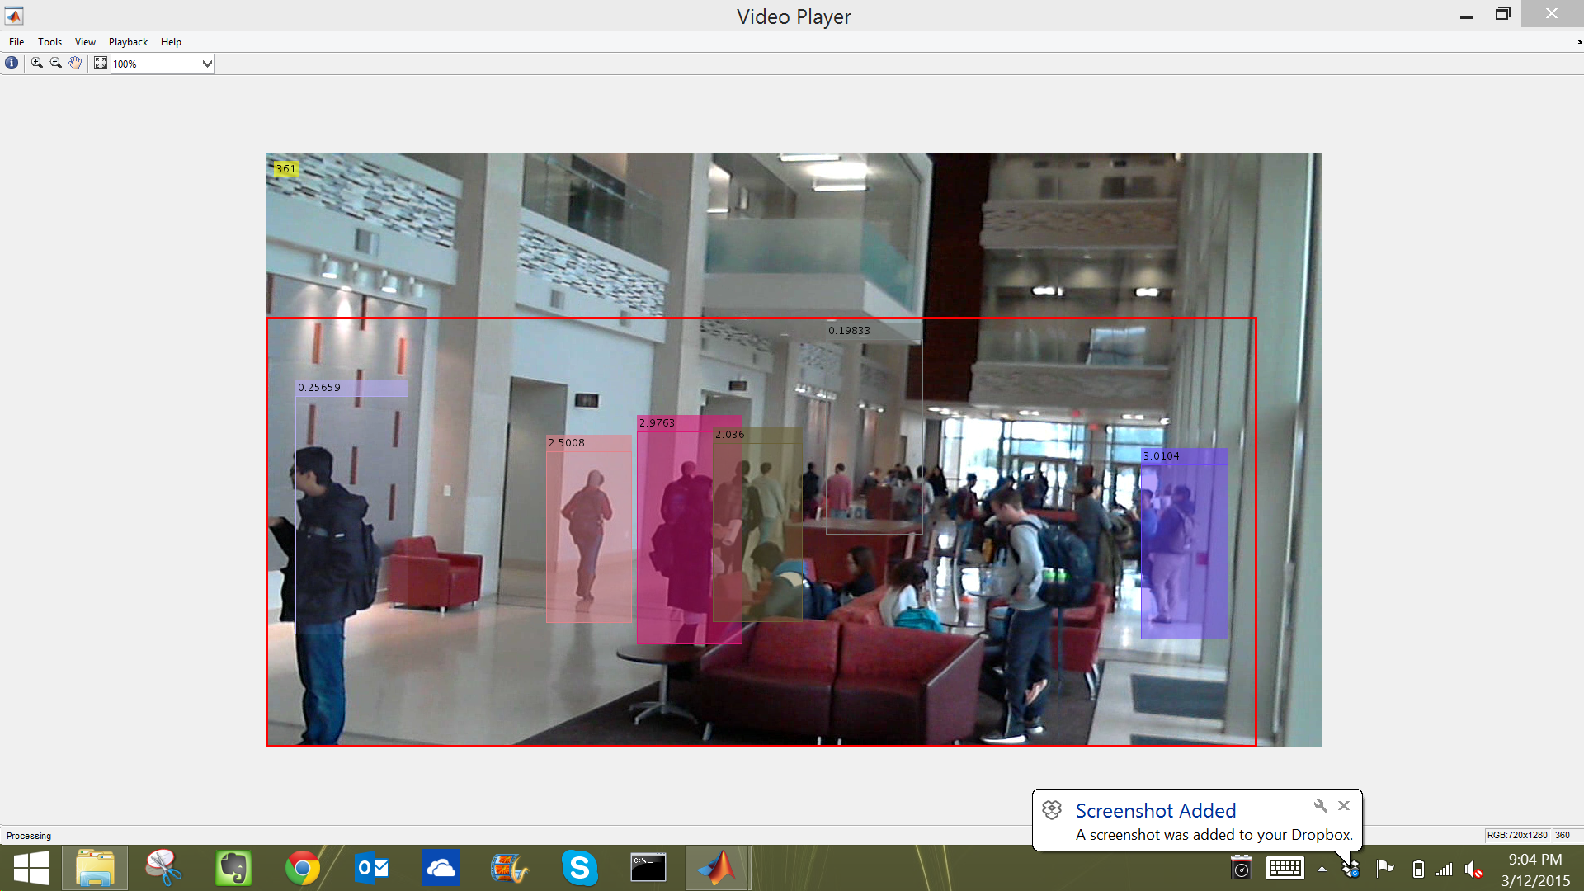

Figure 24: Web Cam video footage in ENPH at Texas A&M

Problems arise when there is significant occupant crowding in the ROI. This issue also appears to be more apparent when the camera is further away from crowds. In the figure above, the weakness is clearly visible. Sources of error come from expected minimum size of occupants, overlapping box ratios, and possibly the occupant height filter that predicts occupant’s height and size in the calibration file.

Contrary to previous beliefs, the people detector has been able to sufficiently identify people sitting down and people traveling in patterns that are uncommon. Samples of pedestrians dancing, moving at variable velocities, sitting, and traveling in complex foot traffic patterns have been collected to identify weaknesses in detections. So far, a few “specialized” cases that were previously described have successfully been enumerated. However, this information was only received from two video samples. For all cases, taking more samples will improve knowledge of enumeration ability.

### Enumeration Status 5/2/15 (Dayton)

The appropriate resolution size that was decided on was 700 (wide) x 500 (high) because it is small enough for the matlab code to process quickly, but still allows a decent field of view for enumeration and tracking to take place. This resolution size can be adjusted in the python code that is on the raspberry pi or it can be adjusted from the command terminal on a computer through SSH connection to the pi.

A mount for the pi camera was 3D printed and mounted on to the quad copter frame. The pi camera is intended to point downwards from the horizontal plane ~30° to increase the accuracy of the counting algorithm. The people detector works better when it can view the occupant’s lower body and feet. Also the calibration file uses the lower portion of their body to gather confidence about the data by estimating occupant height based on their feet location on the y –axis of the video frame. A person who’s feet are higher on the y-axis are likely to be further from the camera and are also likely to be shorter in the video frame. If they demonstrate a proximity to the estimated height, they will be counted with a higher confidence interval. The same goes for feet that are lower on the y-axis and are estimated to be taller.

The python code that records video from the pi camera to the base computer is working successfully. All code and documentation used for this was from <http://picamera.readthedocs.org/en/release-1.10/>. The supporting library is at “waveform80 - picamera” on GitHub.

Also the global counter has been added, so that there is a total number that is finally added up while the matlab code is processing the video files.

Cutting out the heavy processing functions in the matlab code to speed it up was not a main concern. Every function is fairly inter-connected to the other functions so attempting to omit sections of the code was causing more problems than it was fixing for now. Also, the speed of the processing has been increased by the reduction of the incoming video resolution and a smaller resize ratio that is implemented in the code process.

### Enumeration Status 5/2/15 (Olo)

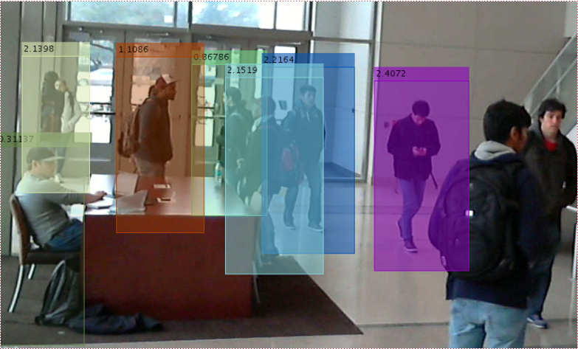Implementing the counter is actually a tricky process. This is due to our previous misunderstanding about how the “tracks” work in MATLAB’s detection algorithm. Please refer to the photo of demonstration provided to the right for a better understanding. At first, it was assumed that for a given video frame, when a bounding box is created to surround a detected individual, a “track” will be created within the program. In other words, through manipulating the “tracks” directly, we should be able to determine the number of people detected easily.

However, after modifying the program based on the theory aforementioned, it appeared that our assumption was defied, since the program kept outputting weird numbers for the total count of people. Therefore, to troubleshoot the problem, a more in-detailed inspection about the MATLAB code is required.

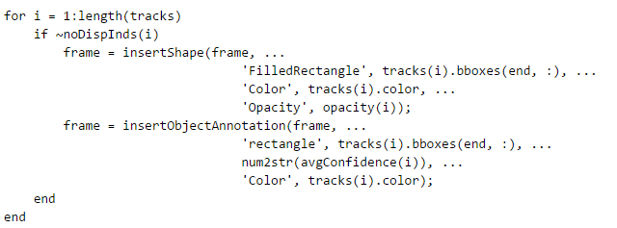If one takes a look at this portion of the code that is extracted from the MATLAB algorithm:

This portion of code is responsible for drawing out the bounding boxes aforementioned on each video frame. If one inspects the condition statement that is within the implemented for loop, one can find that it is actually going through all of the “tracks” created by MATLAB. Those “tracks” are then passed into an if-statement to check if they actually are tracking a person in a video frame. In other words, not every “track” created in the program is meaningful.

With this new revelation, a portion of the MATLAB algorithm can be modified as follows:

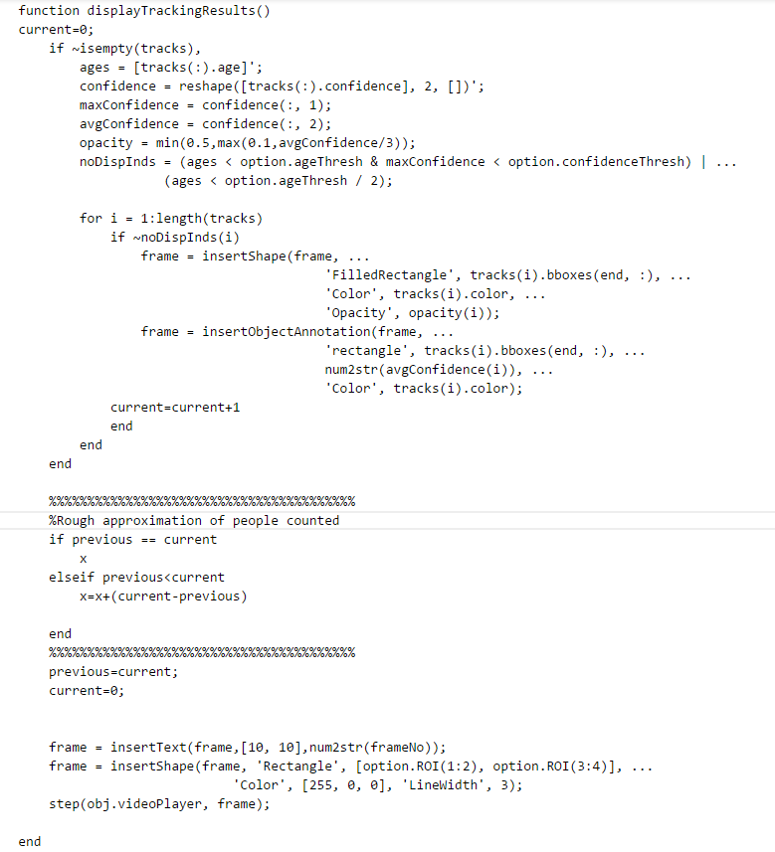

Note the highlighted code above. To implement the people counter, we can simply create two additional variables – previous and current to keep track of the number of people in each frame. Due to the fact that the video input is in forms of a horizontal sweep, we can come up with a rough count of the people detected via comparing two consecutive video frames: the current video frame and the previous video frame. If the number of counts of bounding boxes among the two frames are equivalent, the global counter will not increment, since it is treated as if the people that were previously detected in the video frame remain in the current video frame. However, if the current video frame has more bounding boxes than the previous one, then the global counter will increment by the difference of the number of bounding boxes between the current video frame and the previous video frame.

Despite the fact that this strategy is considered to be inaccurate, it is still pretty dependable.

# Next Semester (Overall Project) (Bradford and Michael)

With all three of the teams beginning to converge on their final solution, it remains important to be cognizant of the fact that all of the teams’ systems must be integrated together on board the UAV. With that understood, as the hardware team works to ensure the ArduPilot works properly with the UAV, they will continue to work with navigation to ensure that the data being outputted can be read by the ROS systems. This is especially necessary of the inertial measurement unit, contained within the flight controller, which is essential for the 2.5D mapping in ROS. On the other side of this relationship, as the map is generated by the ROS packages, data must be fed back into the flight controller to ensure it is moving about the environment correctly. ROS is well suited for control of systems of this nature and the running the autonomous control through this system should simplify procedures. This will of course have to follow calibrating the UAV and flight controller to work with the ROS programs. Once these systems have been proven to coordinate together under test conditions with a controlled environment, the systems will be tested on the actual UAV.

Hardware and enumeration will work together to establish a wireless connection between a base station (most likely a computer) and the UAV. This has become a requirement for enumeration and therefore must be configured next semester. This will also allow navigation to outsource processing of the mapping data if needed.

Navigation and enumeration will need to ensure that the mapping data is being shared to enumerations algorithms to allow for enumeration to determine how many pictures and video must be taken for complete coverage of the environment. Not only this, but as enumeration maneuvers around and captures pictures, the location of the UAV will need to be known and verified by navigation’s mapping programs. In this way, navigation will have to ensure that telemetry and mapping data are always available to be passed along to other processes.

These steps are a guideline to how the project group will organize its efforts next semester. More information on the schedule can be found in the Gantt chart below.

# Integration (Bradford, Michael and Dayton)

## Data Flow (Bradford)

* + - 1. The laser range scanner relays distance data to the Raspberry Pi
      2. An ultrasonic sensor relays distance data to the Raspberry Pi (used for detecting transparent obstacles the LIDAR sensor can’t detect
      3. The Raspberry Pi and base computer communicate over Wi-Fi using TCP sockets
         1. The Raspberry Pi sends it’s sensor data to the base computer which uses the 2.5D point cloud (generated from a combination of the distance data and accelerometer data) to create a 2D grid map
         2. The base computer then determines where the UAV needs to move next by looking at the cells of the 2D grid (identified as open, obstacle, or unexplored) and sending the corresponding motor commands to the Pi
      4. The Pi passes the motor commands along to the multiplexer
      5. The RC controllers commands are sent to the receiver on the UAV
         1. The RC controller has a switch that controls the input selector on the multiplexer
         2. The RC controller also passes along motor controls from the user
      6. The receiver passes along the inputs from the RC to one of the input channels of the multiplexer
      7. Based on the switch input from the RC controller, the multiplexer will pass along either the motor commands from the base computer or will allow a manual user override
      8. The accelerometer (located inside the APM) provides telemetry data
      9. An ultrasonic sensor provides data on the height of the UAV
      10. Motor commands are passed along from the multiplexer to the motors
      11. Telemetry data from the accelerometer and ultrasonic height sensor are sent to the Pi so they can be sent to the base computer along with the LIDAR data
      12. When mapping is completed, the map is sent to the enumeration Pi to determine where the UAV will fly to allow counting of individuals.
          1. The Pi also streams video from the camera to the base computer to be processed for counting and tracking of individuals
      13. The navigation Pi and enumeration Pi are connected to one another to allow two-way communication
          1. The enumeration Pi is fed data on the location of the UAV from the navigation Pi
          2. The enumeration Pi then tells the navigation Pi where the UAV needs to move next (the navigation Pi will determine the specific motor commands itself)
      14. The Pi camera module captures video and sends it to the Pi to be sent to the base computer for tracking and counting

The integration of the Hardware, Navigation, and Enumeration team’s systems was the final step of this project. There were two main integration tasks: communicating the directional commands (navigation team) to the quadcopter (hardware team), and using the generated map of the building (navigation team) to determine an enumeration path (enumeration team). These tasks would require a hardware and software connection between sensors and processors to be successful.

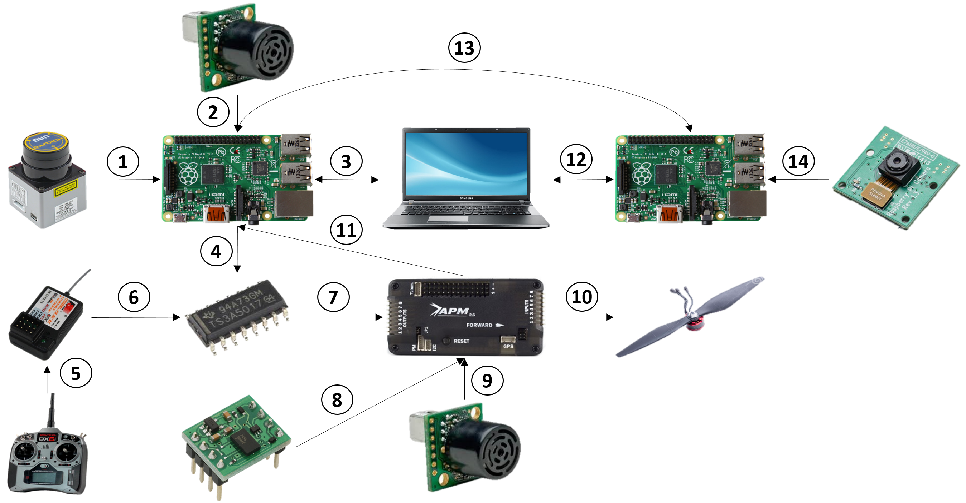

Figure . Data Communications Flow Chart

## Directional Commands (Michael and Bradford)

A 3 way connection was established to send autonomous commands to the APM. A Raspberry Pi 2 with movement directions communicates to the APM 2.6 with the flight controller firmware installed. The APM follows the commands and sends data from the accelerometer, gyroscope, and sonar altitude sensor back to the Raspberry Pi for accurate positioning and map generation. It was difficult to send direction commands to the APM using the serial port due to complications with MavLink. Therefore, the Raspberry Pi mimics the PWM values that the RC would normally send to the APM. The APM receives inputs at 50 Hz and between 5 and 10 percent duty cycle. For example, if the Raspberry Pi needs to communicate to the APM 0 percent throttle, it would send a 5 percent duty cycle for 1000 microseconds on and 19000 microseconds off. If the Raspberry Pi needs to communicate 50 percent throttle, it would send a PWM value of 1500 microseconds. The Raspberry Pi commands along with the RC receiver commands would be sent to a mux switch. When the MUX receives a high signal, the Pi would dominate in sending commands but when a low value was being sent, the RC receiver would maintain control. This allowed the teams to send Raspberry Pi commands over the receiver input pins on the APM while always having a manual user override. When commands were sent, the APM directs the quad copter with the proper motor values using the accelerometer and gyroscope to stabilize. While this is happening the raspberry pie is receiving accelerometer and gyroscope data over the APM’s serial port. This data is used to assist with positioning accuracy of the quadcopter and mapping accuracy. Figure 22 shows a map of the data transfer for sending commands.

Although the hardware team developed three different flight controllers to use for the project, none of the setups had any sort of communication protocols built into them. This forced the navigation team to utilize ROS copter so as to easily interface and pull data from the APM. The Ardu-Copter flight controller firmware was used because it already had communication connections with the RC receiver input pins and the serial port. However, it would have had to be modified to send accelerometer, gyroscope and altitude sonar data over the serial port. As the hardware team was unable to do this, the navigation team managed to set up the necessary libraries that would enable the APM to easily communicate with ROS. To do this the navigation team added a new library folder to the firmware and the new code was uploaded through the Arduino IDE to the APM. On top of this, the navigation team was able to use a portion of the Cberzan Roscopter in order to pull accelerometer data from the APM.

## Counting Location (Dayton and Bradford)

Once the map is generated by navigation, it will be passed along to the enumeration team which will determine where the UAV needs to move to. The critical points, or the points where the UAV must navigate to, will be supplied by the enumeration Pi. The navigation Pi will handle all path instruction decomposition and motor commands. The UAV counting algorithm will use the “directional commands” protocol to execute its search path. Once the path is defined on the map, it will be generated into instructions at a general level of straight, left, and right which should then be converted into motor commands such as “yaw” values and forward velocity. While the UAV is travelling along the point path, the Pi camera will be streaming video to the base computer where individuals will be tracked and counted. Once the UAV reaches a dead end or “spur” in a room that has a single entrance, the UAV must first turn 180 degrees to face the entrance in which it just traveled through, and then complete a 360 degree spin to gather the people count in the room. Large corridors and hallways that the UAV will use as a path are assumed to be sufficiently covered by the field of view provided from the pi camera.

# Conclusion (Bradford, Dayton, and Michael)

The group was able to complete most of the major objectives by the end of this project.

The enumeration team was able to successfully count people up to a certain distance and crowd density. There are limitations to detecting people when they are too far away or the crowd density is too high, but that is not likely to be a situation that occurs in most commercial buildings. For the people search “path algorithm”, the UAV sweep will sufficiently cover all of the territory that the navigation team provides in a map. Limitations for the people search path algorithm may occur if the building is too large for one single UAV to cover in a reasonable time. However, since the algorithm can be scaled to include multiple UAVs, errors that could be generated in large territory can be countered. The method that was chosen for the enumeration of occupants is a method that favors a high speed count of people and cooperation between multiple UAVs.

The Navigation team was able to generate a map and send commands. Communication between the UAV and the navigation team’s equipment has proven difficult and thus a large part of this semester has been devoted to control of the UAV. Though this might normally fall under the Hardware team, the Navigation team members were forced to focus on this in order to help develop a functional UAV. This included setting up the Pi to send PWM values to communicate directional commands to the APM and send flight data out using the serial port. Essentially, all communication between the flight controller, the Pi, and the base computer was done by the Navigation team.

The Hardware team built a functional and stable UAV. The UAV is able to hold the weight of the sensors while maneuvering with enough accuracy through a building. Finally, the Hardware team found a way to power all sensors long enough for the mapping and counting completion.

Along with each team’s personal achievements, the teams were able to send directional commands to the quadcopter. The flight controller on the quadcopter was then able to send accelerometer data for map feedback. The Navigation and Enumeration team successfully sent data from their sensors to a central computers for calculations. The team believes that autonomous control is within reach and that a little more work will prove the validity of their autonomous design.

# Budget (Michael)

Table - Project Budget

|  |  |  |  |  |  |
| --- | --- | --- | --- | --- | --- |
| **Purchase** | **Quantity** | **Cost** | **Shipping** |  | **Total** |
| Hyperion EOS 0606i Charger | 1 | $109.99 |  |  | $870.96 |
| Dji F450 TOP And BOTTOM CENTRAL BOARDS | 1 | $16.00 | $6.65 |  |  |
| apm 2.6 | 1 | $159.99 | $2.86 |  |  |
| 3DR uBlox GPS with Compass Kit and GPS mast | 1 | $97.49 | $2.32 |  |  |
| Arduino host shield | 1 | $24.00 | $9.22 |  |  |
| quad copter landing gear | 1 | $15.00 | $20.66 |  |  |
| quad copter arms | 4 | $26.00 |  |  |  |
| quad copter propeller guards | 1 | $19.00 |  |  |  |
| 1G raspberry pi 2 | 2 | $70.00 | $15.99 |  |  |
| Raspberry Pi 8G SD card | 1 | $12.98 |  |  |  |
| Raspberry Pi 16G SD card | 1 | $20.00 |  |  |  |
| Raspberry Pi 32G SD card | 1 | $35.00 |  |  |  |
| Pi camera | 1 | $25.00 | $5.85 |  |  |
| Quadcopter Propeller | 2 | $60.00 | $9.90 |  |  |
| Raspberry Pi Wireless Module | 1 | $12.95 |  |  |  |
| Ultrasonic Distance Sensor | 2 | $79.90 | $14.21 |  |  |
| Zippy Battery | 1 | $63.32 |  |  |  |
|  |  |  |  |  |  |
|  |  | $783.30 | $87.66 |  |  |

# Schedule (Bradford)

|  |  |  |  |
| --- | --- | --- | --- |
| Task Name | Duration | Start | Finish |
| **TRL Level 1** | **11 days** | **Mon 9/1/14** | **Mon 9/15/14** |
| Speak with Team and Sponsors |  |  |  |
| Evaluation of main objective |  |  |  |
| **Time Frame General Important Dates** | **179 days** | **Mon 9/1/14** | **Thu 5/7/15** |
| Fall Semester | 72 days | Mon 9/1/14 | Tue 12/9/14 |
| Reflection Writing Assignment, Peer Review, Draft Conference Paper | 7 days | Mon 12/8/14 | Tue 12/16/14 |
| Begin Physical Prototyping (Enumeration) | 13 days | Fri 11/21/14 | Tue 12/9/14 |
| Begin Physical Prototyping (Navigation) | 13 days | Fri 11/21/14 | Tue 12/9/14 |
| Begin Physical Prototyping (Hardware) | 13 days | Fri 11/21/14 | Tue 12/9/14 |
| Thanksgiving Break | 2 days | Thu 11/27/14 | Fri 11/28/14 |
| Final Exams | 6 days | Wed 12/10/14 | Wed 12/17/14 |
| Fall Break | 25 days | Wed 12/17/14 | Tue 1/20/15 |
| Spring Semester | 77 days | Tue 1/20/15 | Wed 5/6/15 |
| **Be TRL level 2** | **20 days** | **Mon 9/15/14** | **Fri 10/10/14** |
| Weight Test on UAV | 1 day | Mon 9/22/14 | Mon 9/22/14 |
| Decide on UAV body design | 16 days | Mon 9/22/14 | Mon 10/13/14 |
| Decide on Flight Controller | 21 days | Mon 10/13/14 | Mon 11/10/14 |
| Enumeration Scan Methods invented | 35 days | Mon 8/25/14 | Fri 10/10/14 |
| Find open source software for identifying algorithms | 295 days | Mon 8/25/14 | Fri 10/9/15 |
| Research algorithms for identifying people | 35 days | Mon 8/25/14 | Fri 10/10/14 |
| Acquire MCX to BNC cable | 35 days | Mon 8/25/14 | Fri 10/10/14 |
| Decide on best SLAN methods to pursue |  |  |  |
| **Be TRL level 3** | **46 days** | **Fri 10/10/14** | **Fri 12/12/14** |
| Equipment Selected (Navigation) | 41 days | Mon 9/15/14 | Mon 11/10/14 |
| Have all equipment for maneuverability selected | 41 days | Mon 9/15/14 | Mon 11/10/14 |
| Decide on sensor layout (Enumeration) | 16 days | Mon 10/20/14 | Mon 11/10/14 |
| Decide on sensor layout (Navigation) | 25 days | Mon 10/20/14 | Fri 11/21/14 |
| Complete Budget Proposal | 6 days | Mon 10/20/14 | Mon 10/27/14 |
| Test navigation sensors | 17 days | Sat 11/8/14 | Mon 12/1/14 |
| Purchase basic quad copter components | 21 days | Mon 11/10/14 | Mon 12/8/14 |
| Install Mission Planner | 15 days | Mon 11/24/14 | Fri 12/12/14 |
| Have sensor mapping code written | 8 days | Mon 12/1/14 | Wed 12/10/14 |
| Ensure sensors and processors are integrated | 14 days | Mon 11/24/14 | Thu 12/11/14 |
| Attach sensors to vehicle for initial tests | 7 days | Mon 12/1/14 | Tue 12/9/14 |
| Equipment Selected (Enumeration) | 20 days | Mon 9/15/14 | Fri 10/10/14 |
| Test function of enumeration sensors | 1 day | Fri 10/10/14 | Fri 10/10/14 |
| Get Tau 2 camera to work with a microprocessor | 9 days | Mon 10/27/14 | Thu 11/6/14 |
| Create backup plans | 7 days | Fri 10/10/14 | Mon 10/20/14 |
| Read Tau camera manuals | 6 days | Mon 10/20/14 | Mon 10/27/14 |
| Select Operating system of microprocessor | 6 days | Mon 10/27/14 | Mon 11/3/14 |
| Create pixel sorting algorithm | 6 days | Mon 11/3/14 | Mon 11/10/14 |
| Determine how to create or mimic User Interface | 6 days | Mon 11/10/14 | Mon 11/17/14 |
| Create or obtain algorithms for identifying people | 7 days | Mon 11/17/14 | Tue 11/25/14 |
| Test Function of enumeration sensors | 6 days | Tue 11/25/14 | Tue 12/2/14 |
| Begin testing algorithms on the camera w/o UAV attachment | 7 days | Tue 12/2/14 | Wed 12/10/14 |
| Discover how scanning techniques will be completed or constrained by UAV | 10 days | Mon 12/1/14 | Fri 12/12/14 |
| Complete Budget Proposal | 7 days | Thu 10/9/14 | Fri 10/17/14 |
| **TRL level 4** | **22 days** | **Fri 12/12/14** | **Mon 1/12/15** |
| GANTT chart and Budget Proposal | 9 days | Mon 12/1/14 | Thu 12/11/14 |
| Integrate Equipment | 15 days | Fri 12/12/14 | Thu 1/1/15 |
| Have code working on full video | 22 days | Sat 12/13/14 | Sat 1/10/15 |
| Enumeration will select camera/s | 18 days | Sat 12/13/14 | Tue 1/6/15 |
| Integrate equipment together | 12 days | Mon 9/15/14 | Tue 9/30/14 |
| Install Ardu-Copter Software | 20 days | Tue 12/16/14 | Mon 1/12/15 |
| ROS Hector Mapping Working | 8 days | Mon 12/1/14 | Wed 12/10/14 |
| **TRL level 5** | **22 days** | **Fri 12/12/14** | **Mon 2/28/15** |
| Test Ardu-Copter software with autonomous control | 20 days | Tue 12/16/14 | Mon 1/12/15 |
| Hector Mapping Using Real-Time Data | 31 days | Mon 12/1/14 | Sat 1/10/15 |
| Have camera actively working live (Enumeration) | 32 days | Fri 1/30/15 | Sat 3/14/15 |
| Test Ultrasonic Sensor | 30 days | Tue 1/20/15 | Sat 2/28/15 |
| **TRL level 6** | **22 days** | **Thu 1/15/15** | **Mon 4/30/15** |
| Integrate Ultrasonic Sensor on UAV | 30 days | Tue 1/20/15 | Sat 4/30/15 |
| Integrate advanced grid and A* algorithms | 16 days | Tue 1/20/15 | Sat 4/30/15 |
| 2.5D Hector Mapping with IMU | 32 days | Tue 1/20/15 | Sat 4/30/15 |
| Test Hector Mapping on UAV | 17 days | Tue 1/20/15 | Sat 4/30/15 |
| Pair Exploration Algorithm with ArduPilot | 16 days | Mon 1/19/15 | Sat 4/30/15 |
| Integrate Exploration Algorithm and Mapping | 12 days | Sun 2/1/15 | Sat 4/30/15 |
| Implement Exploration on UAV and Test | 12 days | Sat 2/14/15 | Sat 4/30/15 |
| **TRL level 7** | **22 days** | **Fri 3/20/15** | **Mon 5/12/15** |
| Final Exploration Tests | 12 days | Sun 3/27/15 | Sat 5/12/15 |
| Final Mapping Tests | 12 days | Sun 3/27/15 | Sat 5/12/15 |
| Final Integrated Navigation Testing | 12 days | Sat 3/27/15 | Sat 5/12/15 |

# Bibliography (Bradford and Dayton made recent changes)

1. "The Drag Coefficient." *The Drag Coefficient*. N.p., n.d. Web. 07 Oct. 2014.
2. "Dynamic Pressure." *Dynamic Pressure*. N.p., n.d. Web. 08 Oct. 2014.
3. "Aerosol Transport – Inertia." *Aerosol Transport » Section 3*. N.p., n.d. Web. 08 Oct. 2014.
4. "UNCERTAINTY ANALYSIS." *UNCERTAINTY ANALYSIS*. N.p., n.d. Web. 08 Oct. 2014.
5. "Stats: Estimating the Mean." *Stats: Estimating the Mean*. N.p., n.d. Web. 08 Oct. 2014.
6. “Panorama Creation.” *MathWorks.com*. The MathWorks, Inc., 1 June 2005. Web. 14 December 2014. <http://www.mathworks.com/help/vision/ug/panorama-creation.html#zmw57dd0e12728>.
7. Dalal, Navneet, and Bill Triggs. "Histograms of Oriented Gradients for Human Detection." 2. ACEMEDIA and PASCA. Web. 10 Oct. 2014. <<http://lear.inrialpes.fr/people/triggs/pubs/Dalal-cvpr05.pdf>>.
8. Cortes, Corinna and Vapnik, Vladimir. "Support-Vector Networks." *Machine Learning* 20.3(1995): 273-297. Web. 9 Dec. 2014.
9. "Object Detection and Recognition." *MathWorks.com*. The MathWorks, Inc., 1 June 2005. Web. 12 Dec. 2014. <http://www.mathworks.com/help/vision/ref/vision.peopledetector-class.html>.
10. "Tracking Pedestrians from a Moving Car." *MathWorks.com*. The MathWorks, Inc., 1 June 2005. Web. 12 Dec. 2014. <http://www.mathworks.com/examples/MATLAB-computer-vision/754-tracking-pedestrians-from-a-moving-car>.
11. "Vision.CascadeObjectDetector System Object." *Mathworks.com*. The Mathworks, Inc., 1 June 2005. Web. 13 Dec. 2014. <http://www.mathworks.com/help/vision/ref/vision.cascadeobjectdetector-class.html>.
12. "Acquire Images from Webcams." *MathWorks.* The MathWorks, Inc., 2014. Web. 12 Dec. 2014. <http://www.mathworks.com/help/supportpkg/usbwebcams/ug/acquire-images-from-webcams.html>.
13. Robot, Kinect Based Obstacle Avoider. "Kinect Based Obstacle Avoider Robot." *Kinect Based Obstacle Avoider Robot* (n.d.): n. pag. Web.
14. "Obstacle Detection and Map Building with a Rotating Ultrasonic Range Sensor Using Bayesian Combination." *Academia.edu*. N.p., n.d. Web. 17 Oct. 2014.
15. "Map Building Using Laser Sensor and Stereo Vision." *Map Building Using Laser Sensor and Stereo Vision*. N.p., n.d. Web. 17 Oct. 2014.
16. Gongora, Andy. "Quad vs Hexa vs Octo -copter." DIY Drones. 23 Aug. 2010. Web. 22 Sept. 2014. <http://diydrones.com/forum/topics/quad-vs-hexa-vs-octo-copter>.
17. "Overview of Pixhawk Flight Controller." APM Copter. 3DRobotics. Web. 6 Oct. 2014. <http://copter.ardupilot.com/wiki/common-pixhawk-overview/>.
18. 2., Of, 25, and 29. *A* Search* (n.d.): n. pag. Web. < <http://www.comp.dit.ie/jkelleher/rtf/classmaterial/week9/RobotPathPlanning.pdf>>.
19. "Wiki." *Hector_slam*. N.p., n.d. Web. 14 Dec. 2014. < <http://wiki.ros.org/hector_slam>>
20. "Wiki." *ROS/Technical Overview*. N.p., n.d. Web. 12 Mar. 2015.
21. "Wiki." *ROS/StartGuide*. N.p., n.d. Web. 14 Dec. 2014. < <http://wiki.ros.org/ROS/StartGuide>>.
22. "Using an Ultrasonic Sensor (HC-SR04) on a Raspberry Pi with Python." *RSS*. N.p., n.d. Web. 12 Mar. 2015.<http://www.bytecreation.com/blog/2013/10/13/raspberry-pi-ultrasonic-sensor-hc-sr04>
23. "UNIX Tutorial for Beginners." *UNIX / Linux Tutorial for Beginners*. N.p., n.d. Web. 14 Dec. 2014. < <http://www.ee.surrey.ac.uk/Teaching/Unix/>>.
24. "Tri vs Quad Copter." *RCGroups.com*. 25 Nov. 2009. Web. 10 Sept. 2014. <http://www.rcgroups.com/forums/showthread.php?t=1148358>.
25. Ramsey, Bruce. "Minimum Interior Door Opening Size." *AskCodeMan*. 16 June 2009. Web. 13 Oct. 2014. <http://www.askcodeman.com/viewtopic.php?f=17&t=175>.
26. Gortolev, Mike. "Quadcopter vs Hexacopter vs Octocopter: The Pros and Cons." *Dronebly*. 24 Nov. 2014. Web. 1 Dec. 2014. <http://dronebly.com/quadcopter-vs-hexacopter-vs-octocopter-the-pros-and-cons>.
27. "Spyder Extreme FPV Hexacopter." *Hobby Express*. Web. 1 Dec. 2014. <http://www.hobbyexpress.com/spyder_extreme_fpv_hexacopter_1041971_prd1.htm>.
28. Neer, Katherine.  "How many regular-sized helium-filled balloons would it take to lift someone?"  01 April 2000.  HowStuffWorks.com. <http://science.howstuffworks.com/science-vs-myth/everyday-myths/question185.htm>  13 December 2014.
29. "Three Blade or Two Blade." *RCGroups.com*. 2 Jan. 2012. Web. 11 Nov. 2014. <http://www.rcgroups.com/forums/showthread.php?t=1566384>.
30. "APM 2.5 or DJI Naza Version for Quadcopter." *Flite Test*. 1 Oct. 2013. Web. 15 Oct. 2014. <http://forum.flitetest.com/showthread.php?5894-APM-2-5-or-DJI-Naza-version-for-quadcopter>.
31. "APM 2.6 Set." *3DRobotics*. Web. 29 Oct. 2014. <http://store.3drobotics.com/products/apm-2-6-kit-1>.
32. "NAZA-M LITE." *DJI*. Web. 29 Oct. 2014. <http://www.dji.com/product/naza-m-lite/spec>.
33. "ZIPPY Flightmax 8000mAh 4S1P 30C." *HobbyKing.com*. Web. 13 Oct. 2014. <http://www.hobbyking.com/hobbyking/store/__16226__ZIPPY_Flightmax_8000mAh_4S1P_30C.html>.
34. "DJI F330 FlameWheel QuadCopter Assembly." *APM Copter*. Web. 14 Nov. 2014. <http://copter.ardupilot.com/wiki/dji-f330-flamewheel/>.
35. "E-PROP 23x12,5 Cm 9X5 Zoll." *Graupner*. Web. 1 Dec. 2014. <http://www.graupner.de/en/products/1326.9X5/product.aspx>.
36. "MT2216 V2.0." *T-Motor*. Web. 8 Dec. 2014. <http://www.rctigermotor.com/html/2013/Professional_0912/45.html>.
37. Oborne, Michael. "Mission Planner." *APM Multiplatform AutoPilot*. Web. 24 Nov. 2014. <http://planner.ardupilot.com/>.
38. Owen, Gareth. "How to Build Your Own Quadcopter Autopilot / Flight Controller." Web. 1 Dec. 2014. <https://ghowen.me/build-your-own-quadcopter-autopilot/>.
39. Coxworth, Ben. "Algorithm Lets Quadcopters Keep Flying on Three or Less Propellers."*Gizmag*. 5 Dec. 2013. Web. 8 Dec. 2014. <http://www.gizmag.com/quadcopter-failure-algorithm/30031/>.
40. "Multi-Rotor Frame Configurations." *Coptercraft, Unmanned Aerial Robotic Systems*. Web. 6 Oct. 2014. <http://www.coptercraft.com/multirotor-frame-configurations/>.
41. "RC Quadrotor Helicopter." *Instructables*. Web. 8 Dec. 2014. <http://www.instructables.com/id/RC-Quadrotor-Helicopter/?ALLSTEPS>.
42. "2D-LUA-Based-Robot-Simulator" Web. 14 Dec. 2014 <http://www.codepr oject.com/Articles/33587/D-LUA-Based-Robot-Simulator>
43. "SparkFun Electronics." *• View Topic*. N.p., n.d. Web. 14 Dec. 2014.
44. "Tradeoffs of XBee vs. WiFi for Remote Sensor & Camera." *Raspberry Pi*. N.p., n.d. Web. 14 Dec. 2014.
45. Owen, Gareth. "How to Build Your Own Quadcopter Autopilot / Flight Controller." *Build Your Own Quadcopter Autopilot*. Web. 19 Jan. 2015. <https://ghowen.me/build-your-own-quadcopter-autopilot/>.
46. "Using Hector Slam with Hokuyo Laser Range Finder." - ROS Answers: Open Source Q&A Forum. N.p., n.d. Web. 04 May 2015.
47. Digital Accelerometer. Digital image. Parallax. N.p., n.d. Web.
48. Electric Propeller Motor. Digital image. Dreamstime. N.p., n.d. Web.
49. Multiplexer. Digital image. Alpha-Crucis. N.p., n.d. Web.
50. Pi Camera. Digital image. Adafruit. N.p., n.d. Web.
51. Raspberry Pi. Digital image. Wikimedia. N.p., n.d. Web.
52. RC Controller. Digital image. Aliimg. N.p., n.d. Web.
53. RC Reciever. Digital image. Aliimg. N.p., n.d. Web.
54. Samsung Laptop. Digital image. Wired. N.p., n.d. Web.
55. Ultrasonic Sensor. Digital image. Maxbotix. N.p., n.d. Web.
56. URG Sensor. Digital image. Hizook. N.p., n.d. Web.
57. Jones, Dave. "Picamera." Git Hub, 4 Apr. 2015. Web. 4 May 2014. <http://picamera.readthedocs.org/en/release-1.10/>.

# Appendix

## Failure Mode and Effect Analysis (Bradford, Dayton and Michael)

|  |  |  |  |  |
| --- | --- | --- | --- | --- |
| Function | Potential Failure Mode | Potential Effects of Failure | Potential Cause of Failure | Recommended Actions |
| Flight Control | Instability | crash | PID controller | Determine stability before flight |
| Laser Scanner | No data | crash - bad map | faulty equipment | test beforehand |
| Camera Failure | No data | no count | connection - instability- faulty equipment | Create function to account for vibration - test connection limits |

**Configuration**

|  |  |  |  |
| --- | --- | --- | --- |
| Types of Failure | | | |
| Minor | Major | Critical | Catastrophic |
|  | Path Identifier Fails, SLAM Failure, Movement Determiner, Failure Camera Failure, Purposeful Avoidance by People | Laser Scanner Fails, Movement Failure | Motor Failure, PID Failure, Battery Failure |

**Functional**

|  |  |  |  |
| --- | --- | --- | --- |
| Types of Failure | | | |
| Minor | Major | Critical | Catastrophic |
|  | Laser Scanner Fails, Path Identifier Fails, SLAM Failure, Movement Determiner, Failure Camera Failure, Purposeful Avoidance by People, Movement Failure |  | Motor Failure, PID Failure, Battery Failure |

## Fault Tree Analysis (Bradford)

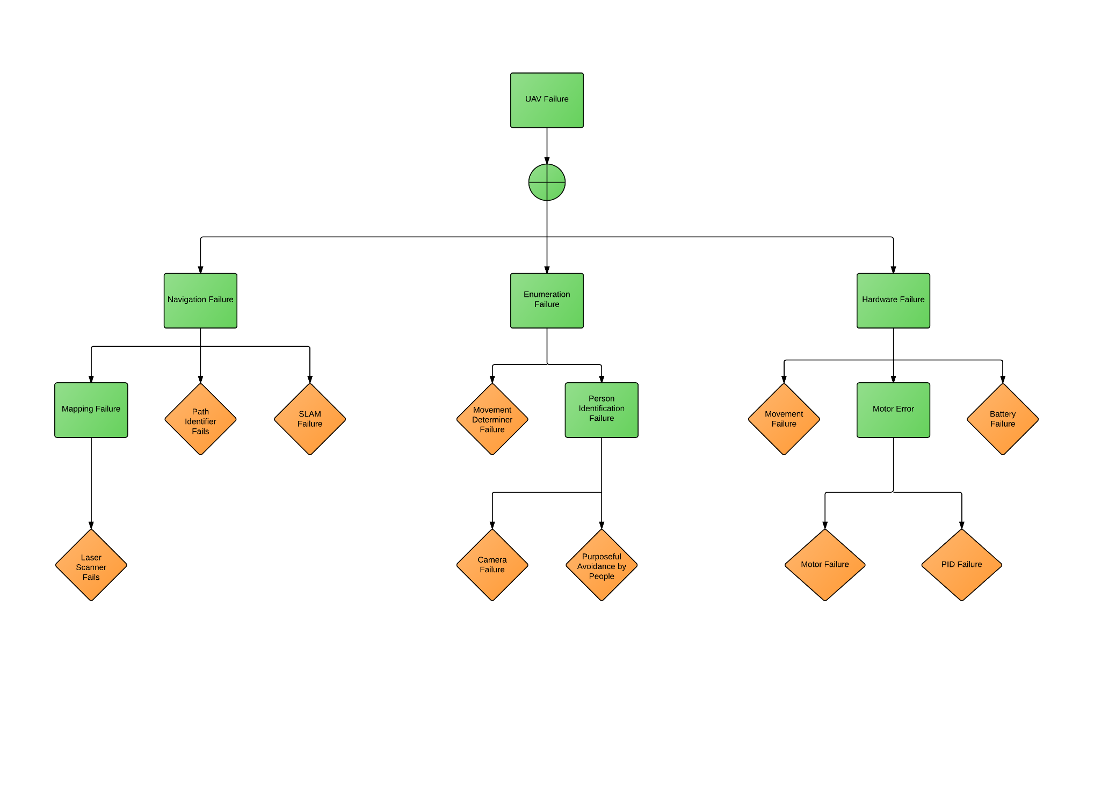

## Cause and Effect Analysis (Michael)

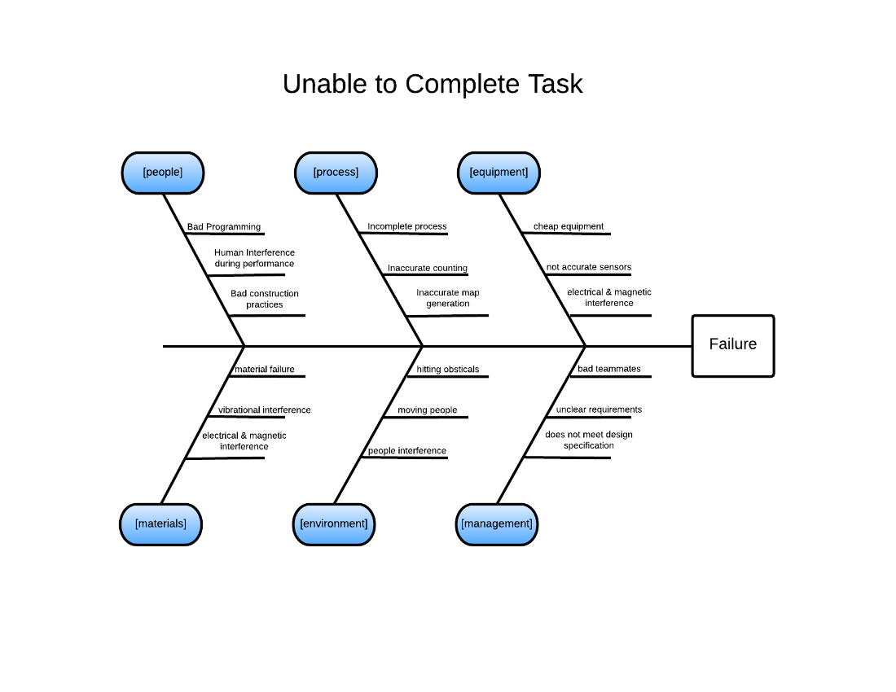

## Quad-copter Dimensions (Ezequiel)

The dimensions below are for the current quad-copter components and mounted hardware/sensors.

* Body
  + Arms span: 7.5” x 1.5” x 0.4”
  + Total span across:  27.5”
  + Center flywheel frame: 4.75” x 4.75” x 0.1”
  + Total weight of frame, motors and rotors blades: 0.8kg
* Battery: 0.7kg, 6.5” x 2.5” x 1.4”
  + Current Battery: Zippy 8000 High Discharge Li-Po Battery
  + Weight: 850 grams
  + Voltage: 4 Cell, 14.8 Volts
  + Capacity: 8000 mA-h (milliamp hours)
  + Cost: 64 dollars on average.
* Battery input/output:
  + 15.3 volt actual reading, 14.8 volt printed output
* Rotor Arms: (MT2216 V2.0. *T-Motor, 1)*
  + Resistance: 10.96 K Ohms per arm including the rotor and ESC
  + Motor specifics: T-Motor Type MT2216-11

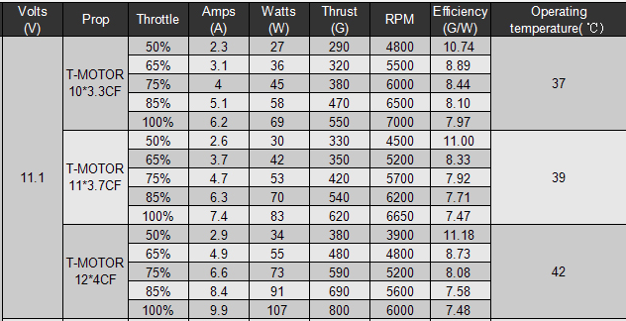

Table 10- Motor specifications (T-11*3.7CF)

* Motor weight: 75 grams
* Motor internal resistance: 135 m Ohms
* Motor diameter: 27.8 mm
* Motor length: 34mm
* Propeller (E-PROP 23x12,5 Cm 9X5 Zoll, 1)
  + Length: 9 inches
  + Pitch: 5 inches
  + Weight: 11 grams
  + Material: Fiberglass

(E-PROP 23x12,5 Cm 9X5 Zoll, 1)

## Calculations and Experimentation

### Weight Test on Hexa-copter (Michael)

The first test the hardware team did this semester was to determine how much weight the hexa-copter could lift.  This test provided a good indication on what multirotor frame is needed for the project.  The hexa-copter was loaded with different weights and throttle was increased until it reached about 5 feet off the ground (approximate height of operation).  Table 6 contains the amount of weight the hexa-copter lifts and the throttle needed to lift off the ground.

|  |  |
| --- | --- |
| Weight added | Throttle |
| 2.5 lbs | 47.5% |
| 3.75 lbs | 100% (Failed) |

Table -Hexa-copter lift test

These results showed that the hexa-copter can lift 2.5 pounds without overexerting the motors.  The combined weight of the navigation and enumerations sensors is not expected to be more than 1 pound so the hexa-copter has more than enough lift for this project.

The results obtained were run on a low charge battery and multiple broken blades. Therefore, the values found above are expected to be the lower limits of the weight lifted.  Weight tests will be run on the quad-copter to verify that the estimated lift capacity will be enough.

### Weight Test on Quad-copter (Michael)

When the quadcopter was assembled, another weight test was done to determine a more accurate lift capacity of the UAV. The test was done with the minimum hardware needed for stable flight. Table 7 contains the amount of weight the quad-copter lifts and the throttle needed to lift off the ground.

|  |  |  |  |  |
| --- | --- | --- | --- | --- |
| **% Throttle** | **Test 1 (lb.)** | **Test 2 (lb.)** | **Test 3 (lb.)** | **Average (lb.)** |
| 50% | .55 | .44 | .33 | .44 |
| 75% | 1.43 | 1.21 | 1.65 | 1.43 |
| 100% | 2.3 | 2.43 | 2.43 | 2.39 |

These results show that the quad-copter will need to operate between 50% and 75% to hold the expected weight of sensors. This should be manageable for the project specifications while still allowing altitude adjustments if necessary.

### Helium Lift Capacity Calculations (Spencer)

These calculations on helium lift capacity were done to determine if a blimp/multirotor hybrid UAV was feasible.  It takes 16 cubic feet of Helium to lift 1 pound of mass. (Neer, 1)  Using this ratio, Table 7 was created to show what sized balloon is needed.

|  |  |  |  |
| --- | --- | --- | --- |
| Volume (ft^3): | .5 cubic ft | 59.5 cubic ft | 14.1 cubic ft |
| Lift (ft-lbs): | .0314 lbs | 3.74 lbs (UAV mass) | ~.9 lbs |

Table - Helium lift calculations

From this table, it is clear that a balloon will not be able to lift a substantial weight of the UAV to reduce the load on the motors.

### Arm Reduction Calculations (Michael)

When considering the hexa-copter design, calculations were done on reducing the size of the arms to decrease size.  The spacing between rotors on the hexa-copter is 2”.  If the arm length could be reduced until the spacing between rotors was .5”, the diameter of the copter could be reduced to provide more clearance as the hexa-copter moves.  Figure 12 contains the diagram to calculate the reduction in length of the modified hexa-copter.

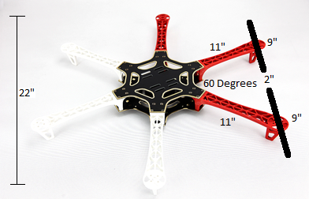

Figure 26- Arm dimensions

The angle between each arm is 60 degrees.  Therefore the distance from the center of the motor of 1 arm to an adjacent arm is the same as the distance from the center of a motor to the center of the frame. When the distance between rotors is reduced from 2” to .5”, the length of each arm is reduced from 11” to 9.5”.  This change reduces the diameter of the hexa-copter with rotors from 32” to 28”.  Although this change would help reduce the size, the arms would have to be custom made because DJI does not sell multiple sized arms so new arms would have to be custom made.

### MATLAB code Sample for People Detector and Cascade Object Identifier (Dayton)

(As of 5/3/2015 this code has been adjusted and updated. Please see Enumeration Code email submittals.)

Note: These samples are just small part of the bigger code and algorithm that will be running. They show variations of some of the settings on the local functions.

close all; clear all; clc;

peopleDetector = vision.PeopleDetector('UprightPeople_128X64',...

'MinSize',[128,64],'MaxSize',[1618,1192]);

% vision.MinSize=[128 64];

% 'ClassificationThreshold'

img=imread('14.jpg');

size(img)

BBoxes=step(peopleDetector,img);

[BBOXES, SCORES] = step(peopleDetector,img)

% Annotate detected people

img = insertObjectAnnotation(img, 'rectangle', BBoxes, SCORES);

figure, imshow(img)

title('Detected people and detection scores');

disp 'Next Result'

%%

img=imread('34.jpg');

size(img)

BBoxes=step(peopleDetector,img);

[BBOXES, SCORES] = step(peopleDetector,img)

% Annotate detected people

img = insertObjectAnnotation(img, 'rectangle', BBoxes, SCORES);

figure, imshow(img)

title('Detected people and detection scores');

disp 'Next Result'

%cascade object identifier comparison

bodyDetector = vision.CascadeObjectDetector('ProfileFace');

bodyDetector.MinSize = [200 200];

bodyDetector.MergeThreshold = 10;

I2 = imread('34.jpg');

bboxBody = step(bodyDetector, I2);

IBody = insertObjectAnnotation(I2, 'rectangle',bboxBody,'Upper Body');

figure, imshow(IBody), title('Detected upper bodies');

%%

bodyDetector = vision.CascadeObjectDetector('LeftEye');

bodyDetector.MinSize = [12 12];

bodyDetector.MergeThreshold = 10;

I2 = imread('visionteam.jpg');

bboxBody = step(bodyDetector, I2);

IBody = insertObjectAnnotation(I2, 'rectangle',bboxBody,'Upper Body');

figure, imshow(IBody), title('Detected upper bodies');

% % % detector = vision.CascadeObjectDetector('')

img=imread('15.jpg');

size(img)

BBoxes=step(peopleDetector,img)

[BBOXES, SCORES] = step(peopleDetector,img)

% Annotate detected people

img = insertObjectAnnotation(img, 'rectangle', BBoxes, SCORES);

figure, imshow(img)

title('Detected people and detection scores');

disp 'Next Result'

### Robot Operating System Code (Bradford)

<launch>

<param name="/use_sim_time" value="false"/>ros

<node pkg="rviz" type="rviz" name="rviz"

args="-d $(find hector_slam_launch)/rviz_cfg/mapping_demo.vcg"/>

<include file="$(find uprobotics)/launch/hector_mapping.launch"/>

<include file="$(find uprobotics)/launch/geotiff_mapper.launch">

<arg name="trajectory_source_frame_name" value="scanmatcher_frame"/>

</include>

</launch>

Figure . ROS Slam.Launch

<launch>

<include file="$(find hector_mapping)/launch/mapping_default.launch">

<arg name="base_frame" value="base_frame"/>

<arg name="odom_frame" value="base_frame"/>

</include>

<include file="$(find hector_geotiff)/launch/geotiff_mapper.launch">

<arg name="trajectory_source_frame_name" value="base_frame"/>

</include>

<node pkg="tf" type="static_transform_publisher" name="base_frame_to_laser_broadcaster" args="0 0 0 0 0 0 base_frame laser 100"/>

</launch>

Figure 28. ROS Hector SLAM No IMU Launch

<launch>

<node pkg="hector_mapping" type="hector_mapping" name="hector_mapping" output="screen">

<param name="pub_map_odom_transform" value="true"/>

<param name="map_frame" value="map" />

<param name="base_frame" value="base_link" />

<param name="odom_frame" value="base_link" />

<!-- Map size / start point -->

<param name="map_resolution" value="0.025"/>

<param name="map_size" value="2048"/>

<param name="map_start_x" value="0.5"/>

<param name="map_start_y" value="0.5" />

<param name="laser_z_min_value" value="-2.5" />

<param name="laser_z_max_value" value="7.5" />

<!-- Map update parameters -->

<param name="update_factor_free" value="0.4"/>

<param name="update_factor_occupied" value="0.7" />

<param name="map_update_distance_thresh" value="0.2"/>

<param name="map_update_angle_thresh" value="0.06" />

</node>

<node pkg="tf" type="static_transform_publisher" name="base_to_laser_broadcaster" args="0 0 0 0 0 0 /base_link /laser 100" />

</launch>

Figure . ROS hector_mapping.launch

<launch>

<arg name="trajectory_source_frame_name" default="/base_link"/>

<arg name="trajectory_update_rate" default="4"/>

<arg name="trajectory_publish_rate" default="0.25"/>

<node pkg="hector_trajectory_server" type="hector_trajectory_server" name="hector_trajectory_server" output="screen">

<param name="target_frame_name" type="string" value="/map" />

<param name="source_frame_name" type="string" value="$(arg trajectory_source_frame_name)" />

<param name="trajectory_update_rate" type="double" value="$(arg trajectory_update_rate)" />

<param name="trajectory_publish_rate" type="double" value="$(arg trajectory_publish_rate)" />

</node>

<node pkg="hector_geotiff" type="geotiff_node" name="hector_geotiff_node" output="screen" launch-prefix="nice -n 15">

<remap from="map" to="/dynamic_map" />

<param name="map_file_path" type="string" value="/home/viki/Desktop/maps" />

<param name="map_file_base_name" type="string" value="uprobotics" />

<param name="geotiff_save_period" type="double" value="0" />

<param name="draw_background_checkerboard" type="bool" value="true" />

<param name="draw_free_space_grid" type="bool" value="true" />

</node>

</launch>

Figure . ROS geotiff_mapperer.launch